Reviewing the Concepts 5.1-5.3
[Name of the Writer]
[Name of the Institution]

Chapter 14
- We must breathe oxygen to stay alive as our cells need energy that plays an essential role in extracting energy from food molecules.

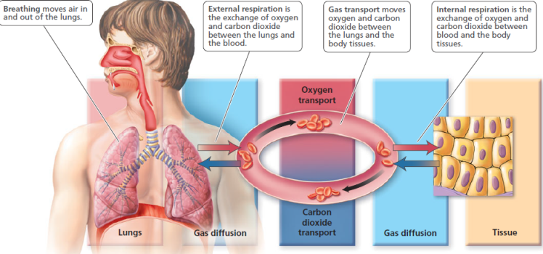
- Most particles and disease-causing organisms are removed with the help of nose. Hair is present inside the nose that filters out these particles. In addition, certain cells in the membrane lining the surface of the nasal cavities and air tubules produce mucus. Cilia then sweep the mucus, trapped dirt particles, and bacteria toward the throat.
- Food does not usually enter the lower respiratory system when we swallow as larynx provides a selective opening to the trachea. The esophagus is behind the larynx and food and drink must pass over the opening to the larynx to reach the digestive system.
- Human speech is produced with the help of vocal cords which are the folds of connective tissue above the opening of the larynx.
- Cartilage rings in the trachea held open trachea and give it the general appearance of a vacuum. Trachea will be collapsed in the absence of these rings.
- The trachea divides into two air bronchi; which further divide into bronchioles. This is known as bronchial tree.
- Air moves into the lungs when the size of the thoracic cavity increases; this increase causes the pressure in the lungs to drop below atmospheric pressure.
- The tidal volume is amount of air inhaled or exhaled during a normal breath, which is (~500 ml). Vital capacity is maximum amount of air that can be inhaled or exhaled in a single forced breath, which is (~3400–4800 ml). Thus, vital volume is more.
- Oxygen is transported to the body cells by the blood. The oxygen that reaches the cells is bound to hemoglobin.
- Most of carbon dioxide is transported from the cells to the lungs through the bicarbonate ion.
- The basic rhythm is controlled by a breathing center located in the medulla of the brain.
- Carbon dioxide after its diffusion from the blood into the cerebrospinal fluid raises the hydrogen ion concentration by forming carbonic acid. This stimulates the chemoreceptors in the medulla and breathing rate is increased.
Chapter 15
- Mouth, pharynx, esophagus, stomach, small intestine, large intestine and anus.
- Mouth starts the mechanical digestion of the food. It also monitors food quality and moistens food. Moreover, teeth in the mouth grind the food and palate present in the mouth prevents food from entering the nose during swallowing.
- Bacteria live in mouth and produce acid. Their activity is increased with the food particles. These erode the enamel. Blood vessels also cause tooth decay.
- Storage of food and regulation of the release of food to the small intestine, liquefaction of food and initial chemical digestion of proteins. Gastric juice starts the chemical digestion of the protein in food.
- Because food is still not fully broken down into molecules.
- Bile assists lipase in chemically digesting fats.
- Carbohydrates are digested in mouth and small intestine. Proteins and fats in small intestine.
- Villi have circular folds in its lining.
- Pancreas
- Recovery of water and electrolytes, storage of faeces as well as fermentation.
- Sight of food, chewing food and presence of acidic chime
- Increase the surface area for absorption
- Peristalsis pushes food along the digestive tract in the right direction
- Chemical digestion
- Small intestine.
- Bolus
- Liver
- Amylase
- Bile
Chapter 16
- Ammonia, urea, uric acid, and creatinine. These are produced through protein digestion in stomach.
- Kidney produces urine, ureter transports urine, urinary bladder stores urine, urethra transports urine from urinary bladder
- By releasing hormones and changing sodium and electrolyte balances.
- Glomerular filtration is blood filtration in glomerulas capsule, tubular reabsorption is removal of useful materials from the filtrate and returning them to the blood and it occurs in loop of Henle,
- By controlling the secretion and reabsorption of hydrogen ions.
- Under the action of ADH and is important for homeostasis.
- ADH causes water reabsorbtion, aldosterone increases reabsorption of Na+ and atrial natriuretic peptide decreases reabsorption of Na+.
- The solute concentration in interstitial fluid increase from the renal cortex to the renal medulla to conserve water.
- Solute concentration of filtrate increases, solute concentration of the filtrate then there is water reabsorption.
- Female urethras are smaller and male urethras are larger. This causes more infections in females.
- Returns useful substances to the blood.

