|  |  |
| --- | --- |
| Weekly Food for Thought… | **May 15, 2019** |
| Dear room 108 families  Play is as important as the work itself. It is even more essential when it comes to the child development and mental growth. It is the vital ingredient that paves the way for effective learning and improves the faculties of child. So, the importance of play for children’ mental and physical growth is paramount.  Mr. Rogers explains, “Play is often talked about as if it were a relief from serious learning. But for children, play is serious learning.”  Play has a role in the child’s emotional and physical well-being. A renowned book (Goldstein. J. 2012) elaborates that importance of play in great length. It explains the vital value of play for the robust and empathetic growth of children | Play in our classroom  Playing activities can be easily incorporated in the classroom by several ways:  Physical play- by making time for jumping activities and physical games  Symbolic play-placing different shapes and playing different sounds  Psychological play- developing the emotional side of the children via pretend play and role play-techniques  As “Play is the lens through which children experience their world and the world of others”, so the practice of play is highly integral in studies as classrooms is the first formal structure, they experience in their lives.  The regular physical breaks in the learning is healthy for the children and it improves their physical growth. Also, the symbolic play that’s is used in the classrooms effectively develops the moral intelligence and the recognition abilities in them. This development is also solidified when it is performed in the pretend play which is based on the physiological development, and enhances their personality growth.  Thus, the role and significance of play is immense for children and it helps them in multifarious ways. |

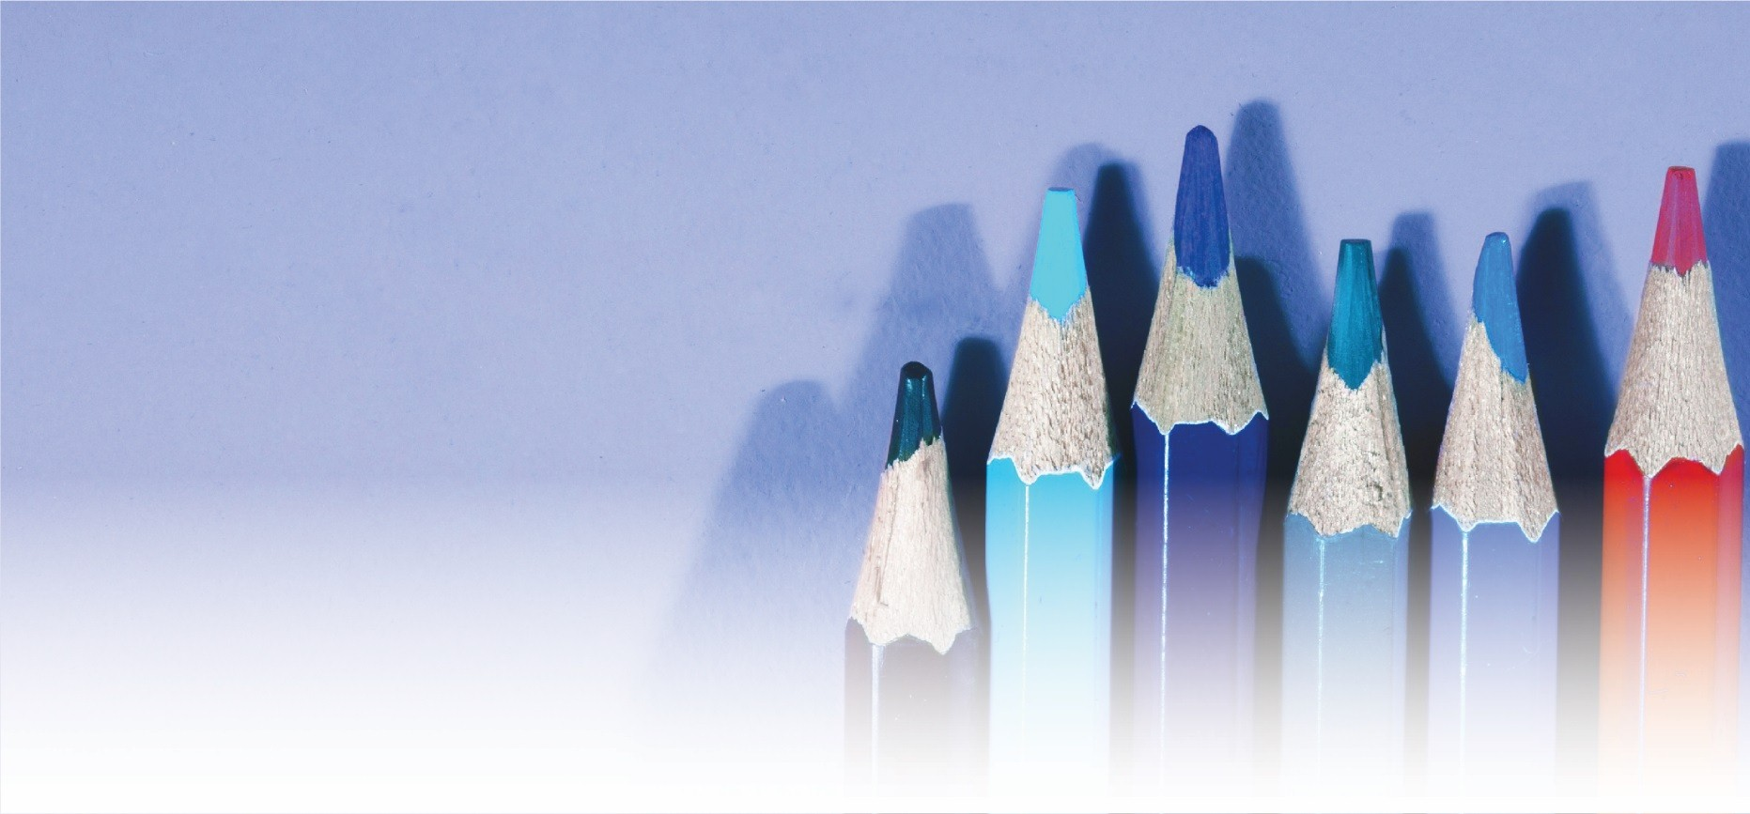

Your name here (you can also include a name for the Lead teacher)