Safety
[Name of the Writer]
[Name of the Institution]

Safety
Fall and injury prevention is a challenging issue across hospitals in the US. In the US inadvertent falls are very common and are a major cause of severe injuries. Especially at the age of 65 and above people get injured because of the falls. Almost 41 out of 100,000 people die because of the falls. Falls and medical errors are consistent with each other. In hospitals falls happen due to technical errors, for example, placing a call light from the reach of the patient, or providing an aggressive physical therapy to the patients when even their balance has not been established (Koo et al., 2009). Another cause of falls is due to an error in the commission that is defined as the error caused by the consequences of any action taken. For instance the occurrence of falls during electroconvulsive therapy. All these medical errors cause severe discomfort which will damage the hospital's reputation.

Problem statement
In Miami hospital according to the statistics, there is a total of 10 falls per month out of 200 patients in which 6 are because of medical errors. It is a huge concern for the hospital executive authorities as this damages hospital reputation. Also, patient dissatisfaction results in major fines hospitals have to pay. So the hospital decided to use PDCA in order to reduce the falls.
PDCA
PDCA stands for plan, do check and apply the approach. This approach is used by many organizations to solve the problems they are facing and improving their standards (Johnson, 2002). 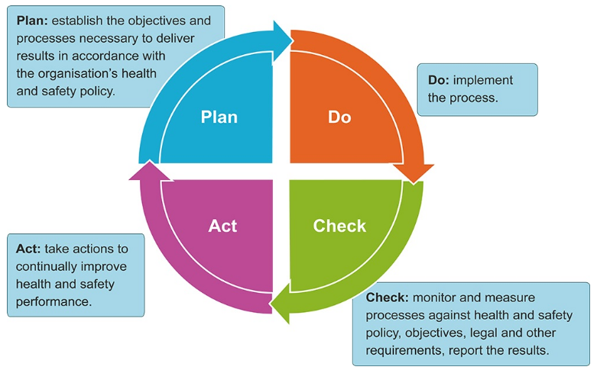
Fig: 1 PDCA cycle (https://www.google.com/search?q=pdca&source=lnms&tbm=isch&sa=X&ved=0ahUKEwjfnfGU8LbjAhXdQxUIHWhrBfkQ_AUIECgB&biw=1440&bih=789#imgrc=JC-Suca4EGthRM:)

Methodology
A stepwise scheme to decrease patients falls in the Miami hospital is proposed by using PDCA. These kinds of projects require extensive provision from the administration of the hospital. The methodology to determine the causes of falls and reducing them respectively is presented. First of all the data is collected from the hospital administration about the number of falls per month. Then the reasons for the falls are enquired. After getting complete data a plan is developed which will further be implemented to see whether it worked or not.

Step 1: Gather a quality improvement team:
Falls depends upon different factors and no specific provider solely is able to create a lasting impact on harms caused by falls. In order to reduce falls, it is important to create a quality improvement team. This team consists of an active member of both physicians and nurses that will report all their findings to the team leader. The QI team should be of at least five members. It is necessary to engage the hospital’s patient safety and quality department as they will assess the reports from the team. There is a need for high-level connectivity between the team members to ensure positive results.
Step 2: Analyzing risk factors and circumstances for falls:
It is important to examine the problem carefully by thoroughly studying the data from the database of fall incident reporting maintained by the hospital. This information will help in determining the factors involved in the falling of patients. These include circumstances involved in the fall like toilets, beds, chairs and time of the day or night. Additionally, the demographics of patients that experienced falls like their age and gender, etc.
Step 3: Selecting a pilot site:
The initial stage of the project is always critical. It is necessary that the priority of hospital leadership is patient safety and fall reduction. The first step is to select a pilot site where all the new changes and will be done. The key determinant in the project is frontline hospital staff as without their cooperation the project won’t work.
Step 4: Determining points of leverage for intervention:
With the help of frontline clinicians, the QI team can easily decide whether elements of the project will apply to all the patients or should base on individuals risk factors. Additionally, the team should look for the incongruity between the existing practice and specific evidence-based interventions that are specifically followed at healthcare institutions.
Step 5: Evaluating each element of intervention:
It is very important to evaluate multiple factors of interventions to assess the individual elements of the project. If there is any failure in the improvements it means that the elements of interventions are not applied and practiced correctly. In order to circulate intervention with the help of pilot site, it is required to document staff education and competence. This evaluation can be considered as measuring the performance of the process measures taken.
Step 6: Investigate the impact of changes:
The impact of the interventions on the rate of falls should be examined carefully. Failure to show any improvements in fall rates depends upon the staff incompetence or the data collected for assessing the situation is correct or not. If there is still a deficiency in the proposed solution then it is important to design a new approach.
Step 7: Reviewing and expanding the project:
If a project is successful in the pilot site then it should be expanded and can be slightly modified as well. It is important to consider that an intervention that is successful in one department might not show the same results in another. It is, therefore, necessary to expand slowly to meet the requirement of every department.
Step 9: Manage new baseline:
The QI team should not assume that this new intervention will always work. It is important to monitor the change regularly in order to maintain balance.

References
Koo, J., Kim, S., Kim, H., Kim, Y. H., & Yoon, E. S. (2009). A systematic approach towards accident analysis and prevention. Korean journal of chemical engineering, 26(6), 1476-1483.
Johnson, C. N. (2002). The benefits of PDCA. Quality Progress, 35(5), 120.

