Economics Assignment
Name of Student
Name of institution

Answer 1
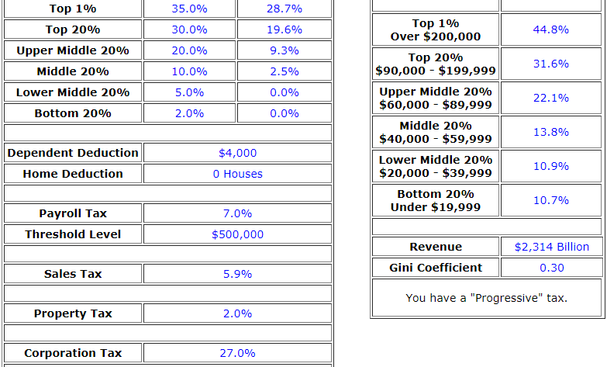
I have assumed that the person above has two children who are fully dependent upon the person. Thus, there is a deduction allowed in the law for the person so we have provided $ 4000 deduction for him. The threshold level of the payroll is set at $500000.
The inequality of income in the society is measured by the gini coefficient. The variable has the values from 0 to 1. The value near to 1 shows higher inequality of income in the society. The inequality of income is not the problem in a single country. The global economy is suffering from this problem. Some economists say that the measure is not able to calculate the numbers accurately.
The above table shows the value of gini coefficient value of 0.30. This shows a low inequality of income a per the tax system depicted in the diagram. This means that the personal taxes are appropriate in the percentages.
There are certain measures that can affect the gini coefficient to rise or fall. The most important aspect in this regard is the increase or decrease in the personal consumption expenditures. This is because these expenditures are affected by the direct taxes. The direct taxes decide the actual sacrifice that the person has to bear in terms of taxes. The gini coefficient is directly affected by the direct taxes.
There are some other factors that affect the value of gini coefficient. The wealth and property tax also affect the value of gini coefficient. The indirect taxes like the sales tax does not affect gini coefficient because these taxes do not affect the disposable income of the people. Thus in order to adjust the inequality of income, the authorities must see the actual sacrifice made by the individuals.
Answer 2
The article has used the concept that refers to the external costs. Whenever an economic decision is made, there are some private costs associated to it. However, these are not the only costs that are associated with the decision. There are some additional costs that must be considered. These costs are the external or social costs associated to any economic decision. The article specifies some situations where the social or external costs are evident. The climate of the earth is changing fast which can have adverse effects on the future generations. These aspects have come to the forefront of the discussions more recently. The people must realize that the climate change has to be stopped. This effort will require certain resources and costs. These costs will have to be borne by quitting some other expenditures. I addition to the costs, there will be certain benefits of the climate control projects. These projects will create a large number of jobs and good amounts of revenues for the country. These will be the private benefits and the overall impact of the project will be calculated by subtracting the costs from the benefits. The project having more benefits than the costs should be continued. As per the article, the projects will have more benefits in the future as compared to the present. However, the costs will have to be incurred now.
Answer 3

In choosing the product, we have made sure that the concepts of elasticity can be properly applied to it. Keeping this in view, I have chosen the flour as the example. We will see the response of the quantity demanded to a change in price.
The quantity has changed from 3 to 2 in two years. The price has changed to $5 from $1. Taking this data, we will apply the following formula to calculate elasticity of demand:
%age change in quantity demanded/%age change in price
This formula can further be analyzed as:
Q1-Q0/P1-P0 * P0/Q0
= 2-3/5-1*3/1
=-0.75
The answer shows a minimal impact of the change in price on the quantity demanded of the product. The interpretation of the figure is that the unit change in the price of the product will bring less than a unit change in the quantity demanded. The nature of the product is that of the basic need which the people cannot quit in any case. The other consideration is the availability of substitutes which are less in case of a basic need. Generally the product under consideration has more importance in overall budget of the family or the unit under consideration. The basic need like bread has more importance in the budget of the people. This means that it is harder for the individual or family to quit the product.
Answer 4
The decision that was taken by me is regarding making the budget when there is an increase in the income. There were some products whose consumption was going to be decreased after the increase in income. These were the inferior goods and they have an income elasticity of demand as negative. There were some other goods whose quantity demanded was increased with an increase in income, these were the normal goods and they have a positive income elasticity of demand.

