How does Justin Kurzel use a range of film techniques in a scene
to emphasise themes and/or ideas?

Justin Kurzel utilize different camera techniques and styles to emphasize themes and ideas in the film. Analysis of these techniques and styles is entirely based on Act 1 scene 3 which takes on the mountains amid intense fog and wind blowing as Macbeth and Banquo prepare to encounter witches. Kurzel intended to make the setting foggy and windy so as to appear harsh and mysterious to the viewers. The setting was also intended to portray witches as mysteriously and actions mystic. 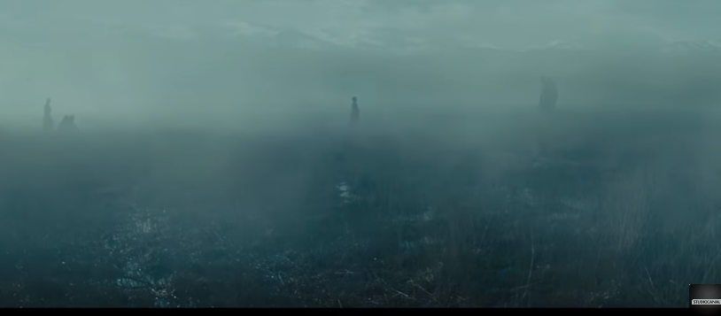
Photo 1: scene showing foggy and windy setting
Kurzel’s use of camera angle technique in the scene portray feeling, tensions and emotions. The low angle shots give easy recognition of actors facial expressions. It is easy to identify different feelings of the actors hence enabling the viewers to understand actors minds.
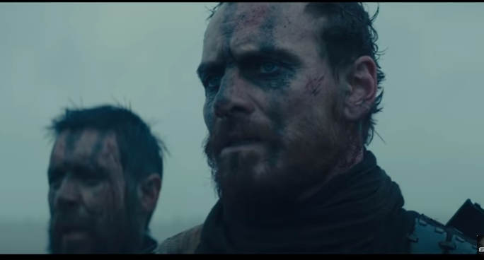
Photo 2: low angle shots
As the witches and a child approach Macbeth and Banquo standing the camera shot changed from full and long shot to extreme close up.
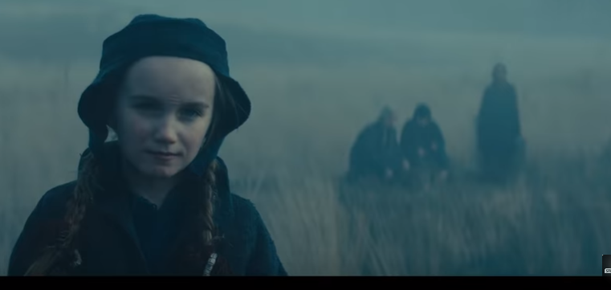
Photo3: full and long shot
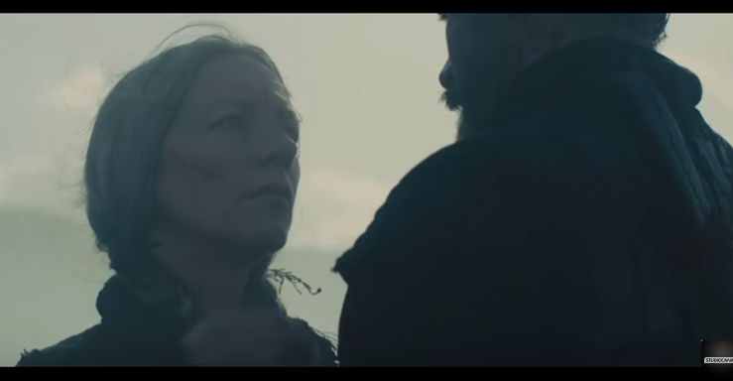
Photo 4: extreme close up
The change on camera shots intended to show the views change in Macbeth and Banquo’s feelings from paranoia and suspicion to trust and free. It also shows witches’ dominance and power. Importantly, as the witches approach Macbeth and Banquo, their approach is accompanied by eerie music in mysterious tune singing in the background. The use of this kind of sound and music make the audience suspicious.
Similarly, Kurzel utilizes multiple camera angles to show character interactions, for instance, kurzel uses a low angle to show Macbeth and Banquo walking across the land, and mid-angle long shots to show the witches approaching the two men from a distance. The use of long angle support the theme of power. The witches are intentionally portrayed as powerful and exhibits strength. As the scene progresses audiences are able to see that the witches bring a message that gives hope to Macbeth and Banquo.
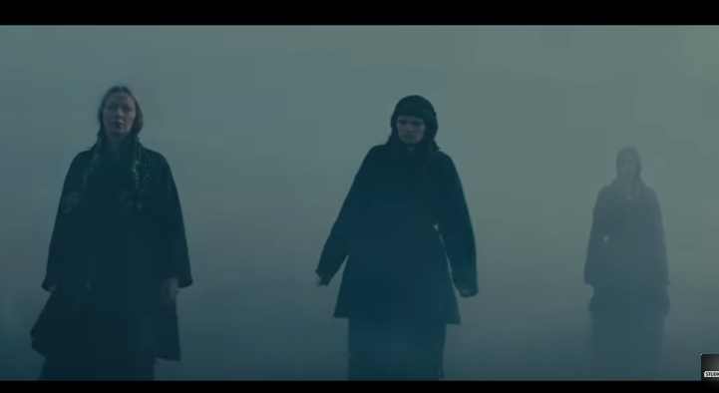
Photo 5: low angle & long shots
Importantly, as the witches interact with Macbeth and Banquo, there is series of camera panning, a technique that involves moving shots across all the characters. The shots keep changing from Macbeth to Banquo, and back. Specifically, the camera panes towards Macbeth to capture his reaction after hearing prophesy about ascending to the throne. His face reads ambition and anger for power.
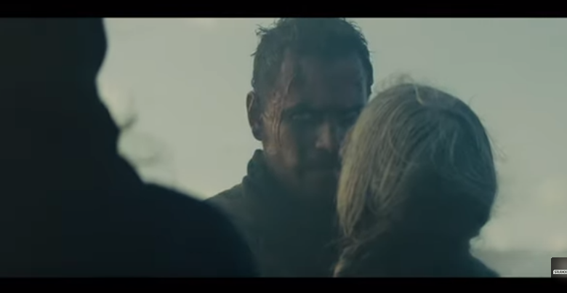
Photo showing Macbeth’s face panning

Kurzel use this technique to capture the feelings of the characters and give the audience better understanding of prophesy as the witches called Macbeth Thane of Cawdor and a future king.
Besides, the low-key light and sharp contrasts enabled Kurzel to communicate the thematic theme of destruction and evil, which is quite a dominant theme in the scene.
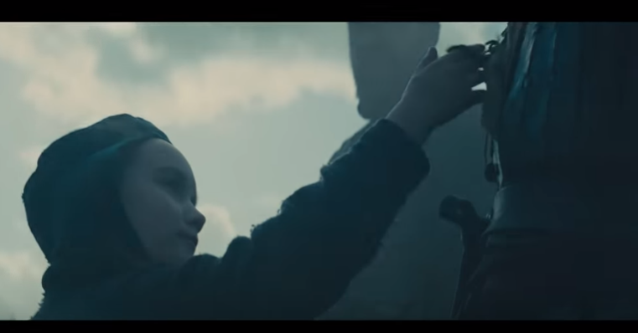
Photo 6: low light and contrast
In the scene, Kurzel chose a dark contrast and low color, which is crucial in setting the film’s mood. The surrounding which was made dark and foggy hence supporting the theme of fate and free will.
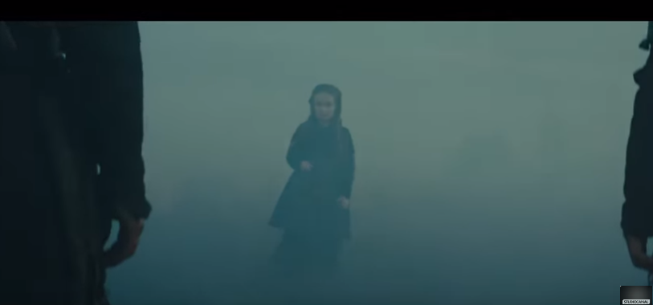
Photo 6: dark contrast and low light plus dark and foggy surrounding

The lighting techniques as it appear above, show the peculiarity of Witches’ actions which Kurzel wanted audiences to perceive it as strange and difficult to understand. Visual effects, and high contrast to support the theme of the aloofness, violence, aggressiveness and stimulation.
In the same way, he used costuming and soundtrack to progressively develop characters and help fulfill the key themes. Macbeth and Banquo appear in the scene wearing in tunics and less formal clothing. When meeting with the witches they appear wearing simple black armor used in battles. This attire serve to show Macbeth and Banquo warring and violent. Witches appear wearing black outfits and had bizarre hairstyles roughly plaited. The witches’ outfits help them appear mysterious-looking which supports the film’s intention of making them look mystical to Banquo and Macbeth. 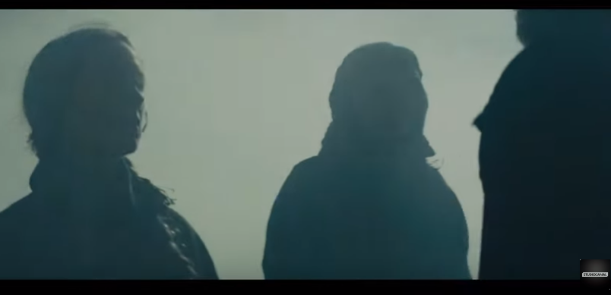Photo: dark clothing, and roughly plaited hair
Furthermore, the witches appear to have very minimal make in their faces. It is easy to see scars and marks on their faces. The costumes use is accurately use to show what people use to wear in the medieval times. The makeup on the Macbeth and Banquo’s faces made them look like warriors. They also appear dirty and rucked. The choice of costumes adorn by men and women in the film help to indicate and explain the topic of masculinity and cruelty. Men’s costumes indicate power, energy, control, and aggressiveness, which support film’s theory that show control and power that men often had on the women. The women adorn clothes that showed submission and weakness hence helping to emphasize the theme of men dominance. In addition, when the witches were about to appear to make an announcement about the throne we could hear people violently and loudly speaking; this symbolizes power, evil and destruction.
In conclusion, kurzel uses different film techniques to advance different themes and characters. He succeeded in capturing thematic aspects of the film and help the viewers understanding different themes.

