Air Quality and Pollution Lab
[Name of the Writer]
[Name of the Institution]

Air Quality and Pollution Lab

Introduction
Air pollution refers to the harmful substances like gases, biological molecules or particles that are introduced into Earth’s atmosphere in excessive amount. Air pollution is one of the leading causes of diseases (Di et.al, 2017). It damages the environment as well as the natural habitat of many creatures in echo systems. In my report, I will be discussing how the quality of air is measured, what AQI actually is and different types of pollutants. Furthermore, I will be comparing three different countries’ monthly average unhealthy days by focusing on the disease that is lung cancer/asthma followed by graphs and drawing a conclusion from the comparison.

Discussion
Air Quality Index (AQI)
The air quality index (AQI) determines the quality of air around us. It tells us about the air whether it is polluted or clean. Additionally, it gives complete information about the health effects that may be a point of concern in that specific area.
The air quality index is used by different government agencies in order to give information regarding air pollution to the public. Some of these are Air pollution index (Malaysia), quality health index (Canada) and Air now (USA). In the US the environmental protection agency, National park services, and national oceanic and atmospheric administration are responsible for creating this website making it accessible for people worldwide. This data provides an insight into the air conditions and how to protect from the potential diseases that have a high chance of occurrence due to pollution.
In the US all the details regarding air pollution in any state are easily accessed by using the Air now website. The site can be accessed worldwide so that every person can avail this facility. It provides an insight into the air condition and the potential diseases caused by pollution. To make it easier to understand the website uses different colors that represent air quality so that people can start taking necessary precautions. As the data displayed on the website is real-time data, it changes after every hour.
Air quality is measured by specialized monitors that record the concentration of pollutants for different locations each day. These measurements are converted into AQI values by using the formula given by EPA. In the US large cities have severe air pollution due to which the AQI may exceed 100 while in smaller cities the AQI is considerably less. AQI factor depends upon certain factors like seasons and time of the day. For instance in winter carbon monoxide level is high as car emission control systems cannot operate smoothly when the temperature drops.

Types of Pollutants
In air now website various types of air pollutants and their effects on humans and the environment are analyzed. The table below shows different types of pollutants their origin, characteristics, potential health risks and the problems they cause in the environment.

Table 1:Types of pollutants
Types of air particulates | characteristics | Origin | Health risks | Environmental problems
Ozone O3 | Pure ozone is blue gas with strong irritating smell | Pollutant in lower atmosphere | Cause cancer, | Damage crops and natural vegetation, greenhouse effect
Carbon Monoxide CO | Color less, odor less, toxic gas | Combusting oil, charcoal, woods | Headaches, hear diseases, lung diseases, asthma | Ozone formation and transformed into CO2
Sulfur Dioxide SO2 | Color less, corrosive gas | Industrial smog | Skin problems, cancer | Acid rain
Nitrogen Oxide NO2 | Reactive gas | Photochemical smoke | Skin problems, cancer | Acid rain

Discussion
In my report, I have selected a disease that is lung cancer/asthma as it is one of the leading causes of death in the world and in the US. According to the statistics, over 8.93 million people died because of cancer in the world and more specifically in the US 21.3% of total deaths is caused by cancer. The most common cancer that is the cause of death in both females and males is lung cancer. Recently during a survey conducted in April 2019, there was total of 76650 people who died because of lung cancer in the US (Nichols).
In this report, I will be comparing three different states’ monthly average of unhealthy days due to asthma and lung cancer. Also, how air pollutants are the leading cause of lung cancer and asthma. For this purpose, I have selected three states (San Bernardino, CA), (Miami-Dade, FL), and (Chelan, WA).

Comparison between (San Bernardino, CA), (Miami-Dade, FL), and (Chelan, WA)
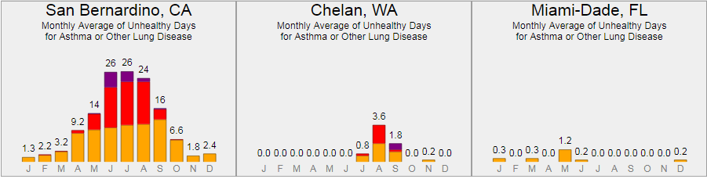
Figure 1 (Source: https://www3.epa.gov/aircompare/index.htm#trends )
In fig 1 these graphs show the monthly average of unhealthy days for people suffering from asthma and lung cancer. Here unhealthy days are represented using different colors. Orange color represents the number of unhealthy for sensitive people. Red color shows a number of unhealthy days for all the people and indigo color shows very unhealthy days. The value above each bar is the index value that is AQI.
It can clearly be seen in fig 1 that California has a number of unhealthy days as compared to the other two states. Especially, in the month of June, July, and august people experience a number of unhealthy days as compared to the rest of the months. While in Chelan, WA august is the only moth where sensitive people face unhealthy days. The main cause of an increased number of unhealthy days in the environment is air pollution. The excessive pollutants like ozone, carbon monoxide are the real culprits (Foell et.al, 1995). The more the people inhale air pollutants the more they are prone to suffer from asthma which may in some cases lead to lung cancer.
Conclusion
It is vital for every human being to breathe air to live and any problem in the air directly affects us. Air pollution is increasing day by day which is a great threat to our natural echo system. Global warming, diseases like cancers, cardiovascular issues, allergies are all due to pollution in the environment. It is, therefore, necessary to plant more trees, avoid using plastics, consume less fuel, etc.

References

Di, Q., Wang, Y., Zanobetti, A., Wang, Y., Koutrakis, P., Choirat, C., ... & Schwartz, J. D. (2017). Air pollution and mortality in the Medicare population. New England Journal of Medicine, 376(26), 2513-2522.
Foell, W., Green, C., Amann, M., Bhattacharya, S., Carmichael, G., Chadwick, M., ... & Kuylenstierna, J. (1995). Energy use, emissions, and air pollution reduction strategies in Asia. Water, Air, and Soil Pollution, 85(4), 2277-2282.
Nichols, Hannah. What are the leading causes of death in the US? Ed. Brighton, UK. Healthline Media UK Ltd. 4 July 2019. 7 July 2019.

