RUNNING HEAD: ACCOUNTING

Sonic health care limited (SHL)
Name of Student
[Name of the Institution]

Contents
Company Introduction 2
Stock Price Information and Analysis 4
Factors Impacting Stock Price 7
Conclusion and Recommendations 8
Bibliography 9

Sonic healthcare limited (SHL)

Company Introduction
Sonic Health care Limited is the parent company of numerous health care practices around the work that combine to form the Sonic Health care group. The company has headquarters in Macquarie Park, Sydney, Australia. Sonic health care is a public limited company listed on the Australian Securities Exchange. Moreover, it is classified as one of the ‘Top 50’ companies in the Australian Securities Exchange (Collyer and White, 2001). Since 1987, Sonic Health care has established itself in eight countries as the third largest laboratory medicine corporation and is the prominent healthcare provider in the country. Sonic has the leadership of a pathologist CEO and a group of directors who have exceptional medical, legal and financial expertise. The company’s success stems from the ideology that our worldwide philosophy of Medical Leadership leads to the supply of exceptional medical facilities. It begins at the Board level and floods through to company’s subsidiaries day-to-day management.
Sonic Health care Limited is an organization based in Australia. The company aims at rendering services in multidisciplinary medical practices and in medical diagnostics. The key services offered by the company include radiology services, laboratory services, and pathology. These services are rendered to medical facilities, medical practitioners, community health services, and their mutual patients. The laboratory services segment of the company includes pathology laboratory services that are available not only in Australia but in the United States, Ireland, the United Kingdom, Switzerland, Germany, New Zealand, and Belgium. The radiology segment offers radiology services merely in Australia. Other segment includes medical centre operations, business office function and other miscellaneous operations. The company staff comprises of more than 36,000 people that include 200 radiologists, 900 above specialist pathologists and thousands of medical scientists and technicians. The primary care and occupational health division join hands with about 2,350 common practitioners at more than 240 centres through Australia. Altogether they deliver quality medical services to over 100 million people yearly.

Stock Price Information and Analysis
Since the company is one of the leading health care diagnostic services providers, and it highly specializes in pathology and radiology services and it was the first company to do so on a worldwide scale. In addition, it employees more than 36000 people and hence the company enjoys a great position in the market and it is declared as one of the principal private operators in Australia, the UK, Germany and Switzerland and second largest in New Zealand and Belgium. Moreover, it is the biggest operator of medical centres and the second major contributor in the Australian diagnostic imaging market. This strong position of the company enables it to leverage current infrastructure to grow its earnings and realise collaborations.
The share price indicates the price of a single saleable share of a company or a financial asset while the share represents a unit of ownership. To speak of share price in the terms of a layman, it is the highest price a person is willing to pay against the share or the lowest amount for which a share can be brought. A share price of a company represents the market worth or value of a company and it is demonstrated in the form of “market cap” or “market capitalization” i.e. stock price multiplied by a number of outstanding shares. The share price is determined by the factors of demand and supply of market and the general rules of law of demand and supply and it is driven to some extent by technical analysis. The market value of company changes as its stock price changes and fluctuates.
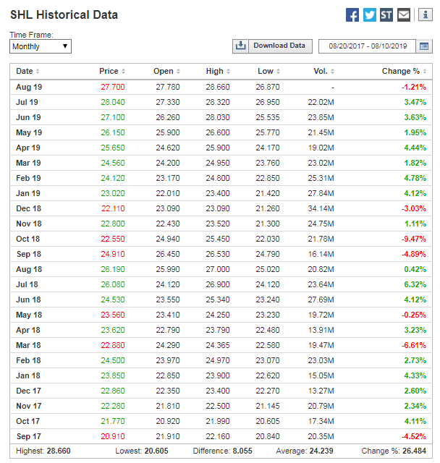
The share price of Sonic Health care Limited of two years shows a very fluctuating trend (“SONIC HEALTHCARE LIMITED (SHL) Share Price & Information - ASX,” n.d.). Though the stock price changes every second as the shareholder's trade shares of a company in the market. However, the analysis of the past two years of the share price of Sonic Health care reveals that the company is somehow stable in terms of its share prices. The share price of the company as of 9 Aug 2019 was 27.70AUD listed on Australia Stock Exchange. ASX Size Rank is 32 / 2,318, the Market Cap is $13.13 billion, and the price to earnings ratio is 25.1 and the dividend yield 2.96%. From the past two years, the highest share price was in July 2019 and that was 28.040, on the other hand, the lowest share price was 20.910 as of September 2017 (“Sonic Healthcare (SHL) Historical Prices,” n.d.). The average volume in the past two years is 24.239 and the percentage change is 26.484. The percentage rise and fall in the prices are also listed in the table below.
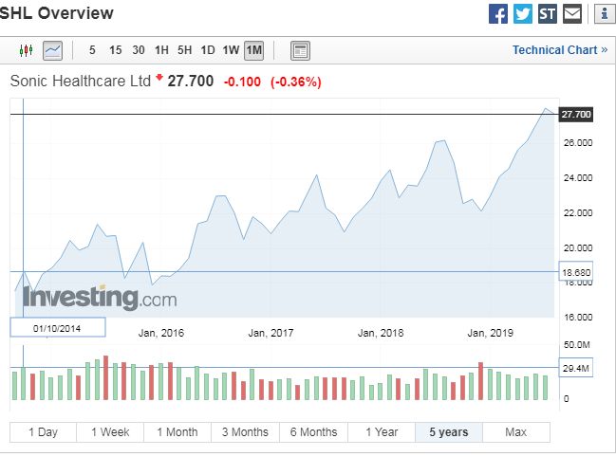
It can be witnessed that there is no major price fall or increase in the stock prices of Sonic Health care. Overall with the few fluctuations and a downward trend at some trends, the trend line of stock market prices of Sonic Health care show an increasing trend. Looking at a broader picture, it can be assessed that the share price of Sonic Health care is up 56% in the last 5 years, clearly defeating the market return of about 11%. In addition, the recently the stakeholders of the company have been getting 13% including the dividends. The last five years can be declared as the years of growth for the company which also indicates that the company has been outperforming and it has attained compound earnings per share (EPS) rise of 4.0% per year. Though the rate of EPS growth is lower than the share price growth i.e. 9.3% per year. It is an indication that the market players hold the company in higher regard.

Factors Impacting Stock Price
There are countless factors that determine and impact the stock price of a company. The price is determined by the factors of demand and supply when the buyers and sellers meet in the stock market, they impact the behaviour of share prices in the stock market. When the demand for shares of Sonic Health care increase, the price increases and when the demand decreases, Sonic Health care shares’ price decreases. There is also an impact of bull vs bear market, price increases when there are more bulls than bears and vice versa (“Trading Basics- Factors that Influence Share Prices,” 2018). Another factor that impacts the price of shares is the dividend announcement, the share’s price decreases when the dividend announced is less than that of investor’s expectations while if they are higher than investor’s expectations, the share price rises.
The company management is also a feature influencing the stock price of a company. Any person in the leadership and management that has a track record of success, impacts positively the share price of the company. The economy of a country, whether favourable or unfavourable controls the price of a company’s stocks. An economy goes through several phases such as peak, depression, recovery and expansion. Share prices are also high in favourable market conditions while low in times of depression. There is a gradual decrease in share prices during the recession and gradual increase during the recovery period.

Conclusion and Recommendations
Stock prices are volatile and even smaller factors and influences have a high impact on the prices of shares of companies. Earnings, the performance of a company, high goodwill, reputation crisis and company’s decisions are other factors that have a high impact on the stock prices. Looking at the performance of Sonic Health care, several factors have contributed to a rise in the share price of the company. According to statistics, the growth in the company’s stock price six months earlier was due to the fact that the company announced its half-year performance results for the financial period winding up, 31 December 2018. According to these results the revenue of the company rose up to 9% to $2.9 billion, Net profit rose 7% to $223 million, Earnings before interest, tax, depreciation and amortization (EBITDA) rose 7% to $471 million, and the Interim dividend rose 3% to 33 cents per share. The company showed an exceptionally well performance in terms of revenues and profits especially from its business in the US. The company’s acquisition of Aurora in the US is reported to be one of the most optimistic factors for the success of the company (Jones, 2007).
Companies like Sonic Health care gives investors opinion and gives an optimistic picture to the investor’s persuading them to buy the shares. Eventually, the stock prices rise due to increase in demand. The current performance of the company also creates the AU$621m by 2022, this will lead to the earning per share A$1.33 in its next year projections. This will persuade the buyers to purchase the shares of the company. It is an appealing industry to invest and the decision to invest must be based on the expert investment analysis. The company faces tough competition from two of its biggest competitors CSL Ltd and Nanosonics Ltd in the stock market as well. If the companies continue to pursue other avenues of natural and acquisition growth, it can enjoy stable growth in terms of its stock price.

Bibliography
Collyer, F., White, K., 2001. Corporate control of healthcare in Australia. Australia Institute.
Jones, J., 2007. Integration and diversification in healthcare: Financial performance and implications for Medicare. Health Sociol. Rev. 16, 27–42.
SONIC HEALTHCARE LIMITED (SHL) Share Price & Information - ASX [WWW Document], n.d. URL https://www.asx.com.au/asx/share-price-research/company/SHL (accessed 8.10.19).
Sonic Healthcare (SHL) Historical Prices [WWW Document], n.d. . Investing.com. URL https://www.investing.com/equities/sonic-healthcare-limited-historical-data (accessed 8.10.19).
Trading Basics- Factors that Influence Share Prices [WWW Document], 2018. . Wall Str. URL https://wall-street.com/trading-basics-factors-influence-share-prices/ (accessed 8.10.19).

