[Name of the Writer]
[Name of Instructor]
[Subject]
[Date]

The Rhetoric of an image (Under the observations of Roland Barthes)

Introduction
Advertising one’s own products has become a widespread practice nowadays. We see advertisement everywhere, on television, on the internet, in magazines, in the form of billboards, and where not. The advertisement industry has grown so vast that almost every organization or firm makes use of it. There was a time when only some companies or organizations used to take help of advertising to market their products, but now, every other company has to take the support of publicity to create awareness about their products and get their sales figures to go up.
In previous days, most of the times, the business was handled by a single owner or a very limited number of people. At that time, the owners relied on their own strengths and used to advertise the products using their own ideas. As the businesses had not grown much and the companies did not earn much revenue, the owners considered it a luxury or waste of money to invest in marketing. Even if some businessperson thought of indulging in marketing activities, he or she would do it himself or herself. The least they would do is to get it done by some family member or any employee of the company, for minimal charges. Those were the times when people had not realized the true worth of marketing and advertisement. People especially businesspeople were unaware of the perks of advertisement and how high the tactics of marketing can take a business.
With the advancement in technologies and the business world, the business people also revolutionized, they started adopting new and smart techniques in every aspect to business to reduce their costs and increase their profits; which is the ultimate goal of every businessperson. With the revolution in every field of the industry, including production, human resource management, logistics and sales, many advancements also came in the department of marketing. The owners and managers of the business firms started realizing the worth of marketing activities and advertisement for their business and also started feeling the need for marketing their products. The organizations began hiring employees explicitly dedicated to marketing purposes and began utilizing their services for advertisement activities. With the growth in the business, the companies started developing a separate department for marketing, where a team of intelligent workers was hired to design various marketing strategies and advertisement plans for the specific products (If the product line was vast) according to the demographics of the market.
Advertisement can be done through any means; a marketer may use a video, an image, a text or even a gesture to show the value of his or her product. We see many advertisements on a daily basis on the internet, on television, during TV shows, while going to work in the way, on a bus, on billboards, in newsletters, on magazines, or even in the form of the actual product in front of us. Everything is advertisement. Many subliminal techniques are used by the advertisers to catch the attention of the consumers. Advertisers try various unique methods to attract consumers and influence them to buy their products. Most of the times, advertisement carry a comic twist or the appearance of celebrities to highlight the importance or use of the product being advertised.
Image advertising is an advantageous and popular method of advertisement. Images project a picture on the minds of the viewers regarding the product. It is an abridged and concise form of advertising but carries a complete message in it. The message may be regarding the characteristics or properties of the product or its use. It can also be about the usefulness of the product for the consumers. Most of the producers use more than one techniques for the advertisement of their products, i.e., they use image advertisement as well as video form for advertising products, and try to be creative as much as they can. The following piece of writing analyzes an image meant for advertisement purposes.
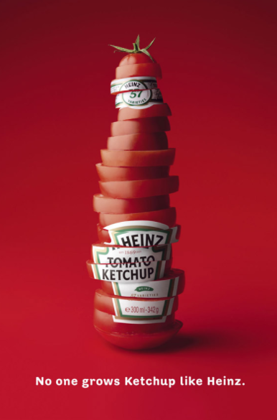

The image mentioned above has been selected for analysis under the observations presented by Roland Barthes in his essay “The Rhetoric of the Image.” (Barthes)

Discussion
The image under analysis has been designed for a ketchup product under the name of "Heinz Tomato Ketchup." Heinz is famous for its quality products in the industry of food products, especially its ketchup products are famous all over the world, for their taste and quality. This image is primarily intended to highlight the best quality of the tomato ketchup produced under the banner of Heinz. The advertisers have put all the emphasis on highlighting the quality aspect of the product instead of providing any information for the usage or the usefulness of this product in daily life.

The Three Messages
The image under analysis, the Heinz Tomato Ketchup image, shows a bottle of tomato ketchup, made of tomato pieces cut in circular form, staked upright in a straight manner, in the shape of a ketchup bottle. This bottle has been portrayed to stand upright in front of a bright red background. The bottle carries the sign and label of a regular Heinz tomato ketchup bottle.
Under this picture of a ketchup bottle, there is a message written in the English language “No one grows Ketchup like Heinz." These words have been written in white so that they can be read easily. If any color had been used, the message would not have been legible, and it would have affected the quality of the advertisement.
All these components and the writing project a potent message on the minds of the viewers, The images set a ground for the quality of the product and creates a positive impact over the brains of the consumer. The image carries all the linguistic message, the denoted message and the rhetoric of the message as well.

The Linguistic Message
The image or the advertisement carries the tag line or the message under it which states “No one grows Ketchup like Heinz." It is a very powerful message as the whole phrase highlights not only the quality of the product but also magnifies the glory of the company. The advertisers have put a focus on two faces of the product, which first of all means that the quality of the ketchup produced by Heinz is unmatchable; the ketchup produced under the banner is unquestionably tasty and delicious.
The other aspect of this linguistic advertisement emphasizes that no other company can compete Heinz in its product’s quality. No other ketchup producer in this world can make ketchup better than Heinz.

The Denoted Message
The other component of the message is an image of a bottle of ketchup, labeled with Heinz regular logo and Label. This is also a very inspiring and impacting image as the container is not shown to be an original glass bottle filled with red tomato sauce. Instead, the bottle was composed of slices of tomatoes, forming a big, juicy tomato. The only difference is this tomato is cylindrical, but the edges are shown round, just as a regular tomato. By the usage of this brilliant technique, the advertisers want to imply that there is no difference between Heinz Tomato Ketchup and a real tomato. The image strongly passes on and focusses on a single message, and that is that Heinz Tomato Ketchup is originally made up of real tomatoes; there is no artificial flavor used.

Rhetoric of the Image
The rhetoric of this image is to imply the fact that Heinz uses only quality raw material in the production of its tomato ketchup that is only ripe and juicy tomatoes. So the consumers can blindly trust the product and use it with complete faith.
The linguistic message used under the meaningful image also conveys the same word in a single phrase along with the other message the no other producer in the food industry can compete for the quality of the tomato ketchup produced by Heinz, as it only uses real tomatoes in the production of its tomato ketchup.

Conclusion
In short, the image used by Heinz for the advertisement of its tomato ketchup is compelling and influencing, it creates a positive image regarding Heinz and its products (in general) in the sight of the viewer and inspires them to buy the product. Moreover, it carries all the elements of an advertisement prescribed by Roland Barthes in “The Rhetoric of the Image.”

Works Cited

Barthes, Roland. The rhetoric of the Image. na, 1993.
Available at: https://faculty.georgetown.edu/irvinem/theory/Barthes-Rhetoric-of-the-image-ex.pdf [Accessed 14 Mar. 2019].

