The Respiratory System and Lungs
[Name of the Writer]
[Name of the Institution]

The Respiratory System and Lungs
The human respiratory system consists of a series of organs which are responsible for taking in oxygen and also exhaling carbon dioxide. Among all the organs of the respiratory system, the primary and major organs of the respiratory system are the lungs which are mainly responsible for this exchange of gas when an individual breathes. The red blood cells are the cells that collect the oxygen from the lungs and then transport it to all that part of the body where it is required. During this process, the red blood cells also collect carbon dioxide from other various body parts and transport it back to the lungs where it is released from the body when the individual exhales. The lungs as mentioned earlier are the main part of the respiratory system that are located in the chest behind the rib cage on either side of the heart (“22.2 The Lungs – Anatomy and Physiology,” n.d.).
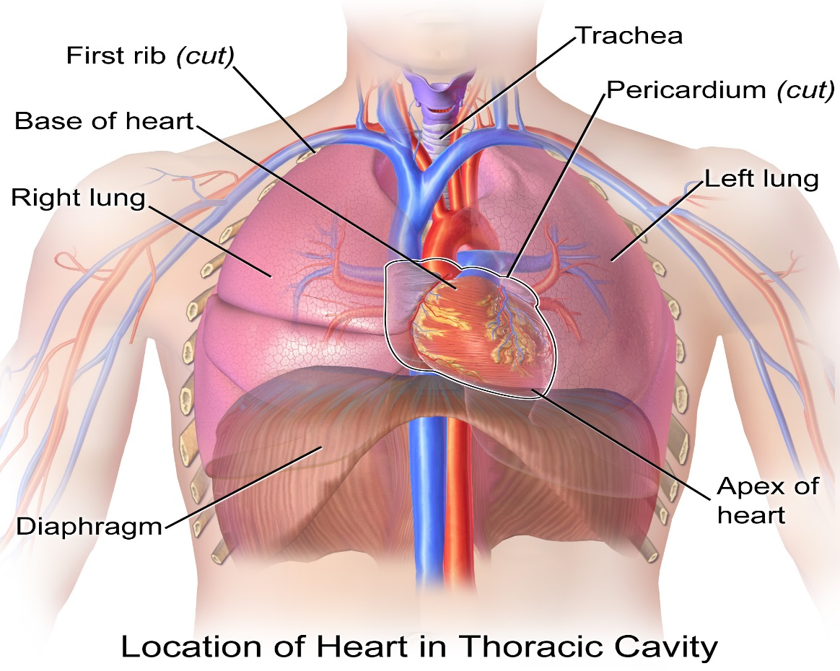
The anatomy of the lungs is different from other body parts. Lungs are basically pyramid shaped and they have paired organs which are mainly attached with the trachea with the help of right and left bronchi, the lungs are then bordered by the diaphragm. The lungs are presently closed by pleurae which are further connected with the mediastinum. These are spongy and pinkish in color and they look like two upside-down cones in the chest of an individual. The lung which is present on the right side is shorter and also wider than the one at the left side, and the left side lung occupies smaller volume than the one at the right side (“22.2 The Lungs – Anatomy and Physiology,” n.d.).
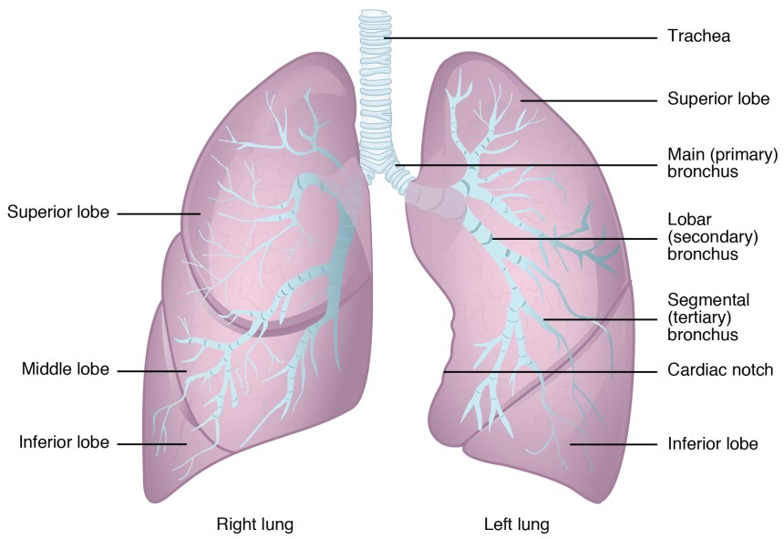
The lungs are composed of different types of specialized cells and tissues. On the lining of the lungs, epithelial cells are present with particular hairs also called cilia. Below these specialized cells, a basement membrane is present which basically a variety of many epithelial cells and under this membrane, a looser tissue is present which is basically full of mucous glands and other specialized cells like eosinophils, lymphocytes, mast cells and other white blood cells that are also called polys. Apart from these there are certain other functional respiratory units are also present which are known as alveoli, these are connected with the trachea with the help of bronchioles. There is also a thin layer of cells that are present between the alveoli that are known as interstitial which has all the blood vessels. Further, the lungs are covered with a thin layer of tissues that are known as pleura, this type of tissue layer is also present inside the chest cavity this provides smoothness to the lungs when breathing (“What are the lungs made of? | Functions of the Lungs - Sharecare,” n.d.).
The most important function of the lungs is to help in the process of the gas exchange called respiration. During the process of respiration Oxygen from the inhaled air enters and mixes with blood and carbon dioxide is exhaled from the body. Lungs help in the process of breathing by inhaling oxygen and exhaling carbon dioxide ("Lung function: What do the lungs do?" n.d.).
The gas exchange that happens because of the lungs is one of the most important ways through which the respiratory system helps in maintaining homeostatic. A gas exchange that takes place in the alveoli of the lungs is one of the most important processes of the body. When the blood passes through the small capillaries in the sacs of alveoli, which changes the pressure gradient that further helps to exchanges oxygen in and out of the blood. Homeostasis is about the right balance and also maintaining the right equilibrium which plays an essential role in the survival of the body. Therefore, lungs and the overall respiratory system helps in this maintenance by exchanging gases between the body and the outer environment (“How Does the Respiratory System Maintain Homeostasis | Biology Dictionary,” n.d.).
Hypoxia is a condition of the body that occurs if the lungs are unable to maintain a homeostatic balance in the body. The blood gas homeostasis is an important part which helps in the maintenance of tissue oxygenation and also in the prevention of acidosis from CO2 accumulation. If the lungs stop playing their role in maintaining homeostasis that is if they stop exchanging gases then carbon dioxide will start accumulating in the body and the temperature in the body will start fluctuating which will further create an additional health problem called hypothermia (“Hypoxia as a failure of respiratory homeostasis. - PubMed - NCBI,” n.d.).
Asthma is one of the most common disorders of the lungs in which the airways of the lungs get inflamed and it may cause occasion spasm. The structural changes in the lungs that occur because of Asthma are numerous and epithelial fragility is one of the most common structural change that occurs in the lungs. Apart from this, the sub-muscular mucus gland gets enlarged, in the walls of the airway, growing airway smooth muscle mass and also thickening of the overall walls of the lungs along with abnormalities of the elastin are some of the prominent structural changes of the lungs (KNIGHT, 2005). Asthma is a common breathing problem in which the airways of the individual get smaller with each passing day. Due to these small airways it becomes difficult for the lungs to exchange gases by inhaling and exhaling so one of the main functional change that happens because of asthma is the change in the intake or exchange of gases (“Asthma | National Heart, Lung, and Blood Institute (NHLBI),” n.d.).
The circulatory and the respiratory systems are closely related to each other. The circulatory system is basically responsible to carry blood to all parts of the body, this helps in the transferring of oxygen, chemical energy and also nutrients to nearly all parts of the body while carrying away carbon dioxide from these organs to the lungs. The respiratory system is a system that is composed of living cells which are required to be supplied by the circulatory system. It is safe to say here that the respiratory system is basically the interface where the circulatory system is able to receive oxygen and eliminates carbon dioxide from the body. The most important interface occurs in the lung tissues where the membranes that are covered with capillaries get involved in the gaseous exchange. Therefore, the respiratory system would never be able to perform its functions it is not nourished by the circulatory system, which means that there is a very close relationship between respiratory and circulatory system (“11.3 Circulatory and Respiratory Systems – Concepts of Biology-1st Canadian Edition,” n.d.).

References
11.3 Circulatory and Respiratory Systems – Concepts of Biology-1st Canadian Edition. (n.d.). Retrieved April 17, 2019, from https://opentextbc.ca/biology/chapter/11-3-circulatory-and-respiratory-systems/
22.2 The Lungs – Anatomy and Physiology. (n.d.). Retrieved April 17, 2019, from https://opentextbc.ca/anatomyandphysiology/chapter/22-2-the-lungs/
Asthma | National Heart, Lung, and Blood Institute (NHLBI). (n.d.). Retrieved April 17, 2019, from https://www.nhlbi.nih.gov/health-topics/asthma
How Does the Respiratory System Maintain Homeostasis | Biology Dictionary? (n.d.). Retrieved April 17, 2019, from https://biologydictionary.net/how-does-the-respiratory-system-maintain-homeostasis/
Hypoxia as a failure of respiratory homeostasis. - PubMed - NCBI. (n.d.). Retrieved April 17, 2019, from https://www.ncbi.nlm.nih.gov/pubmed/9052047
KNIGHT, D. A. (2005). Structural changes in the airways in asthma: observations and consequences. Clinical Science, 108(6), 463–477.
Lung function: What do the lungs do? (n.d.). Retrieved April 17, 2019, from https://www.medicalnewstoday.com/articles/305190.php
What are the lungs made of? | Functions of the Lungs - Sharecare. (n.d.). Retrieved April 17, 2019, from https://www.sharecare.com/health/functions-of-the-lungs/what-are-lungs-made-of

