Your Name
Instructor Name
Course Number
Date
The Significance of Flappers in American History
Introduction
American history is comprised of different significant aspects that played an important role in the overall development of the nation in various forms. It is vital to critically examine different historical approaches to better apprehend the entire journey of the country’s development over the years. Undoubtedly, it is interesting to examine how various historical ideas and practices influenced the lives of people and shaped the overall culture of American society (Rubio et al.). The concept of flappers is recognized as one of the prominent facets of American history that greatly influenced different aspects of American society. This paper focuses on critically analyzing the significance of flappers during the historical period of the 1860s to 1960s through the inclusion of relevant artifact.
Discussion
The generation of Flappers comprised on young Western women during the era of the 1920s. Flapper women attained noticeable position in the American society of that time because they wore skirts, bobbed their hair, and listened to jazz music. The trends of Flappers greatly impacted the overall domain of the period of the 1920s. The generation of flappers was claimed as different because they did what was not expected from the society for the women. It is noteworthy to mention that the generation of flappers was the one who forcefully introduced new cultural spectrums in American society by rejecting the mainstream roles of women.
The women of flapper culture were recognized as different because they openly danced to jazz, smoked, wore makeup, and their philosophy was to live in the moment. They rejected various traditional domains and restrictions by accepting a new philosophy of freedom for women. Their entire lifestyle made them different and noticeable in society. The trends of flappers defined as the sociological image of society during the phase of the 1920s. Flapper fashion was established as the lifestyle for the society to develop the new image and position of women in American culture. The entire prospect of womanhood was greatly redefined by the generational movement that appeared as flapper women.
The age of flappers also named as the Roaring Twenties. It was the time of great transition for American women who expressed themselves openly. The women as representatives of Flapper generation were different because they were interested in strongly sharing their opinion and thoughts with the world. This specific approach was entirely different from the traditional positioning of women in society. The change in fashion eventually helped flapper women to bring change in many other and important aspects of life. It is established that they ensured their social, political, and economic position in society by presenting their active movement. The era of the 1920s was the decade of immense change for American women and the development of flapper generation was the first step of this development (Lusted). The period of the 1920s was the time of great development for women as they won the legitimate right to vote.
The changing conditions for women during the 1920s explicitly indicates the approach of flapper generation that reconsidered the role of women as an important entity in American society. The great influence of flappers can be observed in case of many different areas that ultimately impacted the overall functioning of the society in the 1920s. Change in fashion is one significant example of strong influence of flapper generation. The fashion of American women was greatly influenced by the modern thinking approach of flapper ladies. The fashion industry of the country greatly evolved due to new trends introduced by flapper generation. It is vital to identify how flapper women represented the entire domain of a specific era of the 1920s as it turned as a different social positioning for American women. Flappers were accepted as the new style of women in the society who were willing to take charge of different unconventional prospects.
Above-the-knee length skirts were the new trend that got immense popularity in a large range of American women. The differences can also be observed in the form of bob haircut by their choice. When it comes to wearing make-up than the flapper generation made it more acceptable to consider women with make-up. The social taboo of wearing make-up as the bad repute was greatly rejected by the women of flapper generation (Park). The urge to attaining social status with men was the foundation to achieve the new spectrums of freedom for American women through the practical approach of flapper generation. To achieve equal social position, women of that time were keen to adopt different manly habits. This approach can be clearly observed through the increasing trend of smoking, drinking, and cussing in the case of flapper women. The idea of great liberation was embraced to redefined the status of women in society and rejects the approach of any type of social constraint.
The prominent effect of flapper ideology can also be witnessed in the case of the social prospect of women from a traditional perspective. The flapper women were more interested in entering colleges or considered the option of jobs instead of getting married at a young age. This the result of changing the ideological perspective of women in a great manner. Women as the representative of flapper women were more independent and free as compared to conventional women who lived in a society. Breaking the tradition was the prominent feature associated with the practical domain of flapper generation. Flapper women were keen to raise their voices and recognized their position in society. Women accepted flapper ideology were more interested in lived and enjoyed the moment instead of involving serious social and domestic roles as women.
The particular media portrayal also played a critical role in developed the idea of flapper generation during the phase of the 1920s. There were examples of many women who established their role on screen as the flapper and encouraged the main philosophy of this growing trend. Women were presented as influential models to successfully conveyed the overall ideology of the approach of flapper as the new generation. There were many significant names who successfully represented their position as flappers on TV screens and films. Clara Bow as American artist was one prominent example of the active role of the media industry in the enhanced popularity of flapper generation in society. She successfully represented the era of transition through his domain of fashion and acting skills. Her appearance on screen represented the modern form of fashion and thoughts under the domain of flapper generation.
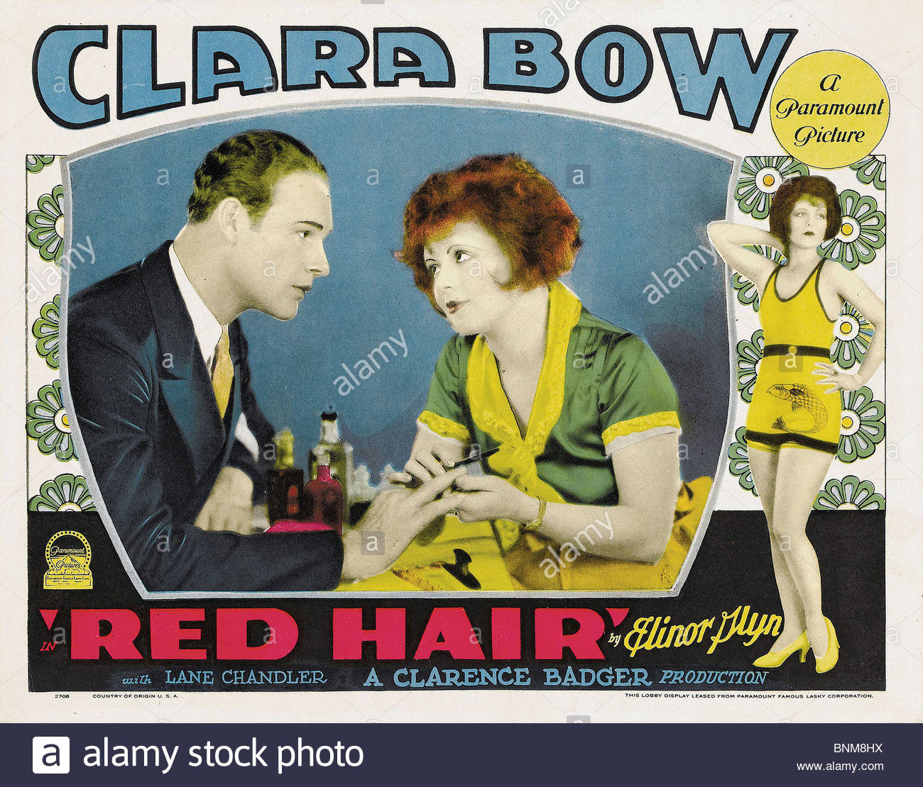
The poster of Clara Bow is used as the artifact to better explained the changing approach of society during the phase of Flappers generation. Her appearance on the poster clearly indicated the redefined fashion approach in American society. Different standards of flapper generation were greatly represented by Clara Bow considering the most flexible fashion prospect.
Conclusion
To conclude the discussion about the significance of flapper generation, it is significant to mention that the idea of flappers greatly represented through different aspects of women’s life. It is also crucial to indicate that the major implications of flapper generation have appeared as different forms of rights for American women. The right to vote was one of the greatest developments that appeared due to bold practical steps adopted by women of that age.

Works Cited:
Lusted, Marcia Amidon. The Roaring Twenties: Discover the Era of Prohibition, Flappers, and Jazz. Nomad Press, 2014.
Park, Soo Hyun. Flapper Fashion in the Context of Cultural Changes of America in the 1920s. 2014.
Rubio, Juan, et al. The Role of Women in the Roaring Twenties. 2012.

