Cyber fitness
[Name of the Writer]
[Name of the Institution]

Cyber fitness

Company Overview
For an organization to have an idea about the sort of security risks that are faced by them, it is imperative that they make sure that they understand how the operations of the organizations are supposed to work. The better the understanding about the operational processes and flow, the better is the likelihood that all the underlying stakeholders in the organization are going to be well placed as far as the organizational decision making is talked about. Not only that, it would also go a long way towards making sure that the business has the sense of insight about some of the risks that are faced by them and how they are going to be mitigating those risks. Now, in the pre assessment, the idea is going to be developed about the processes that are carried out in the organization and based on that premises, it can be made sure that all the prospective stakeholders are in loop about how the functionality of the organization is supposed to work out. Now, some idea about the importance of the company overview is developed. Following are some of the things that are going to be integrated in the company profile so that there is some sense and insight about how the business processes are supposed to work.
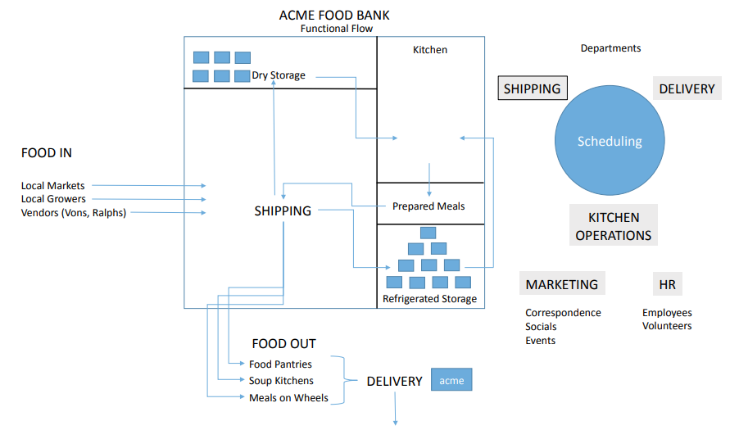

Food Bank
Food Bank is an organization that intends to make sure that fresh food solutions are being provided to the users and procurement of the freshly baked and cooked items is needed to be made. One of the key values and the prospect of the business is to make sure that the local market and retailers should be integrated in the business work flow. The idea behind working with the retailers that are working at the local level is to make sure that the appropriate value addition and value chain activities are going to be carried out that are going to eventually help the business to ensure that they take care of the things in the appropriate manner. The kitchen operations of the business are organized in the manner that the meals are prepared and then when these meals are prepared, effort is needed to be carried out to make sure that the appropriate packing and shipping solution has to be created that is going to ensure that the maximum value is being provided to the customer at the given point of time. The other thing that is very important with regards to the way this whole thing is going to be managed is that how the storage mechanism of the business works as the business has an underlying philosophy that the better the storing solution, the greater is the likelihood that fresh food is going to be served.

Information Flow in and Out
One of the key things that is needed to be done during the course of the operation and the order management is that how the information inflow and outflow is being done. The reasons that this area is one of the most important is due to the fact that this is the area where the business is most susceptible to the cyber threats and there is a need by the business stakeholders to make sure that they completely encrypt and secure this business process. In order to do that, all the information inflow and outflow routes are needed to be known to make sure that the appropriate encryption and cyber security arrangements are carried out as far as the way business IT protocol is needed to be setup. Now what happens with regards to this business is that the data integration is being done with the help of the public subscription model. The idea behind this model is to make sure that all the stakeholders that are involved in the business decision making are made the part of the business process. The other thing that is being done is that how the data producer is going to make sure that they are going to publish the notification whenever there is going to be any change in the data management protocol. For instance, one of the most frequent data exchange that happens in the business is when the sales system is publishing the data for the new customer and based on that information, effort is being made to ensure that the proper billing system for the customer is introduced along with the introduction of the relevant databases. As far as the push for the data is concerned, the data integration module works in the manner that the data is pushed from one system to the another in the manner that how the sales system is pushing the new customers, and how their accounts are going to be opened in the billing system. This is one of the most important information inflows as far as the business goes. When it comes to how the business is pulling the data, then most of the times they are pulling the data in the manner that the billing system is being placed that has the information interface that stores the data. There is API on offer as well that allows the customer to make sure that they have the required accesses so that all the relevant customer needs are being taken care off in an appropriate manner at the given point of time. There is orchestration of the whole information system where encryption is being made. Now some understanding about the information inflow and outflow is being made, the next section is going to look at how the IT domain for the given business is supposed to be working out. Information that flows via human communication such as a business email. This is typically dynamic but can also be modeled in terms of processes and procedures that people follow.
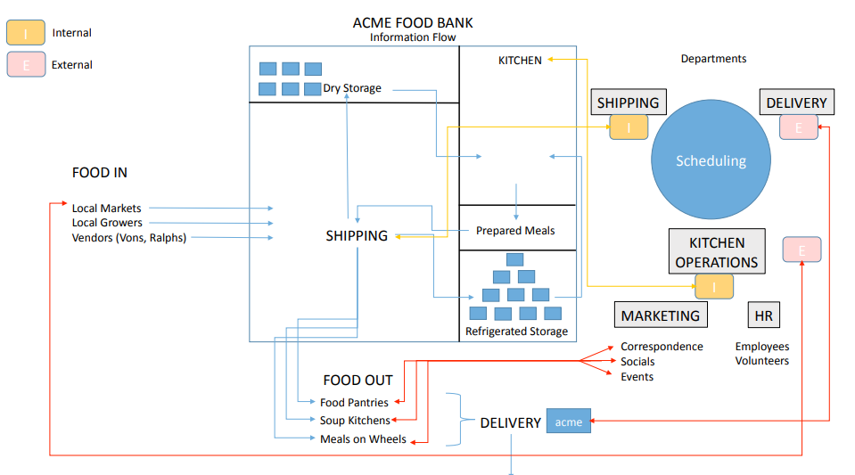

IT Domain for the Business
The effort is going to be made to make sure that the appropriate domain name for the business is needed to be selected. The idea behind the whole thing is to make sure that the auto repair aspects of the system are needed to be kept in mind. When that system is working in an efficient manner, then effort has to be made with regards to how SEO efforts at the part of the business are going to be carried out. It has to be noted that for the business that is working at such a level, it is imperative that they make some sort of effort with regards to the way Domain management should be such that has to be relevant for the business. The effort that is being made at the part of the organization is to make sure that the relevant effort is carried out with regards to how it is going to be made sure that the domain name should be such that should reflect the personality of the brand and how it intends to serve its target customer. The better the business is when it comes to making sure that they are serving their target business, the better is the likelihood when it comes to ensuring that the memorable domain name is going to be setup. What can be seen from this strategy is that the security is not much of an element when it comes to naming the IT domain name and its apparent functionality. Effort has to be made to make sure that when the IT domain policy is being made, the security protocols that exist for the given domain are needed to be kept in mind. Some of the important elements that are needed to be kept in mind when such protocols are developed is that what are the e-mailing and communication interfaces that are being used on the domain. How the information is going to be uploaded on the domain as well as making sure that some of the other elements and mediums through which the transfer of the files is needed to be carried out is out kept in mind with regards to how the information exchange is needed to be carried out. Not only that, there has to be an attempt to make sure that how the underlying security protocols for the information storage are going to be specified. So, there are many considerations that must be looked after.

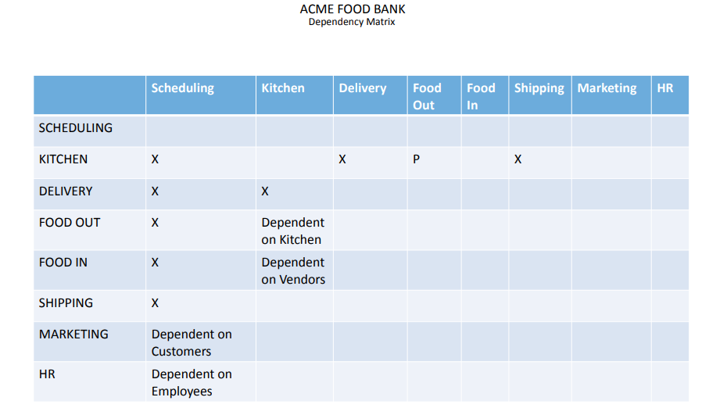

Risk Factors
Even though they are not facing that much of a huge risk in terms of the information security, the fact remains that there is a need among all the stakeholders to make sure that they follow the information security protocols in the manner that is going to allow all the broader stakeholders to ensure that they have the clarity of purpose in terms of the risks that are faced by them. Now, most of the times, one of the biggest IT risks that is faced by the businesses that are operating at such level is that how the capability of the information management system is on the lower side. There is a direct relation between the strength of the IT service protocol and how it is being managed in terms of the small businesses at the given point of time. There has to be realization among all the business partners that there is going to be the cost for the poor security protocols for the business. One of the biggest risks that is faced by them is that they don’t have enough capability as far as the software and hardware capability is needed to be kept in mind. Not only that, they are not using the permanent storage surface for their information and what it means is that the customer profile, customer order record and all other things that could have aided the business decision making are not anymore in the record of the customers. Not only that, there is also the problem of how there is lack of IT continuity in terms of the way business is operating at the given point of time and due to that, there is always this likelihood that all the information that has been received with regards to the customer is lost and thus there is loss for the valuable information at the given point of time. The problem with using the non-encrypted connection is that there are lot of risks to which the user is exposed at the given point of time. There are viruses as well as the phishing that can lead the non-susceptible users to be lured into something that they might give away the information that might be used against them. So there is a need for all the businesses to ensure that they understand the extent to which the IT failures can hamper the long term prospects of that business and based on that premises, effort must be made to make sure that the proper consensus of all the stakeholders is needed to be kept in mind specially when long term decision making is needed to be made at the part of the organization.

Risk Mitigation
The risk mitigation plan is considered to be one of the most important documents for the businesses these days and in this day and age, the organizations are well advised if they are planning in a manner that would eventually make sure that all the underlying risks that are faced by the organization are being managed in the appropriate manner. There are some basic aspects that the organization can incorporate into its working schedule when it comes to the way risk management is being done. By developing the risk for an entity, the business continuity can be made possible for the longer period of time. Information that is published to an event handler. The handler decides where the event information needs to flow. This is associated with a technology known as complex event processing that can look for patterns in streaming events to find things that require action. For example, if someone pulls a fire alarm the handler might wait for smoke detector confirmation before triggering a sprinkler system.

Appendix

Appendix 1

