Your Name
Instructor Name
Course Number
Date

Title: Cultural Brief
In the final meeting od last month my boss decided to visit China to get to know the people working in a similar company like mine so that the two companies could business together. I am interested in this business trip because China is my home country and it is a hub of international business. But its national identity and its national psychology are influenced more by its cultural values. So before moving into this country its broader culture should be understood. Chines people are known for their traditional values (Lin).
Those traditional cultural values include harmony, courtesy, and benevolence, wisdom, loyalty, righteousness, honesty, and piety. Of all these attributes of the local people homey is the core one. Chinese people use harmony to keep a balance between things and they encompass propriety, rationale, and compatibility. They bring things together to let them develop from a state of incoordination to coordination. Thing develop from imbalance to balance and from asymmetry to proper symmetry (Lin).
The modern society of China has brought some changes to its core value of harmony by using it to balance between nature and mankind. They are also working to keep a balance between body and mind and between different communities living there. Many of the businessmen from all part of the world come to China due to their honesty and harmony. (Cheung,)
The other attribute that is more important to the people of China is “Wisdom” they say that they have a very big heart to love someone but they prefer to understand the foreigner first. Honesty is also an important part of Chinese Culture and this moral virtue is highly valued by all the people who visit this place. My motherland is also famous for her loyalty. People are loyal to the country and they are highly patriotic. Family values, respect of elders and celebrating festivals are the other important values of Chinese culture (T.-Yi. Lin)
Chinese are fond of eating mixed food. They mix flavor, spice, taste, and color. They usually eat rice, noodles, and tofu. They also love to eat various types of meat mostly liked ones are duck and pork. Their nonverbal communication is more strong than they verbal one and if someone is talking than interrupting them is considered as a symbol of disagreement. They usually do not like to have eye contact while talking. They also love to keep personal space (T.-Yi. Lin).
My boss will enjoy business with Chinese people due to cultural values like honesty, wisdom, harmony, and loyalty. She needs to be care full while doing verbal communication with them, she also needs to take her food with her because she is going to have rice and noodles for most of the time in China.
Business etiquette in China
As a result of globalization, the number of people coming to chines for business is also increasing. Chines people usually prefer to speak in their national language but if the foreigner used a couple of Chines words while speaking they become really impressed. Chinese employees are trying to use English in their workplace so that they could be able to interact with international partners (Stefan H.)
In the past, the dress code used in the workplace was traditional Mao suit but now the male workers were suit and tie. For women dress suits and smart looking paint suits are acceptable. The bright color is not considered good. Miniskirts are not appropriate for the workplace in China and shoe should not be with open toes (Stefan H.).
However, a handshake is the popular greeting style in workplaces and they welcome topics are a theme about art, climate, landmark, and geography. The people are very careful while talking about the negative statement about anything in the workplace and business cards are commonly exchanged in the workplace. If any foreigner is sitting in a meeting with the Chinese and he or she must be leaving before Chinese coworkers or business partners (Beckers et al.).
Map of China
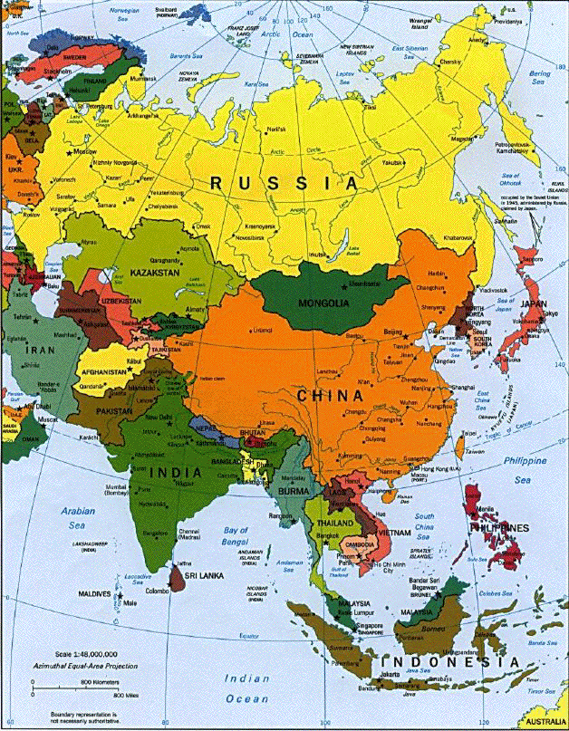
The territory of China lies between 62 longitudes from west to east ad 49 latitudes from north to south. (China Location Map, China’s Location in the World).
The western part of China is not economically developing. Its eastern part is having all the businesses and it controls the overall economy of the country. But the Western part is now under development and various economic growth plans are under discussion for it. (Five Year Plan for West China - Petrex GmbH).

Travel Appendix
The time difference between China and Washington State:
China is ahead of Washington, the USA by 15 hours and although China is as huge as the United States it has a one-time zone that is the Beijing time. If it is 5:00 PM in Washington then it will be 8:00 AM in China (Travelmath.com. N. p.)
The schools, train station, and airports in China operate in odd hours. Some people will be eating dinner at midnight and some cities look very different at 7: am with the sun rising and some will be having start at that time. So working hours in China depends on the part of the country you live (Travelmath.com. N. p.).
Visa requirements:
For a Chia Visa requirements for the passport holders of The United States of America includes filling out a visa application form and paying for the visa fee. The passport should have a validity of 6 months at the time of landing in China and it has an accurate headshot photo. Travel itinerary should also be presented. There are various types of Visa for China and the requirements also depend on the type of Visa you are applying for (China-embassy.org. N. p).
The current rate of exchange of Chines Yuan with the US dollar.
Currently, one US dollars Is equal to 6.89 Chinese Yuan (Xe.com. N. p)
Tourist sites in China:
There are numerous tourist sites that she will love to visit. The top one of them in, The Great Wall of China. It is expanded up to 6000 kilometers and is having Shanhaiguan fortresses in its east and it passes through Beijing and Tientsin. The second number is the Forbidden City and the Imperial Palace, Beijing. It is the largest city in China and is a must-see place in China. The building is at the center of Beijing and it is built in 1406 and the Ming and Qing Emperors used to live there. The third most popular place in China is the “Terracotta Army”. It was found while digging for a well by the farmers in Xi’an IN THE YEAR 1970s. The statues of these soldiers are in the Emperor Qin Shi Huang's Mausoleum and it is the top tourist destination in China Planetware.com. N. p).
The Summer Palace is also a good visiting area and is near to Beijing. Li River is China attracts millions of tourists every year and it is also a must see a place in the country (Planetware.com. N. p).
The local disease that visitors might encounter:
She might encounter waterborne and food diseases like Typhoid fever or Malaria. Dengue Fever, Plague and water contact diseases are most infectious in China (Indexmundi.com. N. p.).She should be careful while walking through grass or swimming in water because she can get caught by a mosquito and could also get a skin infection from the water.

Works Cited:
Beckers, et al. An Analysis of Intercultural Business Communication. 2014.
Cheung, Fanny M. Psychological Symptoms among Chinese in Urban Hong Kong. 1982.
China Location Map, China’s Location in the World. http://www.chinatouristmaps.com/china-maps/china-in-world.html. Accessed 25 June 2019.
Five Year Plan for West China - Petrex GmbH. https://www.petrexgmbh.com/five-year-plan-for-west-china/. Accessed 25 June 2019.
Lin, Tsung-Yi. Psychiatry and Chinese Culture. 1983.
Lin, Tsung-Yi. The Squibb Academic Address: Culture and Psychiatry: A Chinese Perspective. 1982, pp. 235-245.
Rise at 11? China’s Single Time Zone Means Keeping Odd Hours - The New York Times. https://www.nytimes.com/2016/06/17/world/asia/china-single-time-zone.html. Accessed 25 June 2019.
Stefan H., Verstappen. Chinese Business Etiquette: The Practical Pocket Guide. 2015.
"Time Difference Between Washington And China." Travelmath.com. N. p., 2019. Web. 26 June 2019.
"How To Apply — Embassy Of The People's Republic Of China In The United States Of America." China-embassy.org. N. p., 2019. Web. 26 June 2019.
"XE: Convert USD/CNY. United States Dollar To China Yuan Renminbi." Xe.com. N. p., 2019. Web. 26 June 2019.
"15 Top-Rated Tourist Attractions In China | Planetware." Planetware.com. N. p., 2019. Web. 26 June 2019.
"China Major Infectious Diseases - Demographics." Indexmundi.com. N. p., 2019. Web. 26 June 2019.

