Gender roles and norms in Wartime

Gender roles and norms in Wartime

Introduction
World War I was a catastrophe for human civilization. For the first time in the history of human civilization, the WWI practically manifested the concept of total war. The war expanded after the use of modern warfighting technology. Each side was attacking its adversary irrespective of the gender targeting norms practiced in peace situation. It was for these reasons that regular norms attached to genders could not remained consistent throughout and in the post- war times.

Discussion
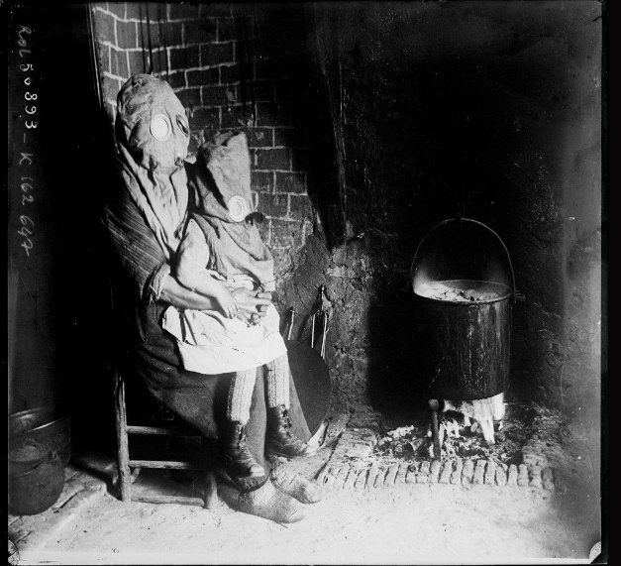
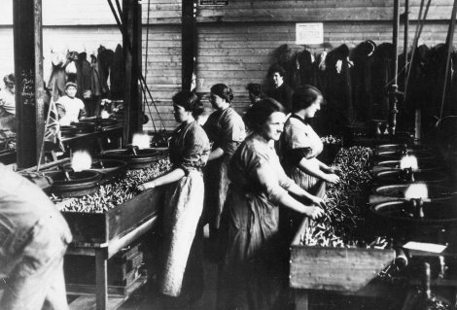
Men and women were a single target and they were supposed to perform the same role. Historians argue that there was no best option for any belligerent to use the firepower irrespective of the gender and border limits. Each side did so in order to avoid own vulnerability. There are proofs from the history which suggest that the depending nature of men over women or women over men was eliminated. Each segment of the society was not disconnected to the war. Carpenter argues that agents from the civil society use to propagate false narratives about war, which resulted in women being part of the active fighting force. At the war fronts, there are many incidences which are supportive of the facts that many women have died fighting for the sovereignty or survival of the state. The picture taken from completion of historical photographs of the WWI shows the severity during the war times this picture was taken in Germany when the axis forces were using shell bombs to target the civilian population. The use of gas masks provided the opportunity to breathe clean, therefore women and children’s use to wear these mask. The role of the states in the crisis also remained very regulative. In order to maximize the number of the acting working force, they inducted citizens irrespective of their genders roles. The gender stratification otherwise, at that time would have eliminated the last living person of that state. In this complete process of recruiting women, the state authorities reorganized the basic facet of their lives. For example, during those times women were not allowed to take food that can have negative effects on their health, or they can feel weak. Women were not shared with every kind of information. The generals who were in charge of the flow of information or communication altered use to alter information which could have demotivated or terrified the women at the battlefield. Since, each institution of the society, including the state, women, men and some differently gendered people were fighting for the same cause they were targeted irrespective of their affiliations.
Figure 1Women and her child wearing a gas mask.
Figure 2 Women’s working as ammunition workers
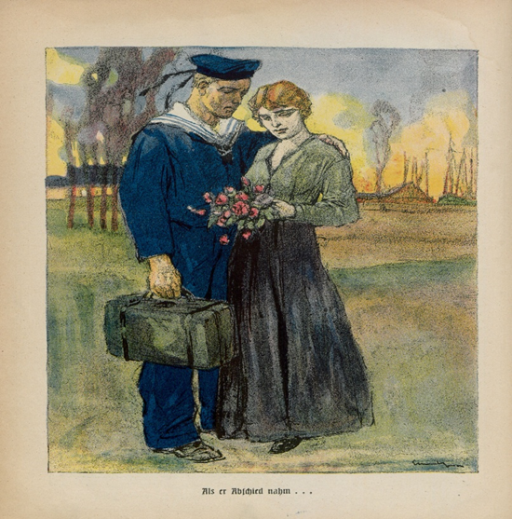
The gendered role was altered during war times. Men and women were fighting against the common enemy irrespective of their gender appearance. Different from the prehistoric times, when women were used for the self-satisfaction of the army personnel’s, in this war, there was no such concept. Women role was altered as a whole. In the camps, they use to sleep on the same floor where male soldiers use to sleep. They were expected to support the war in every way possible. Similarly, the role of men was a bit changed. There was no second thought about men that they will live inside a certain territory and will care about their own lives. Each men participating in the fight was not a trained soldier. A tailor, a barber, a car painter, etc were all part of the active forces. There were many reports about gay sex happening at the war fronts, the reason was just that there was a desire for intimate relationship. This picture shows how women use to spent time near the war fronts. At times when there was a lack of the workers in making ammunition, women were called to meet the human resource need. This picture was taken in America. The women active in the picture depicts the exact nature of their role as discussed in these paragraphs. Irrespective of the situation in the peace times, women were not celebrated as mothers, sisters, wives or loved ones. Similar to this, men were not supposed to take care of their children like father, brother, husband or a boyfriend. The cause of everyone was the same that was to eliminate the enemy to protect one’s own motherland. The altered roles of both men and women have observed at each state involved either directly or indirectly in war.
Figure 4 the legacy of Post- War
The legacy of the world war radically transformed the gender roles in society. Previously, different notions were attached to the roles of man and woman. They were expected to fulfill their traditional roles and expectations in their own particular sphere of competence. Men were assumed to control authoritarian positions in society and even homes. Nevertheless, such archaic ways of life were totally misfit in the post-world war one scenario. War changed every aspect of lives and so is the case with gender roles and behaviors. World war one changed European politics and domestic politics as well. The most significant change in gender role was the grant of voting rights to a woman. This was the first time in history where a woman received political recognition and their political life took off. Later on, this political participation was limited, but still, some states did not allow them to vote. In addition, women became more secure and more assertive in society. Their male counterparts gave them due to place in homes and society. Postwar resulted in more harmony among genders as a male gave some of their authority to their women, and this picture is an illustration of how male and female used to court their companions in the post-war period. Nevertheless, things did not change for minorities and other racial groups in society as they were recognized in society. Furthermore, there was no change in family life and demographic pattern. It shows that how it radically transformed the gender roles in the post-war period.
Conclusion
The changed role of both men and women was the toughest thing to observe during war times. The role of gender was changed as a concept and each person from that time onwards have experienced a change in his or her nature. Similarly, the debate about gender norms has changed. People during the war times and in the post-war times were concerned about gender roles. The changing nature of the gender roles and the norms one side impacted on societal interactions and on another side, it changed the nature of literary inputs by the scholars. They were concern about how society will adopt the new extended roles of different genders. It was for all these reasons that extended role of genders started to make their place in the world. The only reason for their acceptance was the strength the inter war period provided to them.

Bibliography:
Alison, Miranda. “Wartime Sexual Violence: Women’s Human Rights and Questions of Masculinity.” Review of International Studies 33, no. 1 (2007): 75–90.
Carpenter, R. Charli. “‘Women and Children First’: Gender, Norms, and Humanitarian Evacuation in the Balkans 1991–95.” International Organization 57, no. 4 (2003): 661–694.
Goldstein, Joshua S. War and Gender. Springer, 2004.
Westing, Arthur H. Cultural Norms, War and the Environment. Vol. 5. Sipri Publication, 1988.

R. Charli Carpenter, “‘Women and Children First’: Gender, Norms, and Humanitarian Evacuation in the Balkans 1991–95,” International Organization 57, no. 4 (2003): 661–694.
Miranda Alison, “Wartime Sexual Violence: Women’s Human Rights and Questions of Masculinity,” Review of International Studies 33, no. 1 (2007): 75–90.
Arthur H. Westing, Cultural Norms, War and the Environment, vol. 5 (Sipri Publication, 1988).
Joshua S. Goldstein, War, and Gender (Springer, 2004).
Alison, “Wartime Sexual Violence.”

