Discussion
[Author Name(s), First M. Last, Omit Titles and Degrees]
[Institutional Affiliation(s)]

The Greek and the Roman are countries situated in the Mediterranean. During the colonial period, the Greeks and the Romans both imparted an influence upon each other. Both the nations had an interaction through the trade through the black sea and the Mediterranean region. Rome integrated into the Greek lifestyle yet there are many differences between ancient Rome and ancient Greek. Romans were great builders and architects, but in terms of the style and design, they were immensely influenced by the aesthetics of Greeks. One of the most common examples of the use of Ionic, Doric, and Corinthian Orders.
Despite the similarities, there are many differences too between both of them. They both used marble but Romans preferred concrete for more free-flowing structures. Pantheon is an ancient Roman temple that is very much similar to the Greek temple Parthenon. However, the Greek built Parthenon for Athena their mythical god while Pantheon was constructed in Rome for the celebration of the gods of Rome. The exterior pattern of the Pantheon is influenced by the architecture of the ancient Greek just like Parthenon. Pantheon was a concrete structure maintained by the decorative Corinthian pillars contrary to the Parthenon was a Doric sanctuary which was maintained by Ionic posts. (“Difference between Greek and Roman Architecture of Antiquity,” n.d.).

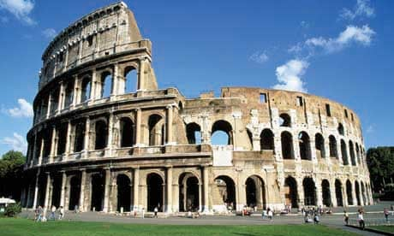

The gigantic stone arena namely Colosseum was constructed near A.D. 70-72 by Monarch Vespasian. After the passage of a decade, the son of the emperor Titus opened the amphitheater for the famous 100 days of games (“Colosseum - HISTORY,” n.d.). It was the biggest stadium in the world of Rome and not like the previous amphitheater that was built digging the hillsides for the proper support, it was free standing. Over time about two-thirds of Colosseum got destroyed. Now it's the tourist attraction for Rome. I always have been fascinated by the ancient buildings, and this amphitheater is one of them. Whenever I got a chance in life I would love to visit the ancient structure.

References
Colosseum - HISTORY. (n.d.). Retrieved May 21, 2019, from https://www.history.com/topics/ancient-history/colosseum
Difference Between Greek and Roman Architecture of Antiquity. (n.d.). Retrieved May 21, 2019, from UKEssays.com website: https://www.ukessays.com/essays/architecture/the-differences-between-the-greek-and-roman-architecture.php

