Your Name
Instructors Name
Course
Date
The United States has always been a nation of immigrants. However, the attitudes towards new immigrants have always hesitated and hostile. The United States is changed from a country of welcoming everyone to expelling and kicking out people from the country. The early people in America were also immigrants that came during the last ice age. So, the foundation and success of the country depend entirely on the policy of immigration. The country faced rising immigration issues in the early 20th century. More than 14.5 million immigrants came to the country between the years 1900 and 1920. This huge number of migrants changed the perception and attitude of different policymakers towards immigration policies. New legislations in 1903 and 1907 were introduced to strengthen the national immigration laws. Different commissions were formed to investigate the reasons for immigration from southern and eastern Europe. These commissions proved very influential in developing the immigration act in 1917.
The sentiments against Immigration grew more and more, despite that many immigrants were serving faithfully in the US army. Since most of the immigrants were European which led and many were from German Descent, which led to emotions of anger among people against them. Many Irish people were also subjected to hate as they supported Germany in WW1 and hoped that a German victory will lead to Irish independence from Great Britain. This led to the emotions of Isolation and Nativism in the mind of many Americans and led to the closing of the immigration door for many people.
Different literacy tests were introduced to check whether immigrants were able to read and write in the native language. More hard and difficult medical examinations were introduced which further reduced the number of immigrants traveling to America. The immigration number further reduced due to the outbreak of World War 1. New duties were further introduced to assess the people about their work and whether they were spies or just refugees. Passport compulsions were also introduced in 1918 and paperwork was further made detailed and eventually, proper border crossing cards were introduced.
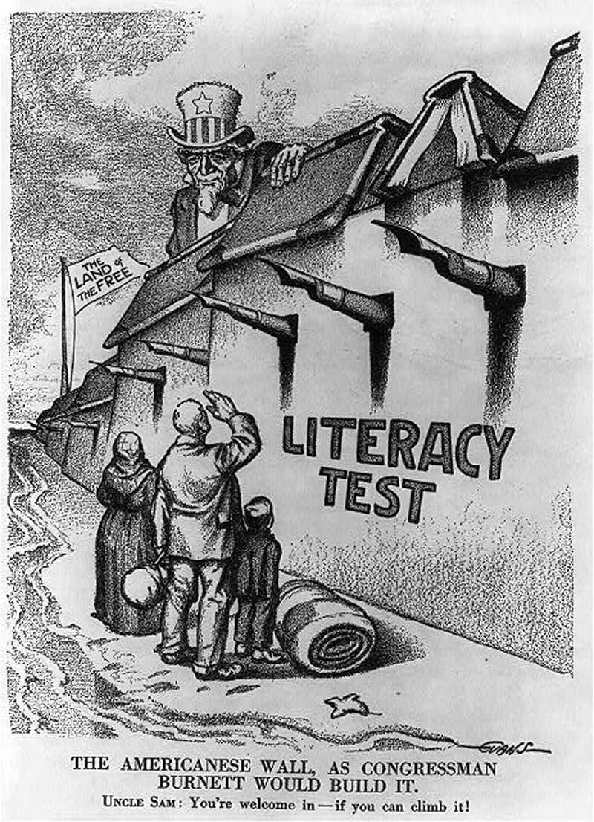
(“‘The Americanese Wall,’ March 25, 1916”)

In the 20th century, Ellis Island in New York was created as the base camp for immigrants. This resulted in a decrease in the number of immigrants from east European countries. Many of the immigrants were coming to America for a better living so they were poor and lacked money. Many groups surfaced and asked authorities to take literacy and medical tests of the people that we're entering the country. The president’s art that time opposed the theories however, in 1917 congress passed the bill and made the education requirement compulsory. Later in the 1920s quotas were introduced on nationality basis which reduced the people entering the country from Africa and the Eastern European countries which were at war against the US. Immigration from Asian countries was also cut short. However, at the same time Visas were available for people from Great Britain and Western European which shows that the policy was primarily not to restrict the number of people coming to the United States but to restrict people that were at war with the country. However, the basic purpose of the immigration act was to reserve a sense of homogeneity in the United States (Milestones: 1921–1936 - Office of the Historian).
European Anarchism was at its peak at that time and people from Europe escaped from the reason ranging from famine, religious disharmony, political persecution, and inequality. The vast majority of the incoming immigrants came and settled in the cities to make a better living for themselves. The lack of opportunities for local people, fear of conflict and imposition of European Anarchism pushed local people to revolt and act against them. The local natives turned to government and asked for policies like Americanization, isolation, and Nativism. The concept of Nativism was to show superiority towards American that was living longer there as compared to incoming people. Local nativists pointed out that the incoming immigrants will bring a mindset of European Anarchism and their assassination of Italian and Spanish presidents with them (Huber). The urbanization that occurred after the postwar was also one major thing that angered the local people. The increase in the population of cities meant that their growth was very rapid and a disconnect was created between rural areas and cities. Expanding cities means that more opportunities were available in cities and those opportunities were preoccupied with the incoming immigrants. The incoming immigrants were also skilled and have huge experience in industries. People who left rural areas for opportunities felt that their place was already taken by someone else. Cities were liberal and sinful for rural Americans and they felt that they were left behind their times.
The nativist movements were part of the American culture before the start of this immigration period and throughout the country's history. It dates back to the Know-Nothing Party of the 1840s when different Irish and catholic groups created an organization to promote Nativism in America (Young). This party did nothing on the national level however, it created a sense of feeling that there is a need for a policy that can control the laws and regulations that can deal with people immigrating to the country.
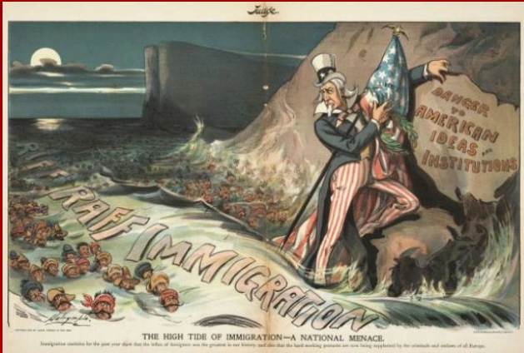
(Brandenburger)
The current policies of the American government are more like a revisit to the past. The sense of white superiority and feeling among the public and government institutions that a certain religion is a danger to the existence and survival of American society. The current ban on mosques and the immigration ban on Muslims from certain countries is a reflection of the immigration policy of 1924. A certain group of people is being targeted and put to a patriotic act. The similarities between the Nativism in early 1900 and that of today. Especially the way it is targeted towards a specific group and nationality. There is a huge misconception that if a person came from outside the country his existence will be threatening to the local people however this has not been the case historically and many countries have enjoyed its benefits. The prime example of Which is America itself followed by one of its neighboring countries in Canada. The people who have suffered the most from Nativism in recent times are Mexicans and Immigrants from middle eastern countries.
The concept of Americanism was changed in previous decades. Being American in the past few decades was to be someone who fights against terrorism and work for its supremacy in the world. However, with the new Government, it has changed significantly again. The concept of racism and White supremacy is making its way again. Nativism and Americanization are making their way again. Its study shows that Nativism identifies that it cannot be eradicated and it works in cycles to make its way again. One thing that is also important to note that immigrants themselves can also adopt the concept of Nativism so can their descendants. Complete eradication of Nativism may be impossible however, steps can be taken to improve the legislation and immigration policies.

Work Cited
Brandenburger, Mackenzie. The High Tide of Immigration—A National Menace. 2012.
Huber, Lindsay Perez. “Make America Great Again: Donald Trump, Racist Nativism and the Virulent Adherence to White Supremecy amid US Demographic Change.” Charleston L. Rev., vol. 10, 2016, p. 215.
Milestones: 1921–1936 - Office of the Historian. https://history.state.gov/milestones/1921-1936/immigration-act. Accessed 8 Nov. 2019.
“‘The Americanese Wall,’ March 25, 1916.” IDCA, 5 June 2018, https://iowaculture.gov/history/education/educator-resources/primary-source-sets/immigration-regulation-response-and/americanese-wall.
Young, Julia G. “Making America 1920 Again? Nativism and US Immigration, Past and Present.” Journal on Migration and Human Security, vol. 5, no. 1, 2017, pp. 217–35.

