Abstract

The word "quantum" itself is perplexing enough, and it becomes irresistible in unique combination with the promise of computational power that outstrips anything we've seen so far. But what is the term quantum computing exactly? Unlike other computers, quantum computers are not confined to two states; they encode information that may exist in superposition as quantum bits or qubits. Qubits are 1, 0 and all the possible values which can reside between these two. The commonly known type of a quantum computer s D-wave systems which we are going to discuss in this paper. The D - Wave quantum platform of the next generation might include ongoing upgrades through the cloud, a new quantum system.

History

A new state of matter characterized by non - trivial topological properties was predicted by theoretical physicists Vadim Berezinskii, J. Michael Kosterlitz and David Thouless in the early 1970s. later in 2016, this work earned the Nobel Prize in Physics. Researchers from D - Wave demonstrated this phenomenon by programming the D - Wave 2000QTM system to form a frustrated two - dimensional artificial spin lattice. Without quantum effects, the observed topological properties in the simulated system cannot exist and are in close agreement with theoretical predictions.
A practical architecture of a quantum computer requires hundreds to thousands of quantum bits ("qubits"), but up to now realizations of qubits by methodologies such as nuclear magnetic resonance (NMR) seem highly inappropriate for the miniaturization required to support the construction of a multi - qubit machine at minimal cost (Gershenfeld, and Chuang).

Introduction

D - Wave's quantum computer uses the concepts of quantum dynamics to speed up and develop new methods to resolve discrete problems of optimization, sequencing, material science, and machine learning. BURNABY, British Columbia, Sept. 24, 2018 — D - Wave Systems Inc., the developer of Quantum Computing Systems, published a study demonstrating a quantum mechanical phase transition using its 2048-qubit Quantum Computer. This intricate quantum simulation is a major step towards drastically reducing the need for time - consuming and costly physical research and technology development. D wave quantum computers work based on a technique called quantum Annealing.

Quantum annealing
The quantum bits in terms of quantum computing are also referred to as qubits that are the cheapest energy states in the superconducting loops comprising the D-Wave QPU. These states have a disseminated current and a proportional magnetic field. A qubit may be 0 or 1. Like conventional bits. However, since the qubit is a quantum abstraction, it can also be simultaneously in a 0 and 1 state quantum superposition.
It is possible to show (visualize) the physics of this process with an energy diagram as shown in Figure 1. As we can see in (a), (b), and (c), this diagram changes over time. To start with, there's only one (a) valley with one minimum. The mechanism of quantum annealing runs, the barrier is lifted, and as a result transforms the energy diagram into the potential (b) for double-well. And here's the left's lowest point.
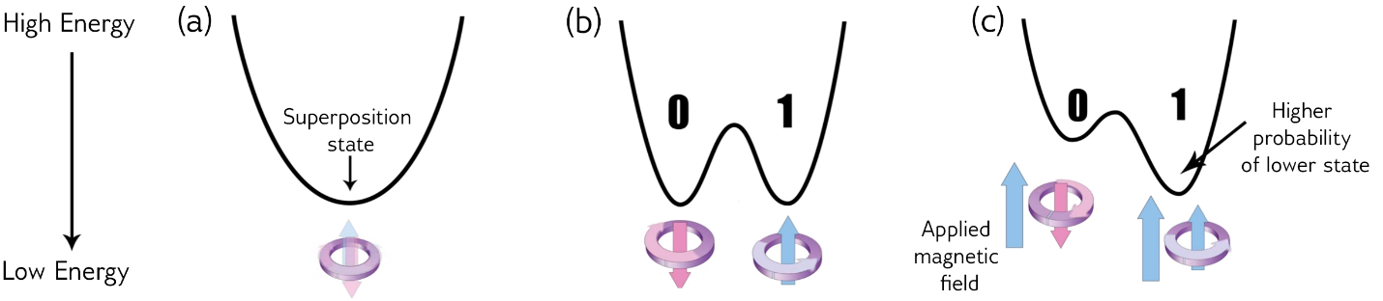
Figure 1

The qubit’s probability ending in the 0 or 1 state is equal (50 %) to all else being equal. However, by enforcing an external magnetic field to the qubit (c), we can maintain the probability of it falling into the 0 or 1 state. As a result, probability of the qubit for ending up in the lower well is increased due to the tilting of the double well potential. The magnetic field generated here is controlled by the Bias which is a programmable quantity. The energy of the qubit usually gets minimized because of bias. In real bias show their abilities by combining to link and start influencing each other. This process is done with the coupler. Couplers, biases and qubits get entwined. At this point, the system has many possible outcomes in a entwined state. At the ending of the anneal, each qubit is in a typical state representing, or very probably close to, the minimum energy state of the actual problem. All this happens in microseconds in D - Wave systems.
D-Wave Systems announced D-Wave One on 11th of May 2011, described as "the world's first commercially available quantum computer", operating on a 128-qubit chipset (Johnson MW, 2019) using quantum annealing (a general method for finding the global minimum of a function by a process using quantum fluctuations) to solve optimization problems. The D – Wave One fabrication principal was based on D - Wave's early prototypes.
In May 2013, a collaboration between NASA, Google and the Space Research Association of Universities (USRA) successfully launched, among other fields of study, a Quantum Artificial Intelligence Lab premised on the D - Wave Two 512-qubit quantum computer.
In June 2014, D - Wave introduced another quantum implementation ecosystem in collaboration with 1QB Information Technologies (1QBit) computational finance company and DNA - SEQ cancer research group to focus on resolving real - world problems with quantum hardware ("D-Wave Systems Building Quantum Application Ecosystem, Announces Partnerships with DNA-SEQ Alliance and 1QBit | D-Wave Systems", 2019).
The release of the in January D - Wave 2000Q system allows a variety of energy landscape searches by providing unique features that provide users programmable direct control over the annealing training schedule. Understanding the fine details of quantum annealing more deeply and to develop better controls for it kept on increasing continuously. The release of the D - Wave 2000Q system allows a variety of energy landscape searches by providing unique features that give users programmable direct control over the annealing training schedule ("Introduction to Quantum Annealing — D-Wave System Documentation").

How D wave models as a quantum system

The systems of D-Wave can be considered as a large collection of magnets, each of which can flip orientations. These are not qubits in the same way as the quantity processor components of IBM or Intel are, but they rely on quantity behavior to perform calculations. There is nothing on its own that favors one orientation over another. But put a second magnet next to each other and the two influence each other; now, if one flips its orientation, it changes the system's energy content. The current system of D-Wave scales up to 2,048 individual magnets, together with the associated control hardware, which determines which of these magnets are connected and how strong the connection is.
In this case, the modeling system become identical like the D-Wave computer itself, suspiciously. It is a cubic arrangement of magnets that can roll, called a "transverse-field Ising model." If these magnets are instructed to alternate orientations as you migrate in any of the three dimensions, there will be an anti-ferromagnet. But configurations can also be found in which the orientations are deranged, forming what is called a "spin glass" (magnetic properties spring up from particle spin). They have well-defined energies, including a low-energy state, while spin glasses are disordered.
Whereas the individual magnetic bits in a D-wave system are primarily in one plane, the connections between them can be controlled so that the system realistically simulate a three-dimensional lattice's behavior. The largest lattice to fit in the processor on the current system generation is something that is a cube with eight magnets on one side.

Computer system

The conceptual frameworks for the D - Wave approach came from experimental results in condensed matter physics, and in specific from work on quantum annealing in magnets by Dr. Gabriel Aeppli. These ideas were later resurrected in the language of quantum computing by MIT physicists Ed Farhi, Seth Lloyd, Terry Orlando and Bill Kaminsky, both of whom published in 2000 and 2004 (Farhi, E., Goldstone, J., Gutmann, S., & Sipser, M. (2000)).And a specific incentivizing of this kind of idea using superconducting flux qubits, a close cousin of the designs produced by D - Wave. And a specific incentivizing of this kind of idea using superconducting flux qubits, a close cousin of the designs produced by D - Wave.
And a specific incentivizing of this kind of idea using superconducting flux qubits, a close cousin of the designs produced by D - Wave. To understand the roots of much of the controversy around the D-Wave approach, it is important to note that the roots of the D-Wave approach to quantum computing originated not from the conventional field of quantum information, but from the physics of experimental condensed matter.

Support Circuitry: Reading Qubits
A substantial part of the circuitry surrounding the qubits and couplers is a structure of multiple organised switches (also formed from Josephson junctions) that create circuits that both address each qubit (route pulses of magnetic specific information to the correct positions on the chip) and store that information for each device in a local magnetic memory element. Most Josephson junctions are used in a D-Wave Quantic Processing Unit (QPU) to make up this circuit. Readings are also linked to each qubit. During computation, these devices are inactive and do not directly affect the qubits ' behavior. After the calculation is fully operational and the qubits have resolved into their final (classical) 0 or 1 state, the readouts are used to search the value held by each qubit and return the response as a bit string of 0's and 1's to the end user.
This is a very vastly different architecture than conventional computing. The QPU does not have memory buffer areas (cache), but each qubit has its own small chunk of memory. Indeed, the QPU is architecture more like a biological brain than a conventional silicon processor's ' Von Neumann architecture. One can suspect of the qubits as neurons, and the couplers as neurotransmitters that control the information flow between those neurons.
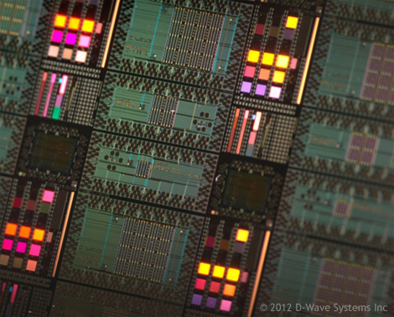
Figure 2 shows a picture of the final QPUs in a superconducting electronics foundry after manufacturing. Using modified techniques from the processes used to make semiconductor integrated circuits, the QPUs are ' stamped ' onto a silicon wafer. This wafer image shows several QPUs. The highest, near the bottom center, has a connection of 128 qubits with 352 connecting elements. On each individual QPU, the qubit or a coupler circuits are the cross - hatched patches that appear in the following image. This is generally known as a Rainier QPU and was the form of QPU found in the quantum computer of D - Wave OneTM.
Figure 3
Figure 2
The methodologies learned from the semiconductor industry resulted in the design and construction of a D-Wave, Large-Scale Integration (LSI) owned manufacturing infrastructure. This manufacturing ability is unique. Figure 3 shows a cross section of one of the QPUs produced at D-Wave's superconducting electronics foundry. The manufacturing process developed can yield superconducting circuits from LSI (128,000 + Josephson junctions in the D-Wave 2000Q system for the 2000-qubit QPU). It is the only superconducting production facility able to produce the superconducting processors of this complexity.
Figure 4
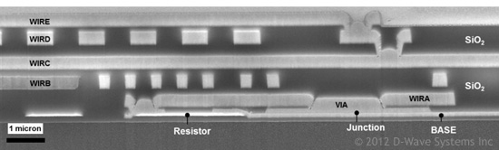

microscopic cross - section of D - Wave QPU, manufactured using a 6-metal layer wiring process. Near the bottom of this sandwich framework is shown the layer used to form the Josephson junctions.

Future of D wave quantum computers

For the past 10 years, the qubits on D-Wave's Quantum computers have nearly doubled steadily each year. This growing trend is expected to keep increasing. Simply scaling the current production process to add more qubits in the same way that they are currently arranged to create QPUs with up to about 10,000 qubit numbers. Going beyond 1000 to hundreds of thousands or millions of qubits will involve major overhaul, but there are certainly ways to do that and operating system improvement is not seen as a intrinsic barrier.
Quantum computers will transform the world, leading to the most challenging problems with better and faster solutions and tremendous applications. D-Wave quantum computers are ideally suited for solving many difficult problems in optimization, machine learning, sampling and cyber security. With 2000 qubits and new control features, the D-Wave 2000Q quantum computer can solve bigger problems than previously possible and with better performance. A growing community of developers is using the unique capabilities of D-Wave systems in a variety of applications to solve challenging problems.

References
Gershenfeld, N. A., and I. L. Chuang. "Bulk Spin-Resonance Quantum Computation". Science, vol 275, no. 5298, 1997, pp. 350-356. American Association For The Advancement Of Science (AAAS), doi:10.1126/science.275.5298.350.
"Introduction To Quantum Annealing — D-Wave System Documentation Documentation". Docs.Dwavesys.Com, 2019, https://docs.dwavesys.com/docs/latest/c_gs_2.html. Accessed 27 Mar 2019.
"D-Wave Systems Building Quantum Application Ecosystem, Announces Partnerships With DNA-SEQ Alliance And 1Qbit | D-Wave Systems". Dwavesys.Com, 2019, https://www.dwavesys.com/press-releases/d-wave-systems-building-quantum-application-ecosystem-announces-partnerships-dna-seq. Accessed 27 Mar 2019.
Johnson MW, et al. "Quantum Annealing With Manufactured Spins. - Pubmed - NCBI". Ncbi.Nlm.Nih.Gov, 2019, https://www.ncbi.nlm.nih.gov/pubmed/21562559. Accessed 27 Mar 2019.
Farhi, E., Goldstone, J., Gutmann, S., & Sipser, M. (2000). Quantum computation by adiabatic evolution. arXiv preprint quant-ph/0001106.
Dwavesys.Com, 2019, http://www.dwavesys.com/sites/default/files/D-Wave%202000Q%20Tech%20Collateral_0117F.pdf.

