Your Name
Instructor Name
Course Number
Date

Media Bias
Media biases have affected the decisions of the public and this has caused a change in the values of the conservatives and liberals. Conservatives perceive that liberals are more biased and progressive. On the other side, conservatives have their own biases in the media where they are thought of as creating a layer of fear and divisionary thoughts among the public.
Bias is considered negative and is defined as the deviance from realities and as an absence of one or more conditions. Media bias means supporting and favoring a particular party, individual or any huge group, and shows one-sided opinion and favoritism which may result in controversies. Media bias is a concept that uses the belief systems which contradict the agreements and disagreements about any topic or area, which has an impact and meaning. Media biases can be used for positive or negative motives. Both ways change the perception and the decision-making power of an individual or group. The decision is to be made according to observations and investigations of individuals, but media is becoming the reason for change in the decision making power of people. Media is attracting the public towards it to make decisions based on their broadcasting and tv shows. There are ideological views on some major outlets in the US which show media biases to their linked parties.
The assumption that media is biased, draws attention towards the perspective that media has to be unbiased while treating political issues and politics.
There has been a continuous competition between progressive liberals and conservatives in politics. There are biases in the mainstreaming of new issues by United States media. Media biases affect decision making and public opinions during poling season. It can also impact public opinions. Broadcasting is done in such a way that public opinions change and start reacting based on their broadcasts. People change their opinions without observing and investigating whether Media outlets have favored the liberal members to cite their sources in a disproportionate order.
The Progressive Liberals and Conservatives and Media Biases
Most popular media outlets like the New York Times, USA Today, Fox News Special Report and Washington Times have faced critique from conservatives. These media outlets have shown a major bias towards the liberals(Groseclose and Milyo). The associations with the political parties has made it easier for media groups to give coverage in elections. For reporters, it might not be easier to ignore the biases towards one particular party or candidate because of their ideological beliefs. This is meant to be unattainable and undeniable because of the natural biases of humans and human behavior toward a specific target area.
According to communication scholars, there are no such media biases towards progressive liberal which would change values. Few of them have found some liberal superiorities among journalists but there were some exceptions too. On different levels of government, the democratic and republicans did not find any evidence which would show biases and favoritism towards progressive liberals in their media reports. The areas which were analyzed and examined for democrats and republicans were; selection of stories that favored a particular party over the other and more coverage given by the media to one party as compared to the other party.
The conservatives treat media as the product of ideologies that form public awareness which maintains the supremacy of ruling concerns and interests of the society. Media is considered as the primary actor of social control and journalists are considered as the guards who criticize the government but also support the government most of the time. There is an on-going topic that conservatives believe, media is more giving media coverage to liberals.
One can give examples of both parties towards which media is being biased in changing the behaviors of people, specifically the voting behaviors of people during elections. Both of the groups, the progressive liberals and conservatives can be held responsible for media biases and changing the behaviors during voting seasons. The historical events can be used as proof to show how voting behaviors were changed and what the impacts were.

Media Bias and Voting
The responses by 70 percent of Americans for the question: Does media bias is having an impact on voting agreed. Their responses were like the media bias is there in the media coverage and it has an impact on the voting behaviors and results. They were given many options to choose nay media outlets like New York or any other outlet which could be referred to as media. The introduction of the Fox News channel had an impact on the presidential elections and senate voting during 1996-2000. The conservatives gained 0.4 and 0.7 percentage points in the areas because of broadcasts by the Fox News channel. It was also found that it also changed the voting behavior of the senate by 3-8 percent, they were asked to vote for the conservatives (Media Bias and Voting).
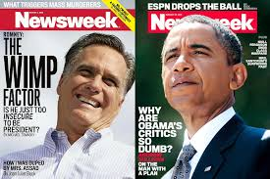
At the end of Barack Obama's presidency, USA Today editorial issued the news that's the president and his administration was free of any scandal which was an upsetting event for the conservatives(“Opinion | Media Bias against Conservatives Is Why No One Trusts the News Now”). There are fewer possibilities that and administration or a government would be free of scandals.
The news outlets have been showing the one-sided story and they show controversial content which changes the behaviors and their opinions get changed by the flow of time and media influence. These two pictures show that how media outlets are buys in creating misperceptions of people by sharing such news which create hype among people and people nowadays are only ready to believe on what they have been subjected to. They do investigate very few times which results in bad decision making and bad consequences like hatred among political parties and people.

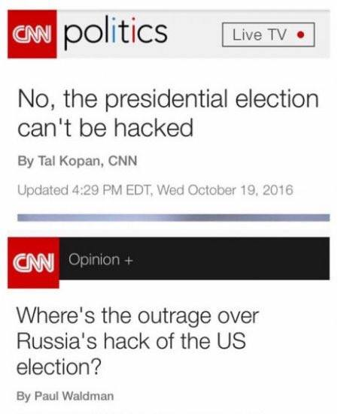
News outlets like CNN are considered as the most influential news media sources. The other part of the story is that such outlets are busy publishing critical and questionable news due to which people stop reading and watching these outlets. Media hype is not always good, it creates fear and anger among people. People tend to react in an aggressive manner and media coverages to increase their viewership and ratings, create issues intentionally.
Media outlets have to stay neutrals and they have to avoid imposing biases on the papers and news channels because of the change in all of the scenarios whether political or something else. The media has to be fair for any of the parties having an ideological thought and background. The media coverage has to neutral and it should be for all no matter which party is in front of the journalist of television anchors. Media biases play a vital role in changing the perceptions and opinions of general public by showing one side of picture, their media coverage is not fair enough to show both ends of the stories. Providing such content and coverage to public which disturbs the unity and peace is not good and supportive for the development of a nation.
Giving coverage to every event and political party, will encourage freedom of speech because everyone would be able to present and convey a message to public. They would be able to convey their aims, objectives, and motives of their concerned parties and organizations

.

Works Cited
Groseclose, Tim, and Jeffrey Milyo. “A Measure of Media Bias.” The Quarterly Journal of Economics, vol. 120, no. 4, Nov. 2005, pp. 1191–237. academic.oup.com, doi:10.1162/003355305775097542.
Media Bias and Voting. https://www.nber.org/digest/oct06/w12169.html. Accessed 19 Oct. 2019.
“Opinion | Media Bias against Conservatives Is Why No One Trusts the News Now.” NBC News, https://www.nbcnews.com/think/opinion/media-bias-against-conservatives-real-part-reason-no-one-trusts-ncna895471. Accessed 20 Oct. 2019.

