Damac Properties and The Glass Castle
Omran Palahang
[Institutional Affiliation(s)]

Author Note
[Include any grant/funding information and a complete correspondence address.]

Damac Properties and The Glass Castle
Around the globe, there are some people who are living life without having basic facilities that are required for their survival and well-being. On the other hand, people are having basic facilities and they enjoy most of opportunities and facilities, which others lack. People living under poverty live a life being homeless, while there are some estates and companies such as DAMAC Properties that were initiated to make developments in the Middle East. This has helped to shape an alluring image of the urban areas and DAMAC Properties has extended its networks after becoming successful.
The glass castle is a memoir that emphasizes poverty due to which many people and families get separated and it is also a reason for many disputes. There are a number of people who are living under poverty line, they are looking for food and shelter for their survival. This story of the glass castle depicts how Jeannette used to live a life as a poor lifestyle. Walls family went through hardships because of a lack of resources which were the basic needs for their survival and to live a standard life. This is an enthralling story of individuals who has no perpetual residence and healthy food. Jeanette's parents chose to live on their own and they rejected societal responsibilities: a life in poverty with no shelter and food not even for their children. Jeannette states that she lived a life in a heart-wrenching situation, while these situations involve immoral parenting, abuse and importantly poverty.
Walls were not being able to provide them healthy food, therefore they had to look for food in school garbage (Walls, 2006). But Rosemary Walls mentions that life without any shelter is an adventure and this is the way how an individual learns to live life in privations. While living a life being homeless is the last option for people who could not afford shelter and they are unable to manage to earn to build their own house. Her father was not being able to continue a job and earn bread for his family.
However, Jeanette tried to chase her dream by choosing a different life to fulfill her dreams. It is the basic human right that everyone should have basic life facilities, they should live a better and deserving life, should have maximum opportunities and they should be richer, while, these opportunities and demands are related to the American Dream (Adams, 2012). American dream suggests that it is important for individuals to have maximum materialistic resources, this will enhance their well-being. When compared to the Walls’(Wyatt-Nichol, 2011), the American dream is simple, and it appears in different ways. Rex and Rosemary use to live an independent life without being controlled and restricted by the government, while this is not questioned as it should have been. One should have money to live a life according to the American dream and they should be controlled by some external sources for a secure life. Parents of Jeanette, to live American life, they were not following the basic requirements, as it does not require freedom and adventure. While, they far from this American dream they believed that freedom is important, therefore they did not even provide food for their kids. American dream requires that basic needs must be fulfilled at least people should take care of their necessities including food and shelter. It would have been possible for children if they were supported by their parents and they would have helped them to achieve their American dreams. They would live a life in which they were provided with their needs, but their American dreams were not fulfilled because of the broken promises by their parents. Every child should be provided with the basic facilities and their basic needs should be fulfilled by their parents because it is their duty.
The DAMAC Properties is a company that aims to develop those regions which are attractive and this company aims to help those who are not able to invest money in infrastructure. This company was established in 2002 which was based in Dubai. This company has extended its units to 9,318 so far, and this provides an amazing private accommodation and helps to improve business. DAMAC Properties company has a number of workers who are hired by a proper procedure, and the company improvements include the designing, planning, and foremen who are given responsibilities. Company has been providing a safe working environment for workers who later assist in better and appropriate ventures' main areas. This company has been involved in many projects such as The Summit, Lake View, Lake Terrance, Smart Heights, and there are more. These projects have provided luxury designs and quality services.
DAMAC Company has a mission to provide quality services alongside valuable facilities to customers in the global market so that they may be able to improve their well-being and they may be able to fund a shelter. This company follows different market segmentation strategies that are utilized to identify these segments of customers in the business market regarding products (Kotler, 2009). Company has always aimed to initiate projects in those areas and regions which has dense and diverse populations and services include quality homes and under ways (“DAMAC Properties,” 2019). This also shapes residential, commercial, and properties of leisure in various regions. There are people like Jeanette who dream of a luxurious life where they would be provided with basic facilities with a designed shelter by popular and skillful designers and engineers. This can be fulfilled when an individual is able to earn and invest in their dreams. One has to be covered with an abundance of resources, and individuals have to also take care of their basic needs and requirements, which are also demanded by the American dream. DAMAC Properties company has been targeting those people who are energetic, and they seek for fun elements to live a life with a standard. Properties also depend on social classes in the society through which people are divided into categories based on their socio-political and economic states. On the global grounds, Dubai is considered as a hub for international and national events
Costumers, those who are being able to pay for services that are available in the market and socio-cultural factors determine the purchasing behavior of people (Pride & Ferrell, 2010). Due to this global recognition, DAMAC Properties has opportunity to make a profit and grow in the international market, while the hoteling and housing schemes are expected to grow in 2020. Tourists coming to Dubai is increasing. There is an opportunity for companies like DAMAC Properties to grow and extend in the global market rather than sticking to one specific region because there is a number of people who would like to spend money more on their shelter and food as these are their necessities. While individuals like Jeanette dreams for a life where she would be provided with healthy food, she does not have to search for food in garbage. They would be able to find shelter rather than living life being homeless and considering it as an adventure. Companies like DAMAC Properties must extend their services around the globe and create opportunities for people who are energetic to work and they can earn to pay for their services.
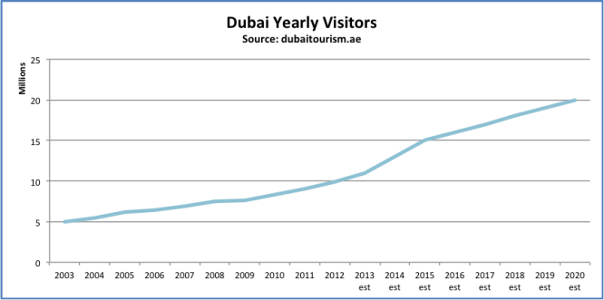 Source (“Official Dubai Tourism and Visitor information guide | Visit Dubai,” 2019.)

References
Adams, J. T. (2012). The Epic of America. Transaction Publishers.
Kotler, P. (2009). Marketing management: A South Asian perspective. Pearson Education India.
Official Dubai Tourism and Visitor information guide | Visit Dubai. (n.d.). Retrieved December 9, 2019, from https://www.visitdubai.com/en
Pride, W., & Ferrell, O. C. (2010). Marketing Express. Retrieved from https://books.google.com.pk/books?id=3dp0cR45FZcC
Walls, J. (2006). The Glass Castle: A Memoir. Simon and Schuster.
Why DAMAC Properties | Leading Real Estate Developer in the Middle East. (2019). Retrieved December 9, 2019, from DAMAC Properties website: https://www.damacproperties.com/en/about-damac/
Wyatt-Nichol, H. (2011). The enduring myth of the American dream: Mobility, marginalization, and hope. International Journal of Organization Theory & Behavior, 14(2), 258–279.

