Student Name
Instructor Name
Course Number
Date
Post 6: Product Life Cycle
Introduction
The product life cycle model is used to analyse a product over the period of its life time. There are four main stages of a typical life cycle namely introduction, growth, maturity and decline. There are specific characteristics of these phases which are generally shown by products. In introduction phase, sales will be lower and company will have to spend more on advertising. The growth stage will see a fight between different brands for market share. In maturity stage, there are only a few players left in the market with a falling demand for a product. The product is not standardised during the introduction stage of product life cycle (D.Pickton and A.Broderick). Product characteristics are also not fully developed and production is lower. In growth stage, there is mass production of the product which will be sold with the help of improved marketing strategies. In maturity, product is standardised and overproduction hits the market and efficient production takes place in the market (The Economic Times).
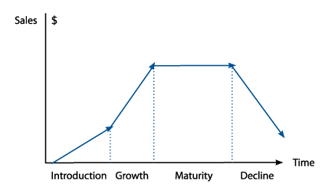

Application
The Kellogg’s Raisin Bran Cereal is in the maturity stage of its life cycle. The product has been in this phase for the last 5 to 7 years with a large number of companies offering many other cereals. This stage of product life cycle is characterised by mass production of a product and company using various techniques to enhance the sales of its product (Sraders). One way to differentiate its product is to introduce the renewable packaging which will show the corporate social responsibility of the company. Another option is to introduce more and more flavours to the product. There is another option for the company to indulge in a price war with their competitors. In fact, the nature of this product is such that companies can successfully lower prices of their product to increase sales. The better option for the company is to keep on introducing the newer varieties of flavours which will reintroduce their product in a new way.
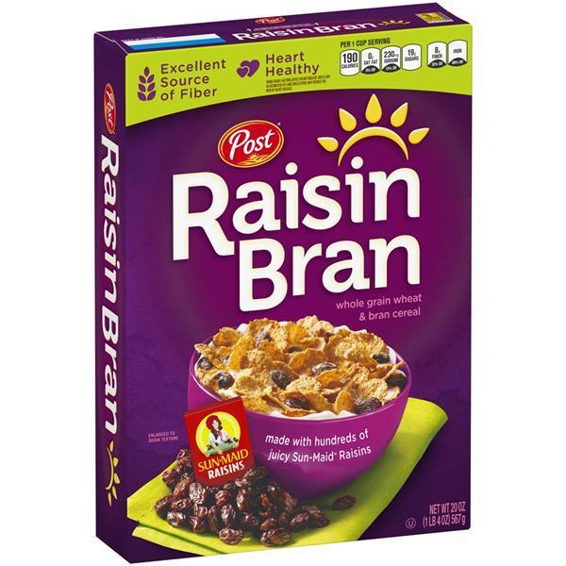

Works Cited:
D.Pickton and A.Broderick. Integrated Marketing Communication. 2nd. Prentice Hall, 2005.
Sraders, Anne. "https://www.thestreet.com/markets/commodities/product-life-cycle-14882534." 4 March 2019. https://www.thestreet.com. 21 January 2020.
The Economic Times. "https://economictimes.indiatimes.com/definition/product-life-cycle." 1 January 2020. https://economictimes.indiatimes.com/definition/product-life-cycle. 21 January 2020.

