The Solow Growth Model
[Author Name(s), First M. Last, Omit Titles and Degrees]
[Institutional Affiliation(s)]

Author Note

The Solow Growth Model
The extrinsic model of economic growth that measures and analyzes the significant changes in the economic levels over time due to the variations in the savings rate, population growth rate, and the technological progress rate of a country, is known as Solow Growth Model. The modern theory related to economic growth is based on this model. This model is based on the following assumptions (CorporateFinanceInstitute):
- If the current population of a country is represented by N, and the future population by N’, then assuming that the constant growth rate (represented by g), it is stated that N’ = N (1+g).
- Every consumer in the economy consumes some part of his income (represented by C) and saves the remaining part (represented by s). Thus, the output which is represented by Y is linked with the consumption through the equation, C= (1+s) Y.
- Every firm in the economy takes labor and capital as inputs to produce respective outputs. Thus, the output level (Y), the capital level (K), and the labor level (L) are all connected through the equation, Y = a*F* (K, L).
- K, K’, d and I represent the current capital stock, the future capital stock, the capital depreciation rate, and the capital investment rate respectively. These all are connected through the equation K’= K (1-d) + I.
It is one of the assumptions of the Solow Growth Model that the function of production follows constant returns to scale (CRS). So, following this assumption, if the levels of capital stock and the labor are doubled, then the output level is also doubled. Therefore, a major portion of the mathematical analysis of this model is focused on the output and capital per employee/worker instead of collective capital stock and collective output.
The Relevance of Innovation and Technology in the Economic Growth of Australia Based on the Solow Growth Model
It is often observed that most of the long term models related to economics have a slow growth rate. The Solow growth model is actually based on the model presented by Harrod Domer. The model is designed in a way that its development depends on the magnitude of production by a country. One of the important factors of the model, experienced by Australia, is the savings rate. The general growth of a country highly depends on its technological progress. Greater the technological progress of a state, greater will be its growth. Another necessary factor responsible for growth is innovation. Explanation of the economic conditions of a company is also important while discussing and applying the Solow growth model on it. In the year 2017, the Gross Domestic Product (GDP) of Australia was approximately $1.3 trillion. And it has been continuously increasing for the last three years. However, this increase is consistent but not too much (TheWorldFactbookAgency—CentralIntelligence, 2018). This is one of the common characteristics of developed countries throughout the world. The same increasing trends are found in the economies of other developed countries like the United Kingdom or Japan. The possible reason for the steady growth in Gross Domestic Product for the countries is the growth right from the initial level.
In the year 2017, the Gross Domestic Product growth rate for Australia was 2.1 percent. A significant increase in the per capita income of Australia is recorded in the past years and its growth rate can be stated as modest. Australia’s per capita income is around $50,000 which is the same as that of Japan but the increase recorded in the case of Australia is around $1500 (TheWorldFactbookAgency—CentralIntelligence, 2018). In the year 2017, the gross savings rate of Australia was 22% of its total Gross Domestic Product (TheWorldFactbookAgency—CentralIntelligence, 2018). Thus, it can be stated that the most prominent part of the economic culture of Australia is its savings culture, which needs to be discussed throughout this paper. The increased gross savings rate of Australia has helped the country in the funding of its investments. However, other countries have a higher savings rate as compared to Australia.
By comparing the economic progress of Australia on the Solow growth model, the growth of the country is found to be nearly declining. In order to make it purely steady, Australia needs to balance its depreciation level. The concerned parties should understand that a single investment cannot improve the rate to the same value as it was before. Capital depreciation can occur on additional investments. The importance of the golden rule cannot be denied while discussing the Solow Growth Model as, on the golden rule level, the capital accumulation is maximum. Graphically, at this point, the slope of the total productivity curve is equal to that of the depreciation curve. The graph attached below explains the phenomenon properly (Dalgaard & Strulik, 2013).

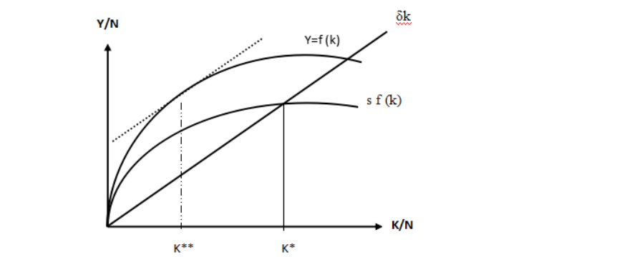
Figure1: The Solow Growth Model
The description of this graph is necessary. The production function of the country is represented by the line which is labeled Y= f (k). The investment done in the country is represented by the line s* f (k). Also, it has to be stated here that the capital generated per worker is represented by the horizontal axis on the graph. And the output generated per person or per person income is represented by the vertical axis. Maximum capital accumulation is represented by point K**. At this point, the slope of the product is maximum. The steady-state, however, is represented by the point K* at which the investment equals depreciation. It can be observed from the graph that the productivity is at its maximum value. Another important conclusion drawn from the above-mentioned graph is that capital dissipation will occur if the country invests beyond this point. Also, it is evident from the graph that the productivity will decrease beyond this point (Solow, 1956). This is due to the diminishing returns of many factors.
Many investigations have shown that Australia is one of the developed nations of the world. The important economic figures like the gross domestic product and the per capita income of Australia verifies its stability. The country has been in the steady-state multiple times. In this context, it can also be stated that the population growth and the technological progress in the country have displaced the level of the golden rule and the steady-state of the country. This has been done by changing the slopes of the production function, investment line, and the depreciation line. The demographic results of the country show that currently, it has been represented by a low death and birth rate, and is included in the third level of demographic transition. Therefore, it will not be wrong to say that in the near future, the country will face minimal population growth. (Jones, 1995)
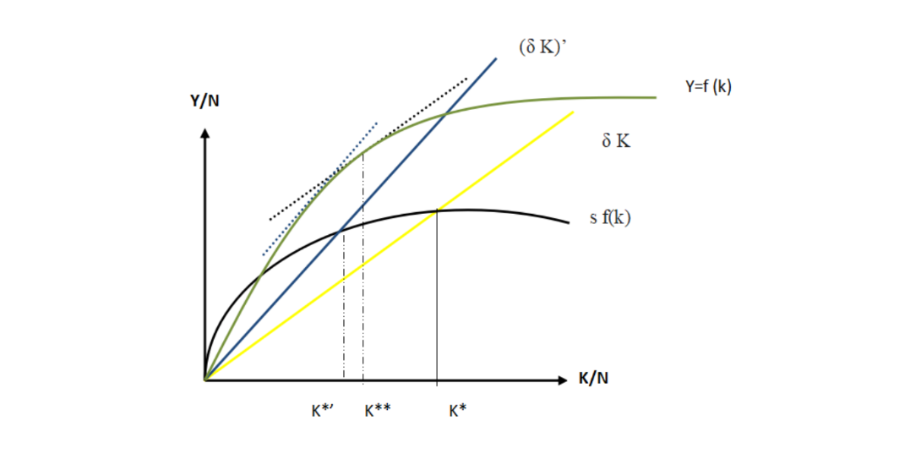
Figure2: The growth process for the developing country
The effects of population growth on the economy of the country are represented by the above-drawn graph. It has been observed that the depreciation line is shifted in an upward direction with the increase in the population of the country. Steady-state of the country also depends on these factors and will surely change. This shift in the graph is from point K* to K*’. Along with the variation in the steady-state level, the golden rule level of the country will also change. In the above diagram, the point at which the productivity function and blue dotted line become tangent is the modified state of the golden rule. Also, the value of capital accumulation is maximum at this point. In this context, according to the golden rule, there is no sign of appearance of any diminishing factors. Thus, Australia is included in the category of either developing or underdeveloped countries.
The possible reason for this downfall is the higher rate of population increase as compared to the country's technological progress. By the results of this analysis, it can be stated that the increase in population growth would beat the overall innovation and technological progress of the country. For such states, the increase in population is massive and on the contrary, their technological progress is minimal. The reason, in this case, can be the decreased investment and saving rates. Higher saving rates of a country encourage its technological progress and innovation. It can be stated that the shift of steady-state to the state of lower equilibrium would decrease the overall productivity and the per capita capital in the country. The inward shift in the production curve explains this phenomenon. As stated above, the population growth of Australia is minimal. But on the other hand, the technological progress of the country is huge in the middle part. Innovation demands a healthy atmosphere and environment for research and development. Thus, it can be concluded that the overall innovation and progress in technology in Australia has beaten its decreased population growth. (Jones, 1995).
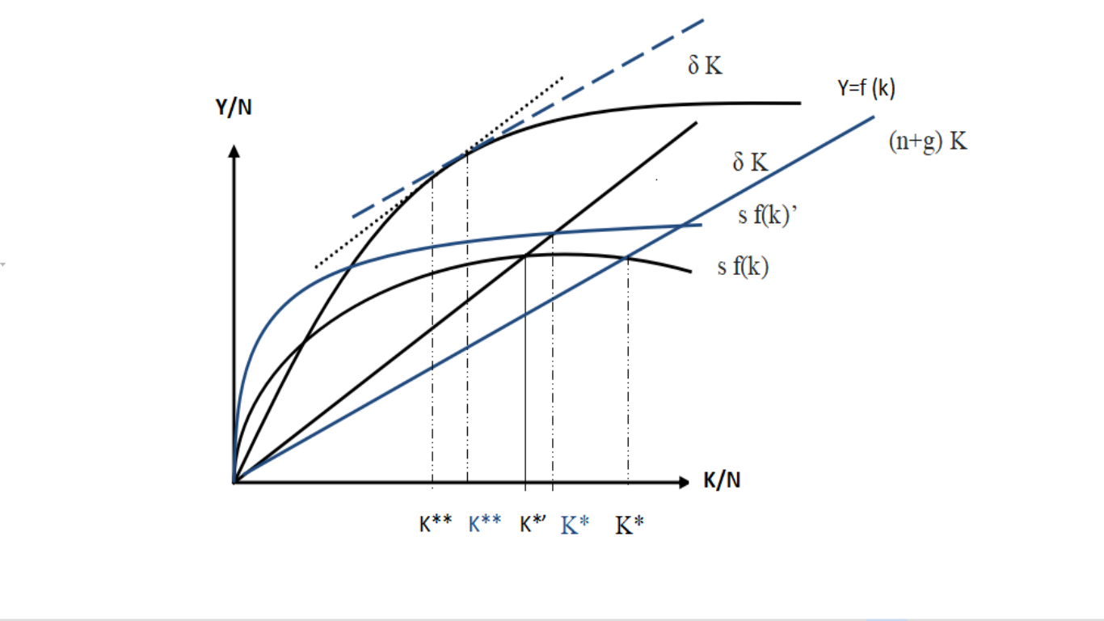Figure 3: Australia and The Solow Growth Model
The above graph explains the trends in the economic growth of Australia. The steady-state achieved by the country in its initial levels are represented by the black line in the graph. The vertical axis represents the per capita income and K* represents the initial steady-state level of the country. Better saving rates of the country have assisted it in its investments, which have resulted in better productivity. The overall dissipation in the capital is decreased in the country due to its advancements in technology. This has increased the per capita income as well as the general income of the people of Australia. In the graph, the income level for the country is represented by the point of intersection of the black investment line and the blue depreciation line. The increased income levels would automatically encourage the increase in saving rates of the country. Ultimately, the change in saving rates will produce some changes in the slope of the line represented by s*f(k). (Blue investment line). It would result in achieving a higher steady-state which is represented by the depreciation line in blue and the investment line represented by K*. The golden rule will also change due to the shift in the depreciation line resulting in the maximum value of capital accumulation. This would further increase the income levels of the people of Australia. This increase can be observed on the graph by the income levels and the point K**. It can be stated here that the levels of income per capita and capital per capita would increase as the country reaches the new steady state.
If Australia continues to progress in the same way and if its economy is not disturbed by any external factors, then it would move on to even higher and better equilibrium level. This would automatically increase the productivity function of the country. However, the consumption level of the country will also increase. Many investigations and research has shown that the consumption level of a country affects its investment rates directly. In this case, the increased consumption level will increase the investment rates of Australia as well. If the savings rate remains the same, then the overall savings will increase. (Blanchard, 2011).
Also, if Australia reaches the steady-state successfully, then it can change its saving rates as well, which will help it achieve an even higher equilibrium state. (Mankiw, 2014). The analysis of this phenomenon will become easier if the reiteration of the savings-investment is also considered. Investments of a country directly depend on its savings. Higher the savings, the higher will be the investment. Thus, in order to promote their economies, developed countries like Australia have to reduce their savings rates. (Blanchard, 2011).
Conclusion
Observing the recent trends of economic conditions of Australia, it is concluded that the increased level of innovation and progress in technology has helped Australia to reach a level of the golden rule of capital and a higher and better steady-state. This would have many positive effects on the overall growth of the country. An important thing to note here is that it is a rare case for any developed nation which has achieved a growth in its Gross Domestic Product of more than 2 percent a year. In comparison with Japan, the economic growth rates in Australia are almost double. However, other economic parameters like the gross domestic product per capita and the savings rate for both the countries have been approximately similar.

References
CorporateFinanceInstitute. (n.d.). Solow Growth Model. Retrieved from corporate financeinstitute:https://corporatefinanceinstitute.com/resources/knowledge/economics/solow-growth-model/
TheWorldFactbookAgency—CentralIntelligence. (2018). The World Factbook. Retrieved from Central Intelligence Agency.
Dalgaard, C. J., & Strulik, H. (2013). The history augmented Solow model. European Economic Review, 63, 134-149.
Solow, R. M. (1956). A contribution to the theory of economic growth. The quarterly journal of economics, 70(1), 65-94.
Jones, C. I. (1995). Time series tests of endogenous growth models. The Quarterly Journal of Economics, 110(2), 495-525.
Blanchard, O. (2004). The economic future of Europe. Journal of Economic Perspectives, 18(4), 3-26.
Durlauf, S. N., Kourtellos, A., & Minkin, A. (2001). The local Solow growth model. European Economic Review, 45(4-6), 928-940.
Heshmati, A. (2001). On the causality between GDP and health care Eexpenditure in augmented Solow growth model (No. 423). SSE/EFI Working Paper Series in Economics and Finance.

