Myocardial Infarction
[Name of the Writer]
[Name of the Institution]

Myocardial Infarction

Introduction
Myocardial infarction occurs when blood supply moving towards the heart is stopped (Thygesen et.al, 2018). Myocardial infarction is known as a heart attack (Thygesen et.al, 2018). Supply of blood towards the heart is stopped due to the accumulation of fats and cholesterol. The accumulation of fats and cholesterol develops plaque in the coronary arteries, the arteries responsible for the inward and outward circulation of blood from the heart. With time, the plaque turns into a clot. The suspended blood flow results in damaging the heart muscle.

Discussion
Signs and Symptoms
The signs and symptoms that appear over time due to the accumulation of fats and cholesterol are numerous (Thygesen et.al, 2018). For instance, an individual might experience pressure and pain in their chest and arms (Thygesen et.al, 2018). Additionally, nausea, lightheadedness, and sudden dizziness are also considered symptoms of myocardial infarction (Thygesen et.al, 2018). Moreover, an individual might feel fatigued and shortness of breath that could potentially result in a heart attack.
Causes
Myocardial infarction results when there is a blockage in coronary arteries. With time, the coronary artery narrows due to the accumulation of cholesterol and fats (Anderson & Morrow, 2017). This condition is called coronary artery disease, responsible for causing heart attacks (Anderson & Morrow, 2017). Another major cause of myocardial infarction can be a spasm of a coronary artery. It results in the shutting down of the blood supply to the heart. Usage of tobacco and cocaine is known to cause spasm of the coronary artery.
Risk Factors
Multiple risk factors can speed up the accumulation of cholesterol and fats in the arteries. Males and females aged 45 and above are at increased risk of heart attacks as compared to younger males and females (Anne-Lise et.al, 2015). Moreover, excessive usage of tobacco puts individuals at increased risk. Individuals suffering from high blood pressure levels, high cholesterol levels, and diabetes are at risk of a heart attack (Anne-Lise et.al, 2015). Lastly, stress, depression, and lack of physical activity may add up to speeding up the accumulation of fats and cholesterol in arteries.
Potential Complications
Numerous complications accompany myocardial infarction. For instance, myocardial infarction often results in abnormal heart rhythm. Abnormal heart rhythm can prove fatal if not treated timely. Furthermore, myocardial infarction can result in sudden cardiac arrest.
Treatment
Myocardial infarction can be treated through either medications or surgeries. Treating myocardial infarction through medication includes administering aspirin. Aspirin helps to decrease blood clotting which helps in the smooth flow of blood. Furthermore, thrombolytic drugs help in dissolving a blood clot. Moreover, morphine, a pain reliever, also helps in reducing the thickness of blood. Surgical procedures, on the other hand, include angioplasty and stenting. Lastly, bypass surgery can be administered in patients with myocardial infarction.

Diagnostic Tests
Healthcare practitioners screen patients during regular check-ups to analyze and look for symptoms and risk factors that might lead to myocardial infarction. Specific tests to check for myocardial infarction are Electrocardiogram (ECG) and blood test. ECG is employed to determine the electrical activity of the heart. The heart pulses are recorded and displayed in the form of waves on the monitor. Blood tests are conducted to check for the presence of certain proteins that might have leaked into the blood following a heart attack.
Types of Myocardial Infarction
There are three types of myocardial infarction
- ST-segment elevation myocardial infarction (STEMI)
- Non-ST segment elevation myocardial infarction (NSTEMI)
- Coronary spasm
Pathophysiology of Myocardial Infarction
Pathophysiology of myocardial infarction includes decreased efficiency of the heart. Furthermore, the force of contraction of the heart also decreases following myocardial infarction. Lastly, the heartbeat becomes abnormal after myocardial infarction.
Patient Education
A widespread patient education campaign is dire need of the hour. Individuals suffering from myocardial infarction need to bring significant changes in their lifestyles. They need to incorporate a healthy diet into their lifestyle. Furthermore, the risk of myocardial infarction can be reduced by exercising regularly. Moreover, managing diabetes, avoiding tobacco, and controlling blood pressure can also help heart patients.

Concept Map

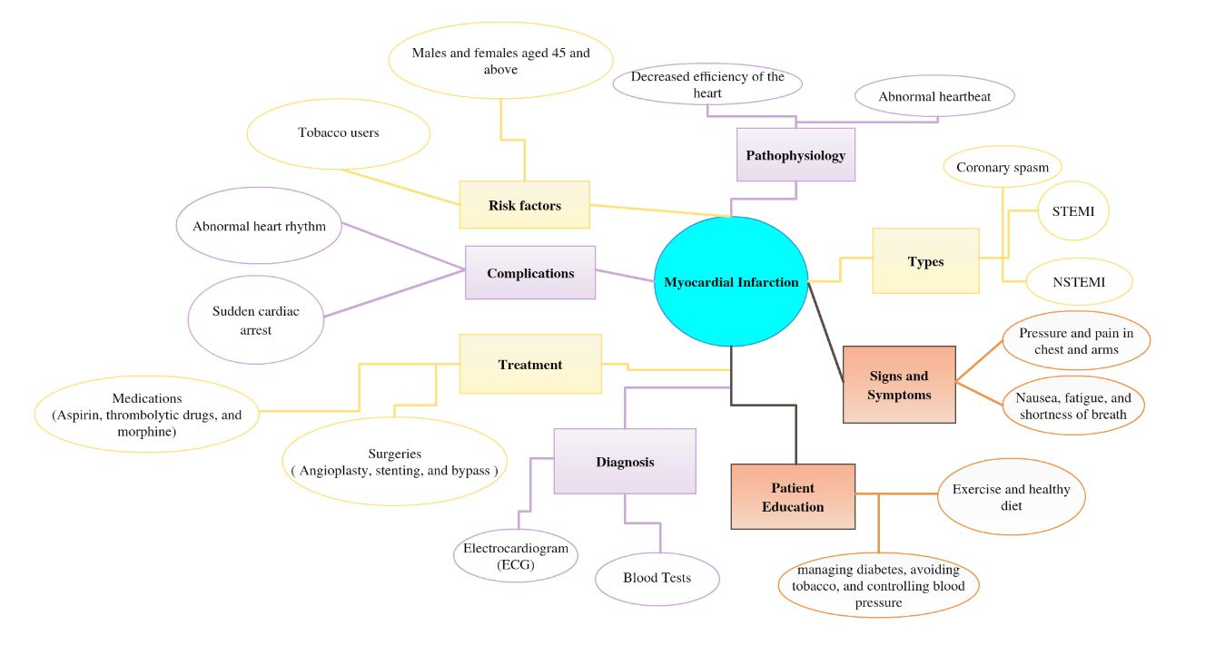

References

Anderson, J. L., & Morrow, D. A. (2017). Acute myocardial infarction. New England Journal of Medicine, 376(21), 2053-2064.
Anne-Lise, P., Chang, C. C. H., So-Armah, K. A., Butt, A. A., Leaf, D. A., Budoff, M., ... & Crane, H. M. (2015). Human immunodeficiency virus infection, cardiovascular risk factor profile and risk for acute myocardial infarction. Journal of acquired immune deficiency syndromes (1999), 68(2), 209.
Thygesen, K., Alpert, J. S., Jaffe, A. S., Chaitman, B. R., Bax, J. J., Morrow, D. A., & White, H. D. (2018). Fourth universal definition of myocardial infarction (2018). Journal of the American College of Cardiology, 72(18), 2231-2264.

