[Name of the Writer]
[Name of Instructor]
[Subject]
[Date]
Assignment # 1
Personality Assessment and Career Aspirations
I took the personality assessment test online and it gave me the following results.
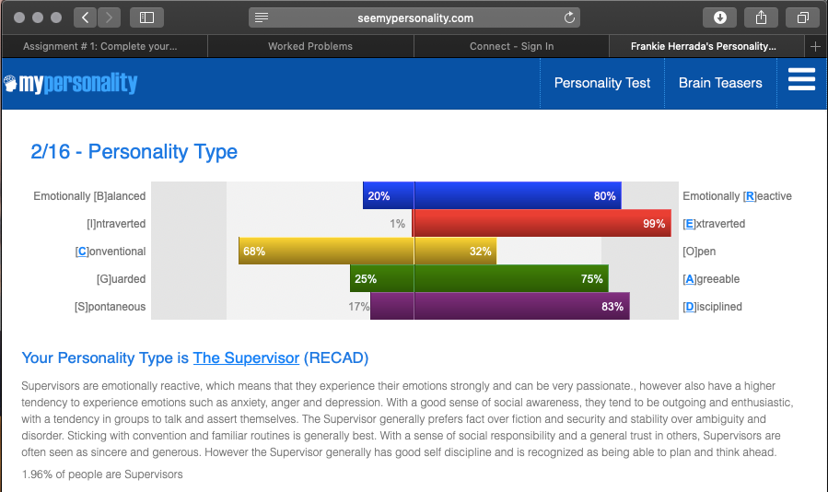
As it can be seen that my personality type is “The Supervisor”. This supervisors are usually expected to oversee the productivity and working of a group of employees and as I want to build my career in accounting, it would be expected of me to keep an eye on the corporate client accounts and supervise account executives. But to reach at that position it’d take experience gained over a course of years.
I had assessed my knowledge, skills and interests quite a long time ago and I was convinced that I should choose a career in accounts and I aspire to become a CPA soon. This career did interest me right from the start because I knew that I was good with numbers and the fact that I can help businesses by counselling/ advising them about taxation and financial issues faced by them by becoming a CPA really excites me.
The duties of an account supervisor include overseeing finance processes, reports band audits to make sure that things are going efficiently and look after the working of the subordinates.
I mainly aspire to become a CPA and it resonates with the qualities of supervisor as in the supervisor thinks ahead of time and performs that tasks that need to be completed. As a CPA, I’ll be supposed to advise business or individuals in their financial matters and so I’ll be required to think ahead of time and respond in due time to help mitigate any dangers to the business. I believe my personality type would help me in this well.
As far as employment is concerned, there are numerous growing business in the country and all of them need financial supervision and advice. Also, many new ones are entering the market and this trend is increasing day by day.
A research conducted about multi owner accounting firms has confirmed that accounting firms attract better employees if they offer them better benefits. This consequently leads to better market position of the firm and higher profitability. So when it comes to monetary valuation, we can say that there are enough incentives for accountants and CPAs to pursue these degrees.
Another research confirms that companies who have employees affiliated with audit firms get better and actionable audit information/ reports. So companies are more likely to hire auditors or accountants who have affiliations for better results.
There have been attempts to gauge the worth of the workers and this has been attracting accounting graduates and CPAs as a research by Robin Roslender from the university of Sterling shows. The findings of the research indicate that this aspect has been relatively less worked on and the workers contribution has been measured by the financial positioning or the market value of the firms. Now attention is being diverted to this so that necessary measures be taken to enhance worker outcomes and improve the market position of the firms.
All my study leads me to conclude that I am a good fit for the job in accounting and my knowledge, skills and relevant experience makes me good candidate for such a job. I can learn and improve with time and hence my prospects will also multiply.

Works Cited
Lennox, Clive. “Audit Quality and Executive Officers’ Affiliations with CPA Firms.” Journal of Accounting and Economics, vol. 39, no. 2, June 2005, pp. 201–31. ScienceDirect, doi:10.1016/j.jacceco.2003.12.002.

Casey, K. Michael, et al. “Employee Benefits of Multi‐owner Accounting Firms: Groundwork for Benchmarking.” Benchmarking: An International Journal, vol. 12, no. 4, Aug. 2005, pp. 354–63. emeraldinsight.com (Atypon), doi:10.1108/14635770510609024.
Kahn, Howard, et al. “Employee Wellness as Intellectual Capital: An Accounting Perspective.” Journal of Human Resource Costing & Accounting, vol. 10, no. 1, Jan. 2006, pp. 48–64. emeraldinsight.com (Atypon), doi:10.1108/14013380610672675.

