Title
Name
Institution

Research and Report
The human circulatory system is a vast system of vessels and organs that are basically accountable for the flow of blood and oxygen from and to the entire body. Without this particular system the body would be unable to resist different pathogens, and also the internal environment of the body like pH and temperature would not be stable which is also called homeostasis. The blood circulatory system consists of four main parts, which are heart, arteries, veins and also blood. Oxygen gas enters the blood flow through tiny membranes in the lungs; this small membrane absorbs oxygen when it gets inhaled. When the body uses oxygen gas and it produces carbon dioxide the lungs then push out that gas. The role of the immune system is quite significant in our body. It helps in fighting against diseases and keeps us healthy. When the immune system works properly, then it can identify all types of threats and foreign agents and then removes them from our body. There are two main types of immunity one is called innate immunity, and the other one is called adaptive immunity (Oplatal et al., 1997). Innate immunity is that type of immunity a person is born with. It mainly consists of the barrier that is present in or outside the body. While adaptive immunity is also called acquired immunity, it targets the basic threats to the body. While the lymphatic system is vessel system of cells and organs that not only carries excess fluid to the body but it also filters pathogens (Lazuardi et al., 2005).
The lymphatic and blood circulatory system are closely related to each other. Blood vessels are not thick vessels that don't leak blood. Blood vessels can also leak blood, but the lymphatic system makes sure that the leaked blood goes back to the bloodstream of the individual. When from the blood vessel a small number of fluid leaks then it is collected between the spaces of cells and other tissues. While some of the blood flows back to the cardiovascular system most of it is collected by the lymphatic system. The immune system is quite crucial in maintaining the homeostasis by preparing the body to resist against different kinds of infections. It also helps in the healing process of the body. It helps in increasing the blood to bring oxygen and other immune cells to the site where the infection has taken place.
The pulmonary circulation is responsible for moving blood between the lungs and heart. In this case, the oxygenated blood flows back to the heart. While the responsibility of systematic circulation is to distribute the blood between the heart and rest of the body. Here oxygenated blood is sent to the body while deoxygenated blood comes back to the heart. While portal circulation is the movement of blood from the gut area through the liver than to the heart.
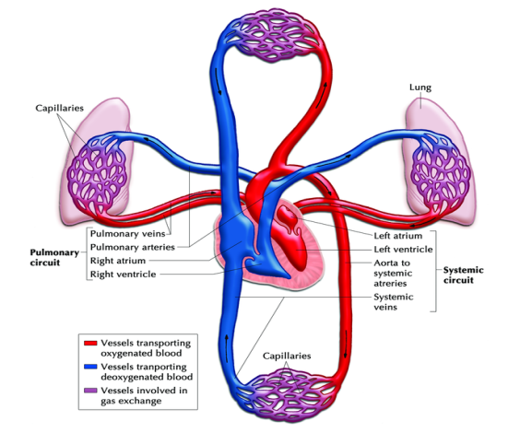
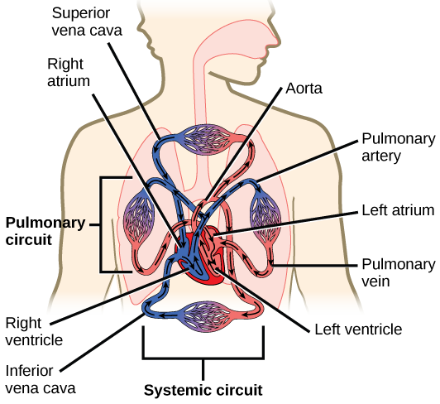
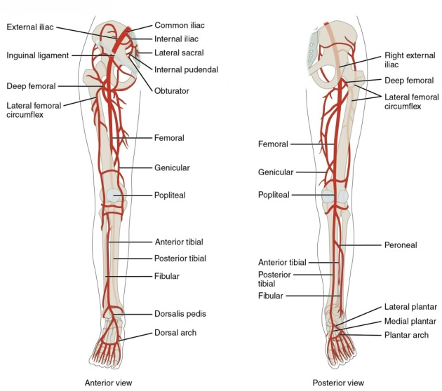
While the T and B cells are both parts of the immune system, the T cells are originated from thymus while the B cells are originated from bone marrow. While the B cells can attach to the foreign bodies on the exterior of the invading virus, the T cells can attach to the antigen on the outside of the antigens. The life span of the T cell is long while the B cells life span is quite short (Calcagni & Elenkov, 2006).
Spleen is situated under the ribcage in the left part of the abdomen. It works incorporation with the lymphatic system to protect the human body against any worn-out red blood cells and other foreign agents. While tonsils act as a filtering agent against any bacteria and virus that enters the body through the mouth (Doherty & Zinkernagel, 1974), these are located in the throat and helps in protecting the body against any foreign body that enters through the mouth.
The human body is made up of a complicated system. Each body organ is specified to perform a specific function. While each of them performs their function quite perfectly but at the same time, they coordinate with each other to carry out the task in a well-organized way. While there is always the thread that a foreign agent will attack the body, therefore, the immune system along with other system make sure that these foreign agents washed away from the body before any serious damage.

References
Calcagni, E., & Elenkov, I. (2006). Stress system activity, innate and T helper cytokines, and susceptibility to immune‐related diseases. Annals of the New York Academy of Sciences, 1069(1), 62-76.
Doherty, P. C., & Zinkernagel, R. M. (1974). T‐cell‐mediated immunopathology in viral infections. Immunological Reviews, 19(1), 89-120.
Lazuardi, L., Jenewein, B., Wolf, A. M., Pfister, G., Tzankov, A., & Grubeck‐Loebenstein, B. (2005). Age‐related loss of naive T cells and dysregulation of T‐cell/B‐cell interactions in human lymph nodes. Immunology, 114(1), 37-43.
Opletal, L., Sovova, M., Dittrich, M., Solich, P., Dvorak, J., Krátký, F., ... & Hofbauer, J. (1997). Phytotherapeutic aspects of diseases of the circulatory system. 6. Leuzea carthamoides (WILLD.) DC: the status of research and possible use of the taxon. Ceska a Slovenska farmacie: casopis Ceske farmaceuticke spolecnosti a Slovenske farmaceuticke spolecnosti, 46(6), 247-255.

