Name
Professor name
Subject
July 22, 2019
Managerial role
The presentation chose collaborative leadership style. A manager needs to be devising new directions for the team. In the given picture the bear is carrying its cub from grasses to plan road. It is guiding them on safe road towards the goal in an efficient manner. The picture conveys the themes of collaborative leadership style as the bear is guiding the cubs. In collaborative leadership style the manager takes the responsibility of building positive relationship with the employees. by developing best ideas of group the leader would manage to unite group and encourage them to collectively participate in the process of problem-solving. Another strength of collaborative leadership style is that the leader promotes team-work and motivate employees to work for the attainment of common goals. The picture transmits similar themes as the bear is focused on building a cooperating spirit.

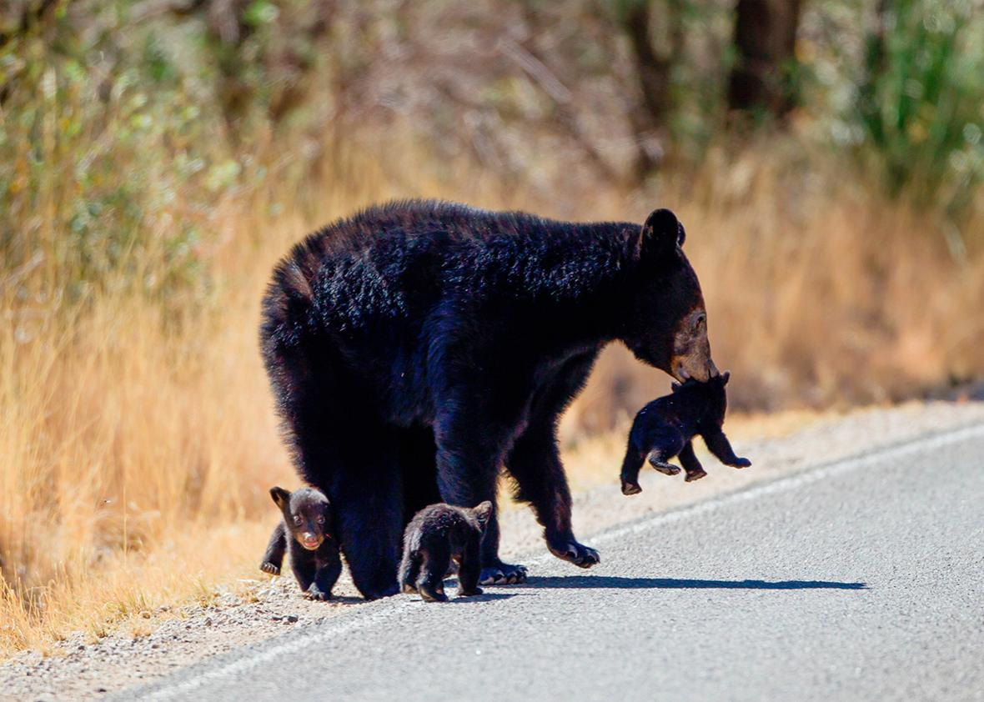
A collaborative leader is the one who can be trusted. In the picture the cat at the top has a strong trust on the one carrying it so it is climbing up confidently. A leader must build up confidence of his or her team through trust and honesty. The picture is the depiction of collaborative leadership and highlights the traits of manager required for such leadership style. The manager who adopts this leadership style must focus on providing support to the employees. He builds a corporative environment in which employees emphasize on finding solutions. The attributes of trust and honesty are required for collaborative leadership style. By building trust the manager can develop loyalty of employees towards organization. This will encourage them to work with dedication and honesty needed for attaining organizational goals.
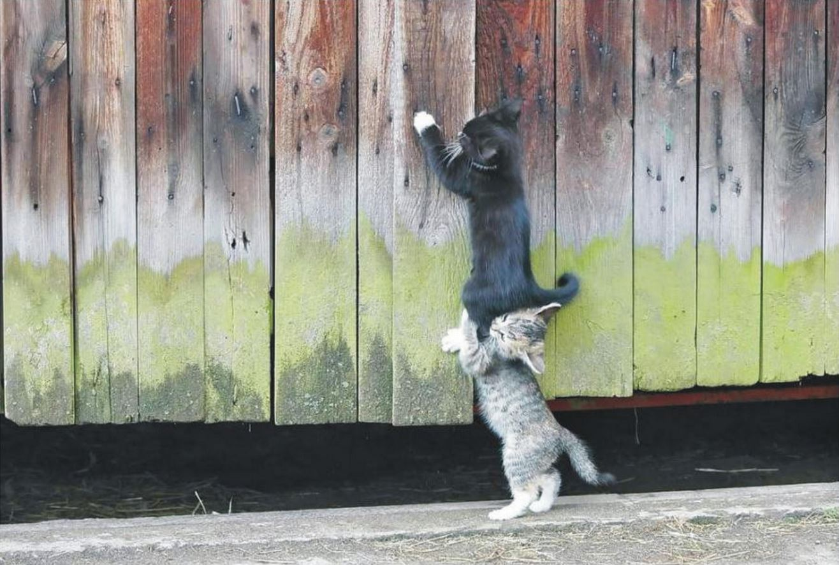
As we read in class about conviction in leadership so a collaborative leader is the one who involves everyone in the decision-making. Sharing of information should be open and problem are solved with collaborative effort. As the picture shows collaborative planning to get work done efficiently. The picture transmits the idea of sharing and team work. The manager taking the role of a collaborative leader emphasize on creating open environment that motivate every member to participate in discussions. The photo is the perfect illustration of group work as the bees are engaged in discussions for formulating strategy. Every team member can share their experiences and opinions that improves the decision-making process. Manager relying on a collaborative leadership style engage all employees for formulating the best work strategy. By involving employees in decision-making process the leader improves their loyalty and commitment.
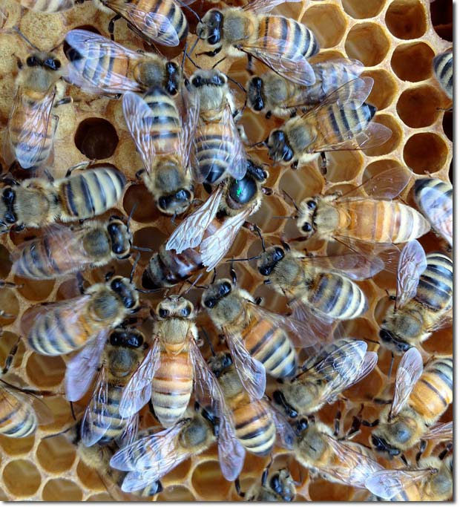
A good leader is the one who keeps balance by holding every one as a team and the subordinate should be equally valued. In the given picture the size of the stone differs but are managed in a way that balance is successfully maintained. So a leader should give equal importance to superior and subordinate to manage the balance in the organization. As our parents give equal importance to every children they got to maintain peace in the house. The picture sheds light on another attribute of collaborative leadership style that is equality. This also indicates that all employees are equally valued irrespective of their differences. It is important for the leader to offer equal work opportunities to the employees. By valuing employees equally the manager promotes positive feelings that enhance their level of commitment and dedication towards the firm. This is an effective strategy adopted by the leader for ensuring that the employees work together. This eliminates negative attitudes form the workplace such as discrimination, biasness and inequality.
A leader should understand the personality type of their team leader and should communicate effectively with them. The given pictures shows a hen covering up its chickens. Some of them are not fully covered and some are hiding completely so a leader must know who needs what amount of care and attention in a given situation. Communication remains one of the significant attribute of a collaborative leader because it allow manager to build positive relationship with the employees. Effective communications are important for transmitting information to the workers on time in appropriate manner. In the picture the leading bird is stressing on addressing the individual needs of the small chicks. This is the same strategy adopted by a collaborative leader for building continuous interaction with the workers. Open and continuous communications improve manager’s ability of understanding employees concerns. This is useful for overcoming negative behavior of workers.
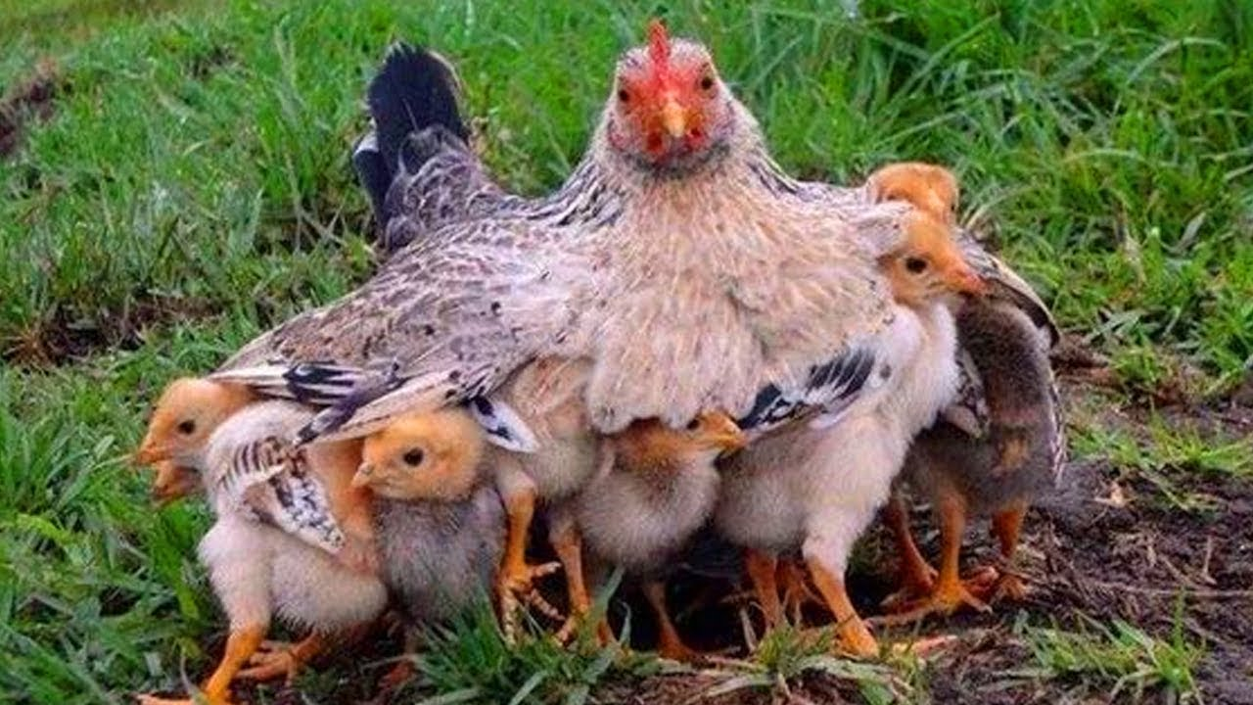

Allying every team member is a proper direction is a quality that every manager must have. The picture shows a pathway that starts from a smaller stone and it means that every tiny part of an organization plays a role to get to the final destination and must be focused to get a clear path. The picture has relevance with the collaborative leadership style because it portrays the leader’s role of providing guidance to the employees. The manager has the responsibility of setting direction for meeting organizational goals. By designing milestones he encourage employees to follow the path in right direction. This leadership style is used for convincing employees to achieve small milestones that lead to the accomplishment of big organizational goals. This reflects that without guidance the employees are unable to remain focused or achieve organizational goals. Direction motivate employees to remain focused.
A leader must be proactive and must be ready for challenges in the way of success. The pictures shows a clear path that is moving in the direction of the sun light. So a proactive leader must stay focus on the ways towards success and must keep its focus on the path of success. In collaborative leadership the manager must be capable of preparing the team to meet challenges. Every business involve uncertain circumstances so the leader has a responsibility of anticipating them and encouraging employees to adopt the right strategy for mitigating challenges. The picture portrays the role of proactive leader who takes action in advance for avoiding negative outcomes. This also reflects the need for adopting problem-solving attitudes. Manager who possess collaborative leadership style is capable of training employees to formulate solutions when they encounter unexpected situations. This improves the possibilities of attaining organizational success.
A good leader has the habits to solve judgments and fix the misunderstanding in a team. The given picture is a description of different ideas that are fixed to make a big clear picture. So a leader must be able to fix the issues to get a good result. The picture has relevance with the trait of fixing situations at workplace that is part of the collaborative leadership style. The manager must be able to unite members for using them for the benefit of the company. This required resolving conflicts and removing disputes between them. By settling the issues the manager encourage employees to focus on work and common goal. The picture also illustrates that the manager has a responsibility for removing misunderstandings that will add to the overall organizational efficiency. This leads to the attainment of positive outcomes such as organizational success. By resolving conflicts the tension is resolved among employees that enhances their efficiency.
As the given leaf cannot survive without any of its vein so maintaining a specialized team is must for the survival of an organization. A leader is the one who can properly delegate tasks to the employs and maintain a specialized team to get a unique product for the organization. The picture portrays the themes of forming specialized team that is capable of taking challenging roles. This indicates manager’s ability of using each employee for the best interest of the company. The leader under collaborative leadership must be able to use employees according to their specialized skills and competencies. This allow manager to attain organizational success. The picture also reflects the strategy of assigning tasks to employees according to their expertise and skills sets. Another theme apparent in the picture that links to collaborative leadership is uniting employees for achieving organizational goals. By assigning right jobs to the right people the chances of organizational success increase.
A leader is the one who is responsible to maintain positive attitude of the team leaders. The picture shows uniformity and light which is of positivity. The picture reveals the significance of uniformity that is prominent theme of collaborative leadership. It also indicates promotion of positive work culture that is attained by building positive attitude among employees. Positive attitudes that a manager emphasizes on include building flexibility, productive attitude and teamwork. By creating positive attitude among workers the leader also manages to eliminate negative attitudes that makes the workplace safe and progressive. The manager who adopts collaborative leadership style is focused on building team orientation. The picture also transmit the themes of collaboration and connectivity as all candles are burning to light. This reveals that a single candle can only produce limited light but more candles can generate huge light.

