Managerial Accounting
Name of the Writer
Name of the University

Managerial Accounting
Q1)
Variable Cost
According to the case study presented in the question regarding the Franks, the first type of costs they incur are variable costs. This comes in the shape of the cost of meals because as they take on more and more children as their business grows, they will have to spend more and more to feed the additional amount of children. This is directly in relation to the definition of variable costs, which are costs that go higher or lower on the basis of how much production output changes (Liu and Tiyagi, 2017).
Sunk Cost
In the case study, the cost of the old washer and dryer machine can be considered as sunk costs. The money spent on buying them cannot be retrieved but they are vital in future decision-making process regarding buying a new washer and dryer. The disadvantage of having a sunk cost is that if they keep increasing in number than the Franks will have problem finding investors in the future for their business if they ever want to expand (Connors, et al, 2015).
Fixed Costs
The cost of insurance and tax can both be called fixed costs. This is because no matter how much production or services does the Franks daycare provide the state will charge the same amount of tax and the insurance will also remain the same (English, et al, 2018). The only way that the insurance might increase is when there is a cause of multiple hazards within the Frank’s home.
Q2)
Relevant information
Relevant is all that information that lets a person or a company to decide whether investing in something is worth the hassle (McVay, et al, 2016). In the case of the Frank’s, they would have to consider the cost of buying the washer and dryer, the cost of delivery, the utility charge, cost of laundry products, the life of appliances (8 years) and the salvage value after 8 years. All these costs and information should be taken into consideration before buying the new washer and dryer.
Irrelevant Information
Irrelevant information has no room in the discussion regarding if a project is worth investing or not (Bahrami and Yuan, 2015). They can be a range of costs or just information that are not useful in the decision making process. For the case study involving the Frank’s all other information and costs such as meal costs, license cost, insurance cost and services cost are irrelevant in the decision process to determine if buying the new washer and dryer is the right option.
Q3)
Cost of Laundering clothes using Red Oak Laundry services
Pickup and Delivery Cost per year
$=\$624$
Total cost per year
$=\$624$
Calculations

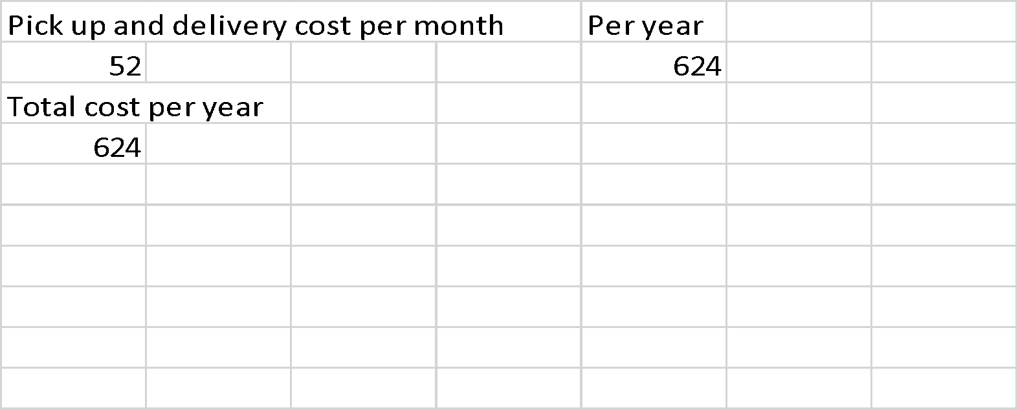

Cost of using the Laundromat Services
While calculating the cost of miles traveled the Laundromat, it is assumed that the Franks travel to the Laundromat two days in a week

Cost of miles traveled to the Laundromat per year
$=\$323$
Cost of laundering clothes per year
$=\$768$
Cost of laundry Supplies per year
$=\$$140
The total cost of using Laundromat services
$=\$1231$

Calculations

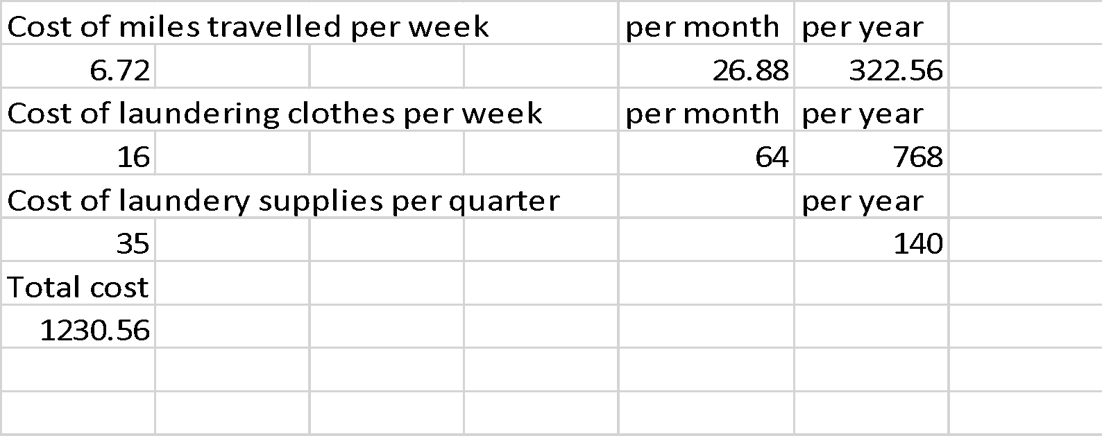

Cost of using their own washer and dryer
Cost of washer
$=\$420$
Cost of dryer
$=\$380$
Cost of delivery
$=\$35$
Cost of utility increase by Washer
$=\$120$
Cost of laundry Supplies per year
$=\$$140
Cost of utility increase by Dryer
$=\$145$
The total cost of using Washer and Dryer
$=\$1240$
Calculation

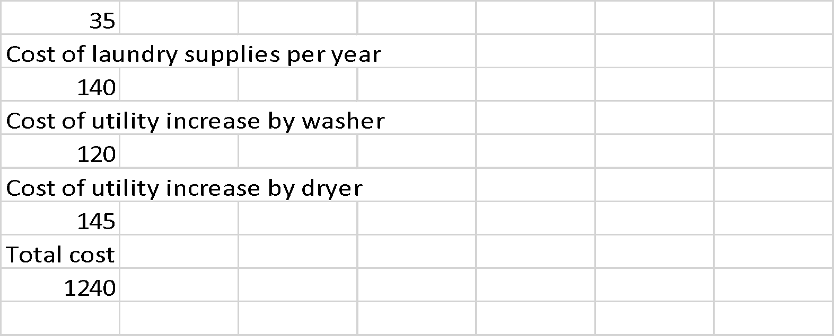

The cheapest option would be to use the Red and Oak Laundromat services but by buying their own washer and dryer they will be able to save yearly costs. This is because most of the cost calculated with a new dryer and washer is a one off and would not occur yearly.
Q4)
The profitability of employing an employee must be looked under all three option of laundry services as well because their use is vital as more children are introduced. With the addition of one employee, three more children can be admitted so they will also be added in the calculations.
Option 1
Using Red Oak Laundry services
The total cost of Red Oak services
$=\$624$
Cost of meal per child per year
$=\$9677$
Salary of new employee
$=\$17280$
Insurance cost
$=\$3840$
License cost
$=\$225$
Revenue earned
$=\$86400$
Total Profit/Loss
$\$54754$
Calculations
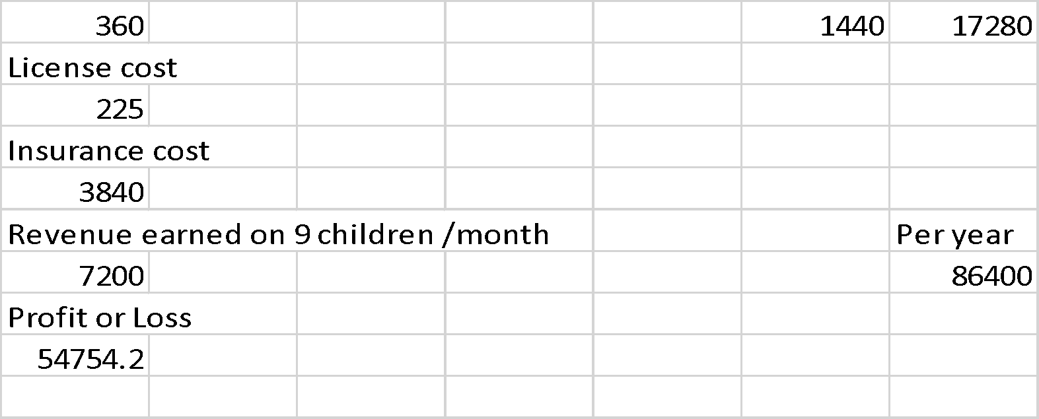
Option 2
Using Laundromat services
Cost of meals per child per year
$=\$9676$
Salary of new employee
$=\$17280$
Insurance cost
$=\$3840$
License cost
$=\$225$
Cost of Laundromat
$=\$1231$
Revenue earned
$=\$86400$
Total Profit or Loss
$=\$54148$
Calculations
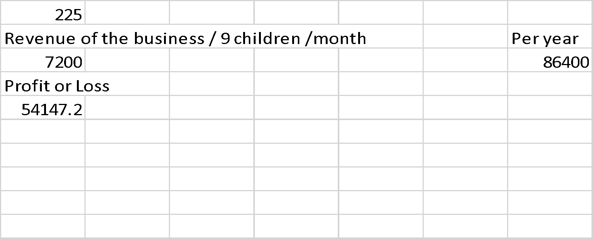
Option 3
Using own Washer and Dryer Cost of meals per child per year
$=\$9676$
Salary of new employee
$=\$17280$
Insurance cost
$=\$3840$
License cost
$=\$225$
Cost of Washer and Dryer
$=\$$1240
Revenue earned
$=\$86400$
Total Profit and Loss
$=\$54139$
Calculations
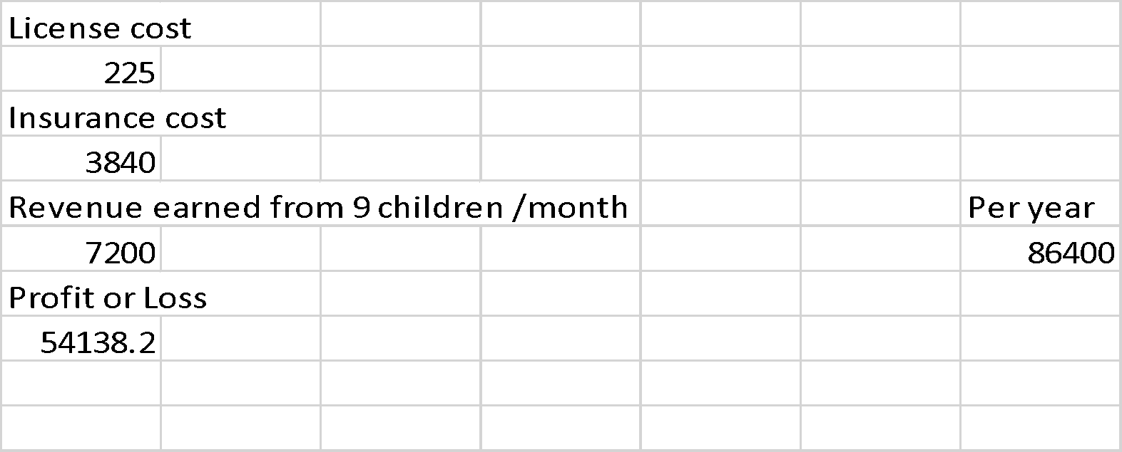
Q5)
Home and rented facility
Rented Facility
Rent
$=\$7800$
Utility cost
$=\$1500$
Insurance cost
$=\$5000$
Total cost
$=\$14300$
Calculations
House
Utilities cost
$=\$600$
Insurance cost
$=\$3840$
License cost
$=\$225$
Total cost
$=\$4665$

Calculations
We will add both scenarios two and three in the same calculations as they both are linked.
So, considering no new employee is hired than the original six children are catered for
Revenue earned
$=\$57600$
Cost of meals
$=\$6451.2$
Profit or Loss
$=\$51148.8$

Calculations
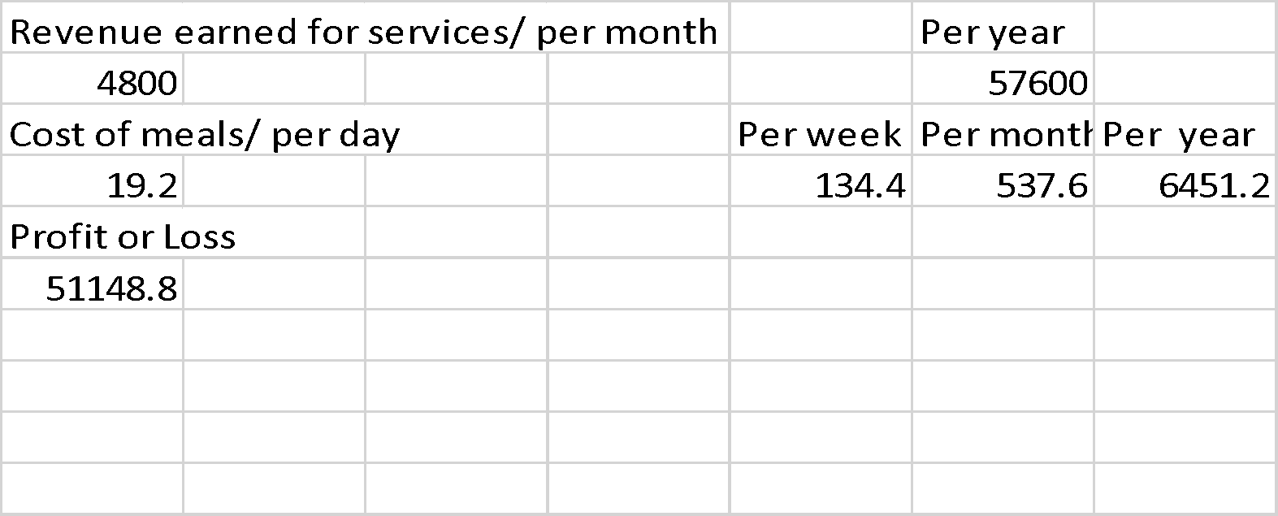
So, consider that one new employee is hired than the number of children increases to nine
Revenue earned
$=\$86400$
Cost of meals
$=\$9677$
Employee salary
$=\$17280$
Profit or Loss
$=\$59443$

Calculations
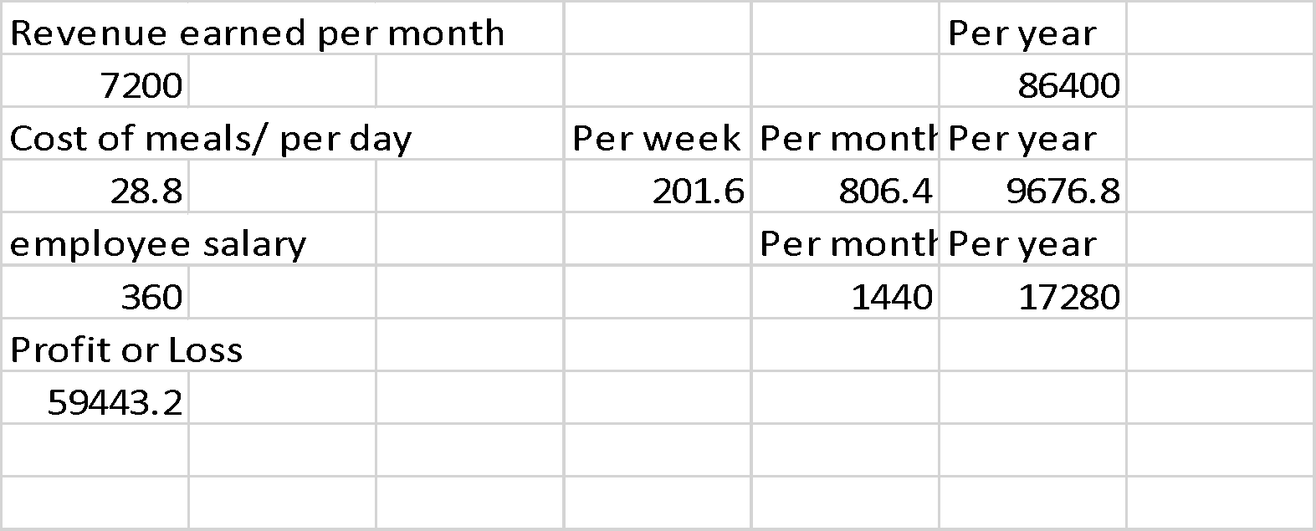
Two employees are hired, this will increase the number of children to twelve
Revenue earned
$=\$115200$
Cost of meals
$=\$12902$
Employee salary
$=\$34560$
Profit or Loss
$=\$67738$

Calculations
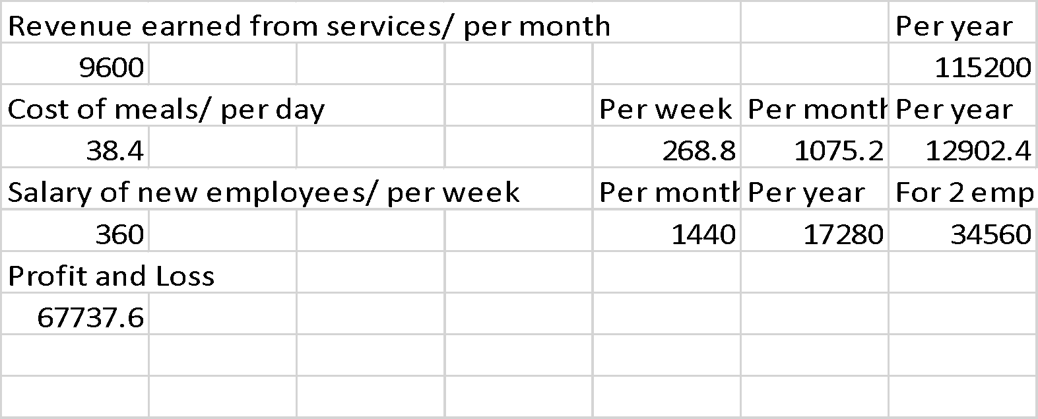
Lastly, three employees are hired and will increase the number of children to be taken care of to fourteen.
Revenue earned
$=\$134400$
Cost of meals
$=\$15052$
Employee salary
$=\$51840$
Profit or Loss
$=\$67508$

Calculations

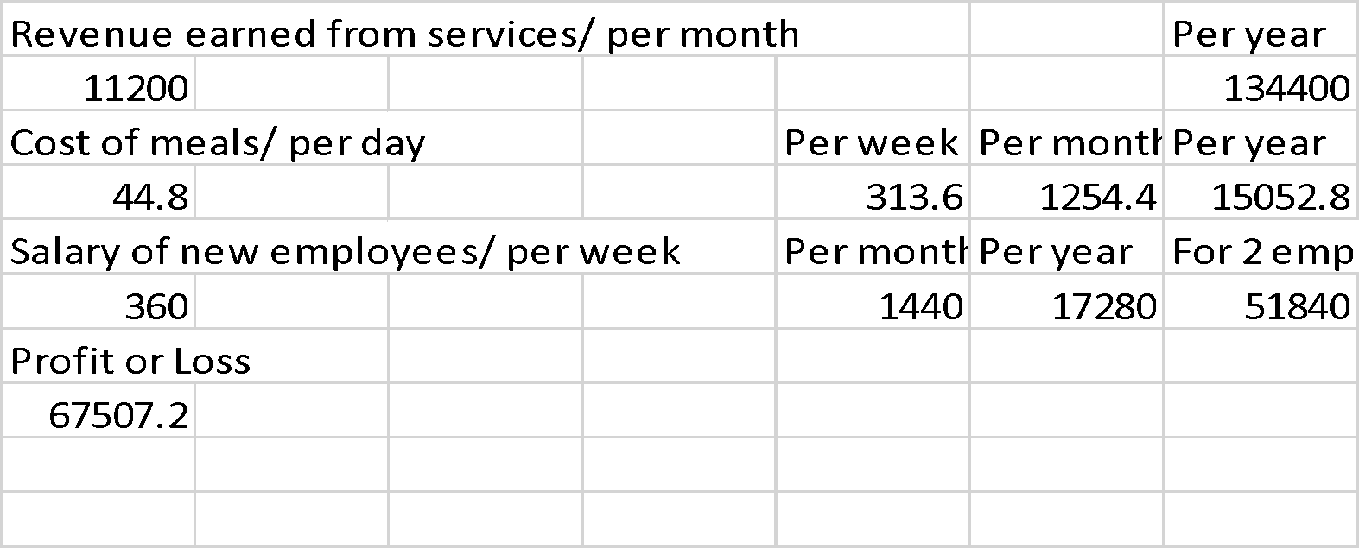
Part B: Journal Article Critique
Q1)
In order to resolve the problems that Apple and Canon were facing, they looked inward and used certain components of the management accounting system to find the solutions to their predicaments. For example in Apple’s case, it first two Apple computers were a success but apple 3 and Lisa were not. So they looked at the sales analyses of the previous two models and came up with reasons for their failure. They then used these reasons to make the Macintosh a success. On the other side, by looking inside their company’s management through the lens of a management performance report, Cannon was able to figure and clear out the gaps in between their management and employees and eventually was able to resolve this problem (Nonaka and Kenney, 1991).

Q2)
Progress needs innovation, without it, most individuals, societies, cultures, countries and even businesses will remain stagnant and never move forward. Take the case of Apple and Cannon, both companies were giants in their industry but were failing due barriers to innovation, mostly in their management structure. When one Cannon was able to fix this problem, they were able to rejuvenate and make an old product profitable. Whereas, the management in Apple only brought innovation in itself until they were shown the true potential of the product that Steve Jobs had created (Nonaka and Kenney, 1991).
Q3)
Firstly, a company should not always bound itself to numbers and figures to determine if its on the right track. This is because if they base their value on just some numbers there is always a high chance of losing great intellectual minds, that could have done great if they were given their space. Secondly, management should take their internal and external environment into consideration while moving forward or in making any decision. This gives them the freedom of being ready for any sort of problem that might arise within or outside the company. Lastly, innovation is key. As already discussed above if anyone in this world wants to move further in life they need to bring innovation to their lifestyle and work. This will help them to keep up with the changing times and keep them ahead of their competitors (Nonaka and Kenney, 1991).

References
Bahrami, A. and Yuan, J., Boeing Co, 2015. System and method of reduction of irrelevant information during search. U.S. Patent 9,146,969.
Connors, A., Conlon, D.E. and Moon, H., 2015. The role of sunk costs and project completion information in different decision environments. In Academy of Management Proceedings (Vol. 2015, No. 1, p. 12442). Briarcliff Manor, NY 10510: Academy of Management.
English, E., Herriges, J.A., Lupi, F., McConnell, K. and von Haefen, R.H., 2018. Fixed costs and recreation value. American Journal of Agricultural Economics.
McVay, G., Kennedy, F., and Fullerton, R., 2016. Accounting in the lean enterprise: providing simple, practical, and decision-relevant information. Productivity Press.
Nonaka, I. and Kenney, M. (1991). Towards a new theory of innovation management: A case study comparing Canon, Inc. and Apple Computer, Inc. Journal of Engineering and Technology Management, 8(1), pp.67-83.
Liu, Y. and Tyagi, R.K., 2017. Outsourcing to convert fixed costs into variable costs: A competitive analysis. International Journal of Research in Marketing, 34(1), pp.252-264.

