Lung Comparison
Author
Institutional Affiliations

Lung Comparison
Lungs are the major organs of the respiratory system and are responsible for the exchange of oxygen and carbon dioxide between body and the atmosphere. The lungs are pyramid shaped and connected with the trachea by left and right bronchi. The diaphragms border the lungs on the inferior surface and are placed at the base of the lungs. Both lungs are surrounded by pleural cavity which consists of two layers; visceral and parietal pleura. Both lungs are suspended over the mediastinum with the help of lung root. The medial surfaces of left and right lung lie within close proximity to various mediastinal structures such as heart, arch of aorta, thoracic aorta and oesophagus for the left lung and inferior vena, superior vena cava, azygous vein, heart and oesophagus for the right lung (Verschakelen & De Wever, 2018).
There is a difference between right and left lung in size and shape. The left lung is larger and narrower as compared to the right lung and occupies less volume than the right. The left lung has a cardiac notch as an indentation on the surface and provides space for the heart. The right lung has two bronchus while the left lung has single bronchi. Both lungs comprise of smaller units known as lobes which are separated from each other by fissures. The right lung has three lobes called as; superior, middle and inferior lobes. These lobes are separated from each other by two kinds of fissures; oblique and horizontal. The oblique fissure runs in a super posterior direction along the inferior border of the lung until the posterior border. The horizontal fissure runs along the sternum until it meets the oblique fissure. The left lung has two lobes called as; superior and inferior lobes and they are separated by oblique fissure (Walker, 2019).
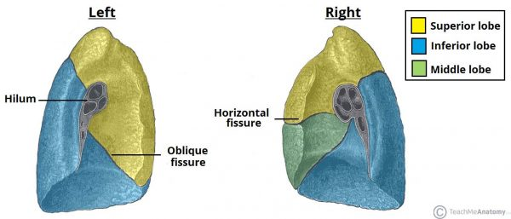
Figure 1: The lobes and fissures of the right and left lungs (Walker, 2019)

References
Verschakelen, J. A., & De Wever, W. (2018). Basic Anatomy and CT of the Normal Lung. In J. A. Verschakelen & W. De Wever (Eds.), Computed Tomography of the Lung: A Pattern Approach (pp. 3–19). https://doi.org/10.1007/978-3-642-39518-5_2
Walker, D. (2019). The Lungs. Retrieved December 4, 2019, from Teach Me Anatomy website: https://teachmeanatomy.info/thorax/organs/lungs/

