[Writer’s Name]
[Instructor’s Name]
[Course]
[Dated]

Analytical Essay
Lee Bul’s exhibition “City of Sun” presented Bul’s work. The Bul’s work I witnessed during the trip presented her painting and sculptures from the past nine years. In this particular exhibition whole of Lee’s work represented edifying and historical events. The whole theme of Lee’s work presented by SCAD Museum spun around the theme of perfection and the failures experienced by the mankind owing to its cultural exertions. I believe that Lee’s personal experience of modernization of 20th century was well presented in the exhibition through her artwork. Her sculptures represented the relationship between technology and humans. In one of her sculptures she used armature made up of steel, mirrored tiles, polyurethane sheets and acrylic paints. I think, this metal sculpture represents the human attempts to the development of the architecture. The picture of the sculpture is as follows.
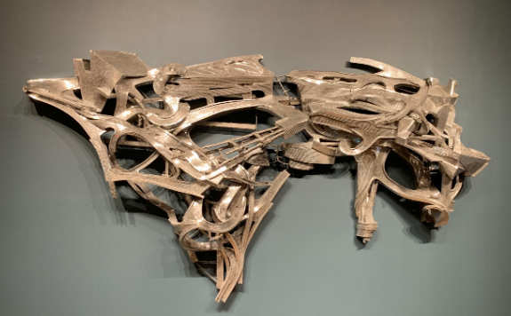
Lee Bul, Untitled Sculpture, 2014.

By looking at Lee’s art, I am of the view that she is inspired of utopian principles of architects. Albeit, through her sculptures she has exposed the failures of society concerning the efforts made to achieve the ideal of architecture.
Most of the Lee’s work I witnessed in the exhibition represented abstract 3-D design and she simplified the human qualities through her work. I witnessed an asymmetrical balance, harmony and continuity in her work. The metal sculpture which caught my eye had so many voids and was casted (Slobodkin). As far as the shape of the sculpture was concerned, this particular sculpture actually had a negative shape and actual color of the material was used in this particular sculpture (Slobodkin). Moreover, continuity can also be seen in Lee’s sculptures especially the one that caught my eye. For creating voids Lee used resorted to carving for subtraction of the material and she removed material systematically from the outside in to create voids.

Works Cited
Slobodkin, Louis. Sculpture: Principles and Practice. Courier Corporation, 1973.

