Environmental Issues
Name
Institution Affiliation
Date

ABSTRACT
For a more suitable future, Different tools and concepts have been developed. The development is done within different disciplines which are for different reasons. In this report, environmental issues have been defined broadly to include those affecting the consumption of energy, Emission of the greenhouse gases, the Carbon footprint and the change of climate with regards to the environment. This report contain brief description of tools of system analysis of the which include the analysis from how different bodies are supposed to be reacting to the environmental regulations. That is also going to include the assessment of the life cycle along with the cost benefit analysis so that some further insight is developed about the material intensity per unit service at the given point of time. This paper should discuss the different analytical methods. As such, we shall use one of the methods to discuss environmental issues.

Environmental issues are described as the harmful effects on the environment caused by human activities. There have been ideas that have arisen that support the management of the environment. The ideas discussed are on the way that will lead to sustainability. The tools discussed on environmental issues present a method that is systematic for measuring the environmental burden. The system tools of analysis lead to how this affect is going to be analyzed at the overall level.

1.1 Environmental Impact Assessment (EIA).
In different regulations, the EIA tool is required. Its main aim is the protection of the environment; this is done by deciding whether to grant the chance to for a project to plan by ensuring that there is local planning.

1.2 Strategic Environmental Assessment (SEA).
The SEA includes the how natural resources are going to be utilized and also the impact of the environment which makes it fit for the use of a strategic level. It also tends to impact how the decision making process is being carried out at the total level at the particular point of time. It is found out that SEA can be used for plans.

1.3 Positional Analysis (PA)
In relation to (Brorsson, 1995). General systems theory and Institutional economics are what PA is based on. looking at different aspects the system analysis is based on Interdisciplinary impact regarding how the environment is going to be affected. What is concluded probably different personnel are supposed to be deputed for this analysis at the particular point of time. Decision situations are made more transparent, Complexity and conflicting interests by the Strategic decision-support. (forms, 1995).
1.4Cost-benefit analysis (CBA)
CBA is a tool that is meant for decision situations. It is used in decision-support since neoclassical economics is what it is based on. This tool is used in calculations of cost and benefits in a project held in society. CBA converts monetary terms converted into monetary terms as an impact by valuation.

1.5Total Material Requirement (TMR)
This tool rhymes with the MIPS-analysis. It does not only focus on the produced services unit but it is also applied on a regional level. Aiming at dimerization, TMR tool may be used for decision-support and communication aiming at dematerialization. It is viewed that from the current activities results from major environmental, Of the environmental burdens, it can serve as a rough estimate. What may function as an indicator is measuring material intensity trends?
1.6 Ecological Footprint (EF).
For learning and communication purposes, EF is mainly used which would result in the overuse of productive sea and land as an indication of dependence. Now, the way EF works, it tends to introduce how the certain segment of the populace is going to be supported by the whole notion. The population that is defined for the given productive area and how it tends to exceed its supply that is going to be gained from the ecological footprint.
1.7 Risk Assessment (RA)
There are different ways that RA can be assessed. The source of risk may be specified in the focus of human health or environmental effects. Operational or Accidental is what the risk may be. (SETAC, 1997) RA extension is being done into the field of our surroundings. The rulings in the 12th amendment are quite clear with regards to how the field of the surroundings are supposed to be worked out at in terms of the data analysis. Some twelve problems were ranked by the Californian Environmental Protection. (SEPA 1996)
1.8Exergy analysis (EA)
The energy concept was introduced by Gibbs in 1873. Later in 1953, Rant suggested the term exergy, and The general definition was given by Baehr in 1965. (Kåberger, 1991). How much work can be performed is not a suitable measurement Energy. For example, different types of works and the creation of structures can be done by electrical energy, that the same amount of energy from heat can never manage. The energy that can be translated to work is Exergy. All the processes of work are where energy is consumed. (Kåberger, 1991).
1.9 Emergy Analysis (EA)
Energy is defined as the capacity for vigorous activity. In other words, it is defined as the ability of matter or radiation to do work. The incapability of doing some work brings us to its other definition. EA tool includes ecological services that are not considered in environmental assessments. Energy flow is covered by emergy. In many years, Energy is reported in many areas like fuels, and the services of humans. Material has both available energy and energy which makes them connected to each other. After explaining all the ESA tools used in the environmental analysis we discussed to use the LCA method required by law, this was because the tool is effective and makes decision making fast and easier. Though this happens to all tools LCA was the most effective
2.0 Life Cycle Assessment (LCA)
LCA, in other words, is referred to as analysis of life-cycle, Eco balance, and analysis of cradle-to-grave. During the 1970s energy crisis developments, methods for analyzing energy production were established. The development of LCA was established due to the influence of the energy crisis. Later LCA was extended, it included not all depletion of resources but also impacts of emissions waste produced other than energy production (UNEP, 1996)
During early studies Sweden, the United States and the United Kingdom (Tillman et al., 1997). People became interested in the LCA as a query on environmental problems increased this was in the 80s. Doubts lose about when an assessment was done where the same products and due to this some varied statements were witnessed. The development of the common methodology also started the same thing. The key thing that has to be noted here is that the method is still under development and the ISO standards for this legislation are still needed to be worked out specially in terms of the way standardization and harmonization is needed to be carried out. During LCA existence it has tried to cover potential environmental impacts. This includes the use of energy waste release and extraction of raw material, as well as its transportation
The aim of the assessment is to understand the role of LCA in environmental analyses. The study is aimed at discussing the relevant environmental issue as such some of these methods were considered for the study
EIA was considered for study but didn’t match. As a result of the situation analyzed, it was deliberate than on the level of the project. We considered using SEA which seemed to be the most appropriate. As described SEA refers to a parallel decision process, contributing to a particular process. As such this system could not be used in this paper. The second reason was due to many changes that were made to the tool due to the lack of proper guidelines. After close consideration of all these tools, we decided to use LCA with is relevant to our analysis. The main reason being the tool broad in scope and it is well known. The analysis was a short time do hence PA analytic system could not be used since it is so broad. It caves all aspects than the environment hence no enough time to cover the tool. The role of the CBA in the given case also did not turned out to be same. The tools that are being used to estimate the overall effect are done in the manner that the material support and the manner of the heat production are made the part of the whole thing. The exergy is the only energy analysis that is tried out. RA is a tool for analyzing chemicals and could not be used in this case.
LCA calculations
Goal and scope
The aim of the study is to show the different ways of using LCA to come up with a database of the effect of the environment. 1MJ is heat production is the functional unit of LCA. This study is intended for the reader who will be making a decision in the future on the environment. Most of the tables and calculations were not included in our research.
Characterization and Valuation
This was the fast study were the weighting method was used since its development (Johansson, 1999). It is based on the valuation of the environmental taxes and fees of Sweden. The methodology used includes factors that are one-step weighting and inventory tables with figures that are multiplied directly with factors containing valuation and characterization. Johansson obtained this factor by use of different characterization methods and combining them with modified taxes and fees that are relevant. To start with there are a number of environment issue and this thesis shall discuses most of them' an how they are analyzed and valued
1 Abiotic resource
To start with, energy use was not common during entry of inventory data, as a result, for nuclear input of power which was to be larger and pre-combustion activities to take a larger percentage of other fuel. For this category impact, characterization methods are used. Finnveden and Östlund (1997) methods were based on the carriers of energy and materials. By this way, their energy is assumed to have the energy of the same content as the one inventory, On a more realistic manner, the energy constraints in this case that are produced to be witnessed on the higher side and have little effect on the result.

Valuation is made from maximum and minimum energy taxes. Since most resource data in the study are energy carriers, more relevant than the other tax suggested on natural gravel extraction tax. There is another method that is based on the demand and balance for resources as suggested by Guinée and Heijungs (1995. Comparison among substances is from the use of Yearly extraction and the ultimate reserve. Any antibiotic resources are considered since no suitable factors for biofuels were given. Tax on fossil gas and tax on coal are used for the one-step weighting factors.
2 Global Warming
The potentials of global warming for all gases are converted into CO2-equivalents as characterized by IPCC (1995). Values 58for 20, 100 and 500 years are utilized which is as a result of GWPs changing over time. Global warming in households is valued by the tax on CO2 emissions.
3 Depletion of stratospheric ozone

The substance that is going to be used in this case is going to be composed of the nitrogen and would be predominantly made of the independent exemption fee that are depleting the layer of the ozone. The effect of the gases in this case turns out to be insignificant in terms of the fee witnessed by it.

4 Photo-oxidant formations
The other thing that is quite important in the given instance is that how the two characterization methods are used to photo oxidant formation. Ozone concentration is where it is calculated that characterized based on the factors on the respective contribution to the formation. The POCP is then presented in the form of the ethene equivalents. The method first time around was suggested and how the presentation of ethane equivalent and how the different ways of the PCOP’s.

These are the maximum formation of zone that is studied by the substance average formation during the average formation. The important consideration is that how the four days are going to be witnessed and the way calculation in terms of the way whole thing was excluded in terms of how the NVMOC. These two are the methods of the combined perspective are witnessed and how the exemption for the higher level of benzene in petrol is going to be accounted. The apparent likelihood of cancer contraction is another element that has to be accounted for.

6 Ecotoxicological effects
Jolliet and Crettaz (1997) developed the method characterized in this section which was based on No Effect Concentrations. Toxic emissions are considered toxic when they specially if there is a case that they are reaching a certain level at the given point of time. . As such polluted volume and concentration are considered as linear. Emissions to water are known as Aquatic Ecotoxicity potentials (AEPs) as they are valued in terms of how the taxation of the general pesticides are witnessed and how they are used in copper and how the air emission is witnessed at the maximum level at the minimum and maximum level. It becomes all the more important if there is high content of lead that is deposited into the stands at the particular point.

7 Human health
Human health is not considered in the valuation weighting system reasons being no taxes for non –toxicological impacts on human's health as well as any working effects on the environment. Toxicological effects on humans are characterization by two methods. One of the methodologies used was that of Jolliet and Crettaz (1997) which is named under Ecotoxicological effects. Calculation of Human toxicity potentials is acquired through the calculation of a fraction of toxin consumed by humans in relation to substance non-toxic dosage. Benzene and lead taxes are combined with HTP emissions using the one-step weighting system. The emissions are later combined with water and the tax used in copper.The Environmental Defense Fund, EDF (1999), come up with the second method which has developed toxicity equivalence potentials (TEPs) that I based on the fraction of human consuming a certain amount of substance that has been emitted. The TEPs impacts are divided into non-cancer and cancer effects. Carcinogenic emissions in the air are valued with the taxes on lead and benzene and well also the pesticide tax used on cyanazine.
8 waste
a weighting factor that will come to use in 1999 is was to determine the tax value os waste. However, the tax is no characterized hence was not used in the study
. Combining values
A large number of results are gained after weighing the different outputs and inputs under their respective categories. More than one weighing process excluding the selected has been used so as to get more comprehensible results. It is always subjective on deciding on the weighing method to use.
Results
A number of results are gained after analyzing the figures of the result.However, no direct conclusion should be made because the analysis is not complete. The discussion made was based on the resulting figures and was used to make the final conclusion. Minimum values comparison of fuels impact on the environment impact shows a great difference between biofuels, waste, and fossil. The final minimum value of the impacts of global warming is contributed by impacts of NOx. Waste is classified into two categories which are dominating.Global warming results in Fossil gas, ending on the highest minimum value.

Application with QSR Code
QR Codes are two-dimensional barcodes that can be read with mobile devices. The easiest way to get a QR Code is to use an online QR Code generator. There you simply enter the data you want to encode and generate the Code right away. Let us explain how to make a QR Code in three easy steps with our free QR Code Generator:

- Choose the QR Code type: for example, use a URL Code for encoding a link to a Web page of your choice.
- Enter the information: in this case, the link that will be displayed after scanning the Code.
- Generate the Code: press the Create QR Code button. Your Code is now ready for download.

Traditionally, QR Codes have been used to encode a Web address. However, instead of creating a QR Code for a website, you can apply it for a variety of other functions: from forwarding to an app store to displaying a Facebook "Like" button. This opens up endless possibilities. For example, make a QR Code with your contact details and place it on a business card or a website. Or link to an image gallery featuring your product. Users are more likely to scan a QR Code if it has unusual and interesting content. QR Codes can be placed anywhere: from product packaging to outdoor billboards. In order to achieve the best quality in printing and make your Code scannable, the image file has to be high­-resolution. Also, depending on how you want to use the created QR Code, you will need appropriate file formats. With QR Code Generator PRO, you are able not only to make a QR Code, but also to download it in four image file formats: JPG, PNG, SVG and EPS.

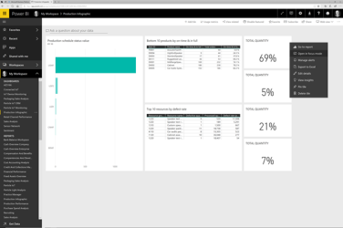

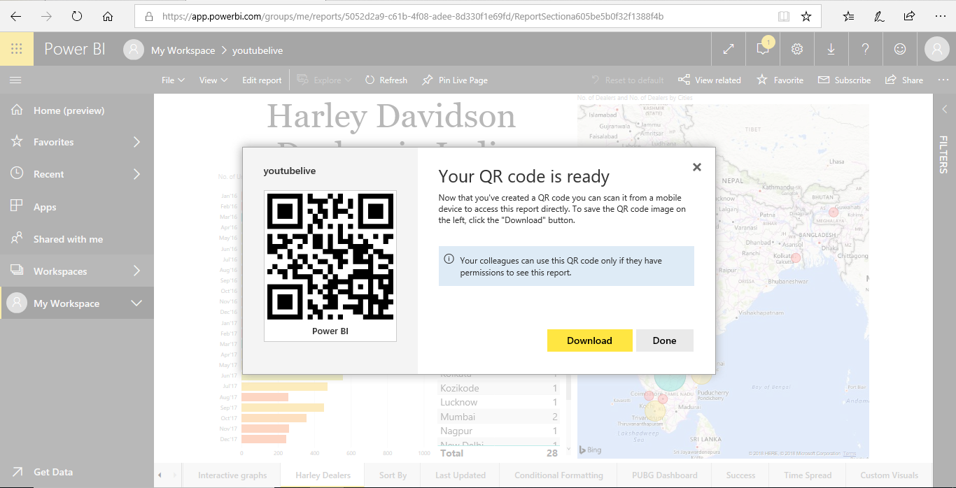

Recommendations
EPA should cooperate closely with agencies, organizations, municipalities, universities, and industries involved in environmental research. In addition to providing research support, mechanisms for cooperation might include participation of EPA management in interagency coordination efforts, participation of staff in scientific meetings and conferences, and incentives and rewards for individuals who seek out and work with their counterparts in other organizations. Collaboration should be maintained in research endeavors, environmental monitoring, data archiving, and environmental policy formulation and evaluation.

Conclusion
In conclusion, most of the calculations were not shown in the paper this was because the paper was a simple illustration of how the analytical tool is used to in environmental analysis. In addition, environmental tools cannot be used to cover all environmental fields in a sensible way. Neither will it ever be possible to provide decision-makers with one true answer. The purpose of guidance and scanning is served by the tools of the systems of the environment. The goal would not be presenting one single figure. Data handling, terminology, development, combining tools and harmonization of terminology would be facilitated by the Integration of concepts and tools. Cooperation and complementation is the solution here as in so many other situations. In addition, most of the analysis methods in use don’t give proper data on the environmental issues hence not effective for use in future analysis, We should consider other analytical methods that more efficient
Bibliography

[1] The´rivel R, Partida's MR. The practice of strategic environmental assessment. London: Earthscan Publications Limited; 1996.
[2] SETAC-Europe Working Group on Conceptually Related Programmes, 1997. Life Cycle Assessment and Conceptually Related Programmes. Report for SETAC-Europe, Brussels.
[3] Kåberger T., 1991. Att beskriva resurshantering. Descriptions of resource management.
Chalmers Tekniska Högskola, Institutionen för Fysisk Resursteori, Göteborg
[4] SEPA, Swedish Environmental Protection Agency, 1996. Risk Assessment - Health - Environment. Report 4595, Swedish Environmental Protection Agency.
[5]Wackernagel et al., 1997. Ecological footprints of nations. Available from http://www.ecouncil.ac.cr/rio/focus/report/english/footprint, (accessed 30 March 1999).
[6] Wackernagel M. and Yount D., 1998. Footprints for sustainability: The next steps. Draft. 83 Wall Göran, 1993. Exergy, ekologi och demokrati. Redskap I ett [7]kretsloppssamhälle. Forskningsrapport TULSA 1994:20, Tekniska högskolan I Luleå. WRI, World Resource Institute, 1997. Resource flows The material basis of industrial economies. World Resource Institute, USA.
[8] Wuppertal Institute, 1999. MIPS online. Available from http://www.wupperinst.org/Projekte/mipsonline, (accessed 1 February 1999).
[9] Zetterberg L. and Hansén O., 1998. Nettoemissioner av koldioxid till atmosfären vid användning av hyggesrester för el- och värmeproduktion. IVL rapport B 1298, Institutionen för vatten- och luftvårdsforskning, Stockholm.
[10]Tillman, A-M., Kärrman, E. and Nilsson, J., 1997. Comparison of Environmental Impact Assessment, Life Cycle Assessment, and Sustainable Development Records. At the general level and based on case studies of wastewater systems. Report from the ECO-GUIDE project. Technical Environmental Planning, Chalmers University of Technology, Göteborg.
[11]Turner R.K., Pearce D., and Bateman I., 1994. Environmental Economics. An elementary introduction. Harvester Wheatsheaf, Hertfordshire, UK, 93-105.
UNEP Industry and Environment, 1996. Life Cycle Assessment: what it is and how to do it. United Nations Publication Sales No. 9C-III-D.2, Paris.
[12]Vattenfall, 1996. Livscykelanalys för Vattenfalls production. Sammanfattande rapport. Vattenfall AB, Stockholm.
[13]Wackernagel M. and Rees W., 1996. Our Ecological Footprint. Reducing human impact on the earth. New Society Publishers, B.C. Canada.

"Defining Life Cycle Assessment (LCA)." US Environmental Protection Agency. 17 October 2010. Web.

