Your Name
Instructor Name
Course Number
Date
Advertisement Analysis
Introduction
In this current era of tough competition, every business needs to manage its operations very tactfully in order to run the business. These steps are not only necessary for the survival of the company by also for capturing the maximum market share and earning the utmost profit. Companies use various strategies in order to achieve these goals; advertisement is among the top of them. Organizations use various mediums for advertising their products and services. These may be print, Broadcast, outdoor media, or internet (mostly social media) (Eberl et al.).

Discussion
The ad that is under discussion for this piece of writing is the print ad for a shampoo manufactured under the brand name of Garnier Fructis. This brand is famous all over the world for its skincare and healthcare products. This specific ad is about Garnier Fructis Pure Clean Fortifying Shampoo.
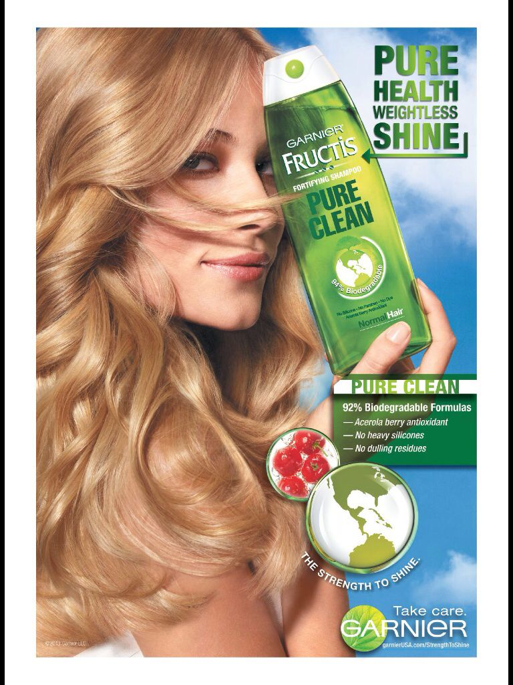
Target Audience
The target audience of this advertisement are young women, especially ranging from the ages of 12 to 40 years. The marital status, nationality, color, religion or caste of these females do not matter as all females love to take care of their hair. As this ad is about a hair care product, the main focus of it is on the growth and strengthening of the hair.

Pathos
The advertisement under discussion conveys a strong emotional message to the target audience. The image used for this advertisement contains the picture of a female model hardly in her late 20s, with flawless skin and smooth, silky, shiny blonde hair. The model is holding a bottle of Garnier Fructis Pure Clean Shampoo in her hand. The advertisers clearly know what every female wants hence they have portrayed the very things in their advertisement. To top that, the ad contains the statement “Pure Health, Weightless Shine”
All these graphics contain a strong emotional appeal for the audience and attract the customers, especially the target audience.

Ethos
The print ad for Garnier Fructis Pure Clean Shampoo conveys a clear ethical message (ethos) to the audience. The ad has clearly mentioned in plain words that this product is “pure Clean”. These words are followed by the message “92% Biodegradable Formula” “Acerola Berry Antioxidant” “No Heavy Silicones” “No Dulling Residues”, and then the ad contains an image of a sphere showing the globe. This shows a deep message that the producers seriously care about the planet, which is why the product is completely ecofriendly.

Logos
The advertisers have also used the logical appeal (logos) in the print advertisement very intelligently. The image contains the words “Pure Clean” in bold letters; one may consider the meaning of these two messages in shampoo ad that it will clean the scalp and the hair very efficiently, but this is not all. These two letters convey a much deeper meaning and indicate that this product is made up of bio-degradable ingredients, hence, its production and usage are completely safe for our planet.

Conclusion
Thus, it can be clearly seen that advertisement carries great value for any business, irrespective of the type of industry. Undoubtedly the main thing that has to be kept in mind is, the target audience and their preferences. Innovative advertisement techniques can help greatly in the achievement of the desired results. Another thing that has to be kept in mind is the careful and intelligent use of logos, ethos, and pathos. A finest example of this can be seen in the case of an ad posted in Cosmopolitan magazine by Garnier Fructis for the promotion of its shampoo.

Works Cited:
Eberl, Jakob-Moritz, et al. “One Bias Fits All? Three Types of Media Bias and Their Effects on Party Preferences.” Communication Research, vol. 44, no. 8, 2017, pp. 1125–48.

