[Name of the Writer]
[Name of Instructor]
[Subject]
[Date]
Hercules upholding the Heavens
Introduction
The legend of Hercules, no less than a super hero for Greeks and a semi form of God. He was a man having multiple qualities at that time. He was famous for his strength and his capabilities towards the empathetic feeling for mankind and was willing to bring the change on the humanitarian grounds. It was considered that he was a god in the form of human beings as he was half mortal and half of the immortal. He was also famous for being the son of Zeus who was also the God for the Romans. The role of Hercules is always remembered as one of the major heroes in the history of the world because of his unusual characteristics which were contradictory in various aspects. He was also famous for his adventures.
Similar to that of the adventures, he was also famous for his good deeds that he did by getting carried away for others as he wanted that the other people should live a life on which they may feel contented. The contentedness on the face of other people gave him the utmost happiness that he wanted to achieve throughout his time. Due to his brave soul and beyond imagination characteristics he was always famous for his attributes. His fame was always observed form the childhood due to which many of the leading artists during the era of renaissance and many of the artists who were really fond of his amazing characteristics and beyond imagination abilities that made him still alive in the eyes of people. There are many of his painting and sculptures that are kept in the various museums all across the world and all these sculptures and paintings are directly or indirectly linked with the Greek Mythology.
Discussion
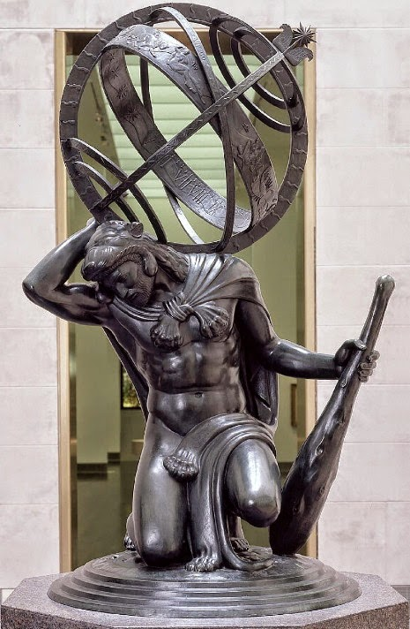
The historic sculpture of the Hercules placed in the Museum of Fine Arts in Houston has the biggest impact in the history. The historic sculpture refers to the typical myth of Hercules where he was holding the heaven right on his head.

This image has the deepest roots entitled with the ancient Greek mythology which has played a significant role in the history ("Hercules Upholding The Heavens" (Paul Manship),2019) . The concept of heaven was defined when he killed his own six sons after the Queen Hera who was the God or the Goddess of that era made him all crazy by fabricating various storied out of jealousy and urged him to commit various criminal activities which were contradicting towards the personality of the Hercules and he was well aware that out of all these activities that these will generate a negative impact on the people of that era and they will be left in the middle of nowhere. At that time the only possible way for him to seek the help was to take from the Oracle of Delphi. He suggested him that only refuge he can seek from this entire situation was to be the servant of the King Eurystheus. This can help him out in all the ways (Safran,2005). By being his servant it was the obligation for Hercules to follow all the rule are regulation and fulfill all his orders as per the expectations of the king. In the ancient Greek mythology all these tasks that were followed by him were known as the Twelve Labors of Hercules and till date all these tasks are remembered by the people who are the staunch believers of the Hercules. There were various tasks that were assigned to Hercules in this entire period of time which were supposed to be followed at that time. All these tasks were to be done by Hercules on his own but all he was able to do was to take help was from the Atlas who was all there supporting him.
If we have a deep look at this historic piece of art, the typical image of Hercules as it was interpreted by the historians, can be seen in it. It was made up of all bronze. Hercules wears his mark lion skin shroud, and holds his huge, wooden club in his left hand. The lion skin shroud still has the head and paws with hooks appended. The front paws are tied around Hercules' neck, bound together with thick rope; or a standard, metal fasten. The lion's back paws covering Hercules' genitalia. Else, he is totally bare, as most Classical figures may be. The craftsman, in his execution of the piece in the mid twentieth century, conveys that Classical perspective to this work in reverence to the Classical artists of the early long stretches of workmanship history (Nielsen, Riley, &Silver, 2017).
By looking at the sculpture made by the artist, in my opinion it was truly depicting the burden and the cost of all the labors that he was carrying right on his head as a way to get rid of all those allegations that were imposed on him and get back towards the life of the righteous path.
Conclusion
The effect of the art work depicted by the artist by making the most unique sculpture of the Hercules was showing their beyond imagination creative skills that have a creative look on the sculpture that shows the burden as well as the affiliation of the mythology that can always give a reminder to the people about the hardships and sufferings and adventures that have been done by the greatest hero of all the times and the other reason was to give that awareness to the people to believe in the past and all the causes that have been linked with the mythology do exist and this can be a lesson for everyone.

Work Cited
Nielsen, Christina, Casey Riley, and Nathaniel Silver. Isabella Stewart Gardner Museum: A Guide. Yale University Press, 2017.
"North America/Sculpture: "Hercules Upholding The Heavens" (Paul Manship)." Mfahouston.blogspot.com. N. p., 2019. Web. 30 Jan. 2019.
Safran, Meredith E. "Re-conceiving Hercules: Divine Paternity and Christian Anxiety in Hercules (2005)." Classical Myth on Screen. Palgrave Macmillan, New York, 2015. 133-145.

