Author’s name
Instructor Name
Art 101
19 November 2018

Research Essay: Walt Disney

The world-renowned animation company was found by Walt Disney and his brother, Roy on the 16th of October 1923 in Hollywood, California. In essence, the company functioned by the name of Disney Brothers Cartoon studio, as a Cartoon studio which introduced many new functionalities over time. The company expanded over time and had a huge impact on the entertainment industry and is now one of the biggest media organizations in the world.

History

Walt Disney who was a very talented artist from his early days. He drew cartoons for various other groups and studios and became a pioneer in cartoon animation while working with a Kansas based Ad Company. The founder of Walt Disney Company, Walter Disney, initiated a company by the name of Laugh-O-Gram Studio which went bankrupt in 1923 and caused the founder to move to Los Angeles. In Los Angeles, the co-founder of the company and his brother, Roy was recovering from tuberculosis. After he travelled to Los Angeles, he sold a movie by the name of Alice’s Wonderland that was produced by Laugh-O-Gram. Disney did not expect the movie to be popular as the quality was still not up to the mark in terms of entertainment, but surprisingly so, it became a hit with the local cinemas. He also signed a contract to make six more films of this kind. After the successful sale of their first film, the brothers decided to make the complete series and thus, found their new company by the name of Disney Brothers Cartoon Studio in Hollywood. In 1927, Disney began his first series of fully animated films within the banner of Disney brothers cartoon productions featuring the character Oswald, the lucky rabbit. This was the first official creation of the company but it was overshadowed by the copyrights claim of his distributor. Disney then altered his appearance to make a new character by the name of Mickey Mouse. The company produced two fully animated films based on this character by the name of Plane Crazy and Gallopin Gaucho (“Disney Company | History & Films”). Both of these films were released in 1928 and turned the character into somewhat a star. These two films were very popular, but were silent movies. The third Disney film based on the same character by the name of Steamboat Willie, was released later that year and the feature of voice was added into the film. This third film was an instant sensation amongst the audience and this film led the era of the dominance of the studio’s dominance over the next several years.
Later, the company started to produce feature films and was inspired by the success it was able to achieve after the popularity of its third animated film. The first feature film made by the company earned more than 400 percent over the budget that was used to make the film. This feature film by the name of Snow White and the Seven Dwarfs was an overwhelming hit when it came to cinemas in the last month of 1937 (Editors, “Disney Releases Snow White and the Seven Dwarfs”) . From that time onwards, the company has directed and produced hundreds of very popular films. The company has, since then, evolved into a trademark company for all aspects of media and entertainment industry. It has been involved in the opening of theme parks across the world that begun in 1955 and it has been able to take over a number of companies in the process as well. Some big names include ABC, Pixar, ESPN, and LucasFilm (Editors, “Walt Disney Company Is Founded”). The company is one of the best examples of a journey from very humble beginnings and has turned itself into one of the most lucrative brands of its time and it still remains, after almost a century of its initiation, one of the biggest names in the entertainment industry.

Competitor Analysis
Over the years, the company has seen a large number of competitors emerging in the market. The company has seen the rise and fall of many enterprises and it has been able to maintain its position of being the global market leader for almost a century. At this moment in time, the company is worth $69.6 billion with its closest competitor being less than a quarter of its worth. The major competitor in the animation industry for Walt Disney is CBS which stands at a net worth of $15.3 billion. The list of competitors fighting for the market include Viacom, Warner Bros, and Sony productions. All of these companies hold their trademark in different parts of the world producing a number of successful animations as well but none of them good enough to take the market lead spot from Walt Disney.

Operations by Region
The company has expanded over the years to several continents with their services and has been able to diversify its services while maintaining the position of the market leader. The main revenue of the company is still being generated in the United States of America, however, the presence of the company has gradually grown in Latin America and Europe as well. One factor that plays a very big part in the success of the company is its online presence. The marketing department of the company is so strong that it enables the content to become popular where the physical presence of the company is close to none. The use of social media along with the traditional means of communication has caused the company to earn large sums of revenue over the years.
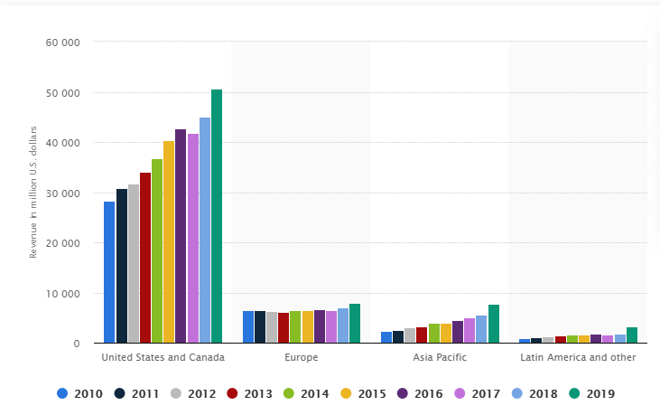
Figure 1-Walt Disney revenue per region

As we can see from the visualization above, the revenue that is being earned by the company is constantly improving in other continents as well. The last year has proven to be a very fruitful year in terms of revenue, especially in Asia Pacific and Latin America.
In terms of employees, the company has a total of 223,000 employees generating a revenue of $59.5 billion. In terms of the variation of employees with the number of years, the company had a total of 195,000 employees in 2016 which was a 5.41% increase from the previous year. In 2017, the number increased to 199,000, which was a 2.05% increase from last year. A similar trend followed the next year when a 1.01% increase was seen in the total number of employees and the total number soared past 200,000. The year 2019 proved to be a very fruitful year as the revenue increased both in the United States as well as abroad. This caused a considerable increase in the number of employees as well. The number increased to 223,000 with an increase of 5.41% from last year.
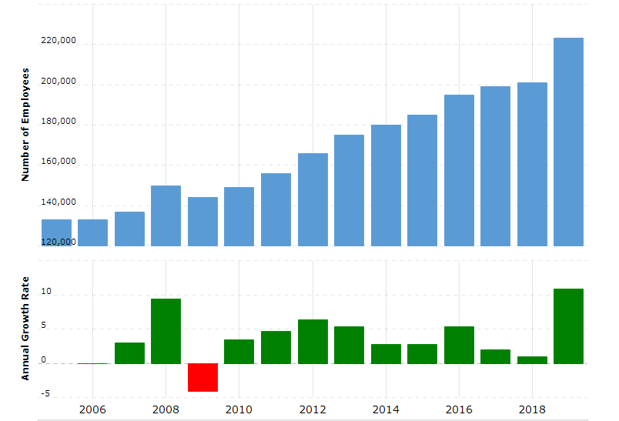
Figure 2- Data visualization of growth and employees over time.
This has caused the company to maintain the lead as a media giant as well as swell the revenues of the company to an all-time high. The growth rate in the last year has also proved to be very high. The regional distribution for the revenue generation of the Walt Disney can be shown by using a pie chart in which all of the regional portions of the company are shown.
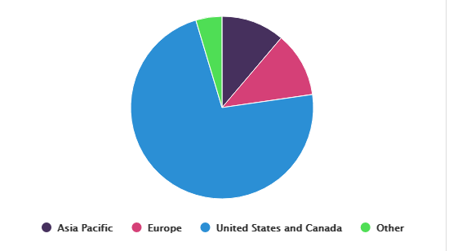
As we can see from the pie chart, the majority of the revenue has been generated by the North American subcontinent. This is why majority of employees in the company belong to the American peninsula. The company has a variety of services that it is providing; the revenue as generated by each segment can also be fully understood with the help of a pie chart visualization.
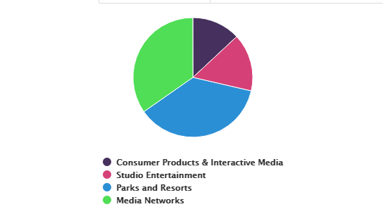
From the pie chart above, one can infer that the majority of revenue is generated by the help of media outlets and the wide network of theme parks and resorts. This distribution has changed considerably over the years, starting from feature films and then extending to cartoon animations, and then to theme parks. This diversification of assets means that the company does not remain confined to only one field of work but can rely on other fields that has provided the company with the required amount of exposure.

Works Cited:
“Disney Company | History & Films.” Encyclopedia Britannica, https://www.britannica.com/topic/Disney-Company. Accessed 24 Dec. 2019.
Editors, History com. “Disney Releases Snow White and the Seven Dwarfs.” HISTORY, https://www.history.com/this-day-in-history/disney-releases-snow-white-and-the-seven-dwarfs. Accessed 24 Dec. 2019.
---. “Walt Disney Company Is Founded.” HISTORY, https://www.history.com/this-day-in-history/walt-disney-company-founded. Accessed 24 Dec. 2019.
Walt Disney Revenue in different regions,
https://www.statista.com/statistics/193263/revenue-of-the-walt-disney-company-in-different-regions/
Walt Disney Growth Rates,
https://www.macrotrends.net/stocks/charts/DIS/disney/number-of-employees

