Continued Influence Effect
Name
[Institutional Affiliation(s)]

Author Note

Continued Influence Effect
When misinformation is provided to an individual, continued influence effect of misinformation (CIE) occur. In case misinformation is retracted, the persons continue to depend on that misinformation for inferential cognitive thinking. It has been observed that CIE occur when misinformation is retracted or provided to individuals. The process of CIE occurs at least partially as a consequence of catastrophe of information or memory (Baddeley & Hitch, 2017). As a result of the integration of memory, persons used to retrieve memory usually because of misinformation (Baddeley & Hitch, 2017). Memory processing occurs from integration and memory encoding process. Integration of memory significantly depends on the process of availability of information, and it requires to be updated as the mental model need it (Baddeley & Hitch, 2017). Therefore, individuals continue to depend on misinformation for interferential reasoning (Baddeley & Hitch, 2017). As mental model has some information related to that event; therefore, internal coherence occurs because of retraction and a poor integration process is integrated.
Review of Literature
The information is usually not fully integrated on this topic because of little trash available regarding information in the mental model (Baddeley & Hitch, 2017). When persons are cued, automatic retrieval process occurs as a result of misinformation and the lack of integrity of available information (Baddeley & Hitch, 2017). During the process of inferential reasoning, participants usually automatically retrieve information form misinformation as that is the only available material for them to retract.
Previous researches have provided evidence that supports the mental model and its updating processes, however, research regarding examination of neuropsychological processes and marker for memory retrieval has not been conducted so far (Baddeley & Hitch, 2017). It has been observed that studies related to the CIE of misinformation have not been conducted to investigate encoding processes of memory. Memory encoding process linked with CIE of misinformation is essentially important for examining mental model; therefore, this study was one of its unique kinds.
According to Johnson and Seifert (1994) model, the striking information from retractions is not a good or effective way to retrieve information. For example, when a judge asks the jury to retract information from their memory regarding previous court case, the memory retrieval is not an effective way by applying this approach (Baddeley & Hitch, 2017). Retracting information from an earlier event is not an effective way to retrieve information as it has been observed that this kind of situation failed to diminish the impact of information on related reasoning and memory (Baddeley & Hitch, 2017). Researchers have been trying to find the answer to the question of why removing information from memory is difficult from misinformation? The answer to this question is that memory model encodes event (Baddeley & Hitch, 2017). For example, narrative of a plane crash is related to the story of the associated relationships and therefore, it is difficult for people to forget that event and also the retracting misinformation would be difficult.
Memory retrieval is a complex process that includes the memory model and integration of information (Baddeley & Hitch, 2017). A coherent interpretation is usually established, comprising of causal relationships among objects in the incident (Baddeley & Hitch, 2017). The interpretation of misinformation is difficult as it is associated with the coherent interpretation process (Baddeley & Hitch, 2017). Two ERP components are relevant with memory research among which one is that occurred in left frontal positivity around 500 and 1100 ms post-stimulus that has been associated with process of encoding (Sari, Koster, Pourtois, & Derakshan, 2016). Several researches have been conducted that have evaluated that memory retrieval was easy for the information that was delivered later (Radvansky, 2017). This information was depicting higher positivity at F3 of left frontal site between 500 and 1100 ms as compared to the information that was not effectively recalled (Baddeley & Hitch, 2017). Second part that is important for memory retracing was P3b component and is linked with context updating according to Donchin’s theory (1981). It has been assessed through various studies that component P3b is associated with the revision of mental model; however, it must be induced by an incoming signal.

Methodology

Study Participants
90 participants were selected for the study in which 15 participants were assigned for 6 groups. The data was collected from two cohort studies of 400 participants. The data was used from 400 participants because after excluding the participants not qualifying for the study were excluded. Considering n=90 in which participants failing the criteria to an accuracy level of 40% were included. The participants failed to answer a minimum of 3 correct questions from fact questions were included. The study participants were selected on the basis of fact questions such as participants were not on task and attention was diverted somewhere, having a bad memory. Participants failed to 2 word trials in the task of Ospan were excluded. The Ospan expected range was 4+/-1. Participants who recalled the statement 6 in retraction were included. This left with 15 participants as rest of them was removed to get only 15 to take an equal number in six groups exactly.
The data from the six given groups was analyzed, and the insights were then used to test the hypothesis. The data gathered from the six groups is given below.
The group number is given in the first column with the task number, followed by the retraction number. The last column comprises of the dependent variable that is supposed to be analyzed. The statistical analysis, if applied to the data collected from each group, reveals some very interesting information (Baddeley & Hitch, 2017). The statistical analysis of group 1 reveals that the mean of the values rests at 1.6 as shown in the figure below. The values lie between 0 and 3.
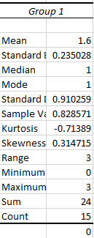
Figure 1 - Statistical analysis of group 1
Similarly, applying the same statistical analysis techniques on group 2 reveals a decrease in the values of CIE, along with the mean of the group.
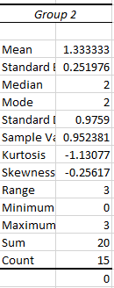
Figure 2 - Statistical analysis of group 2
In the same way, the analysis of the third group indicates the fact that the values of CIE are close to zero for the whole group. The maximum value recorded for the participants in the group 3 is 1, with the minimum obviously being zero (Baddeley & Hitch, 2017). The values for this group are the least from all the group that are participating in the experiment.
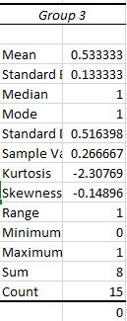
Figure 3 - Statistical analysis of group 3
In the same way, the statistical analysis of the data collected from group 4 gives us an idea of how the values of CIE can vary from a group top group. This batch of fifteen participants gives us some of the highest recorded values for the experiment. The stats are shown below,
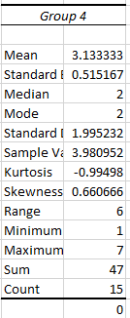
Figure 4 - Statistical analysis of group 4
As previously mentioned, the same statistical techniques are being applied across all the groups. The trends, as seen in the fifth group, which consists of fifteen participants, show that the mean value has come down from 3.33 in the previous group to 1.33. This group generally gives us an indication of the value of CIE that can be considered as normal. The statistical analysis of the data, as seen in this group, is shown below.
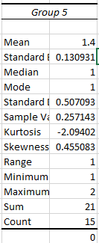
Figure 5 - Statistical analysis of group 5
The data that is collected for the last and final group, i.e. group 6 is shown below. The mean value shows that if we take all the groups as a whole, the mean value of CIE will range from 0.5 to 1.6. This has to be understood that one group, i.e. group 4 in this experiment can be considered as an outlier. The results for the statistical analysis of group 6 are given below.
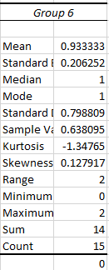
Figure 6 - Statistical analysis of group 6
Similarly, in order to compare the collective results of the 6 groups, we can make a combined bar chart so that all of the readings can be understood and analyzed simultaneously. The combined bar chart is shown below.
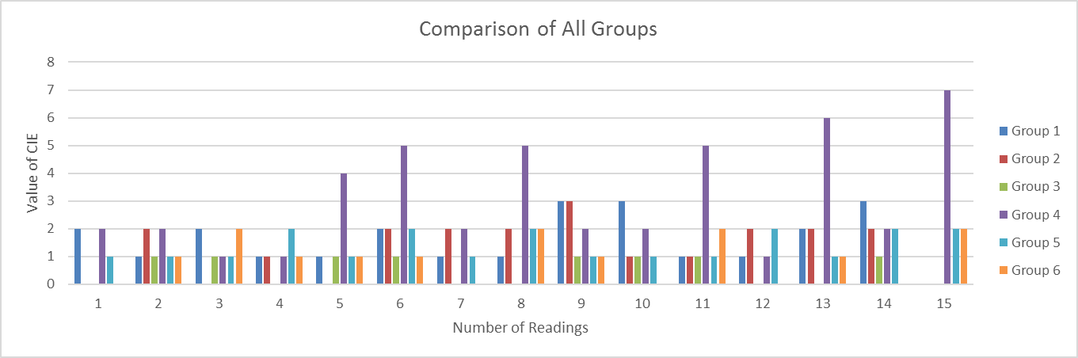
We can see in this visualization that there is an outlier group in the data and that is group 4.
Afterwards, a single factor ANOVA is applied to the data to test the null hypothesis and the other hypothesis. There are some assumptions that are attached to the ANOVA test and before the application of the ANOVA test, one should test those assumptions. The first assumption is that the dependent variable is normally distributed in each group. In order to test this assumption, we had to visualize the data using bar graphs of each group to see if the dependent variable is normally distributed in each group or not.
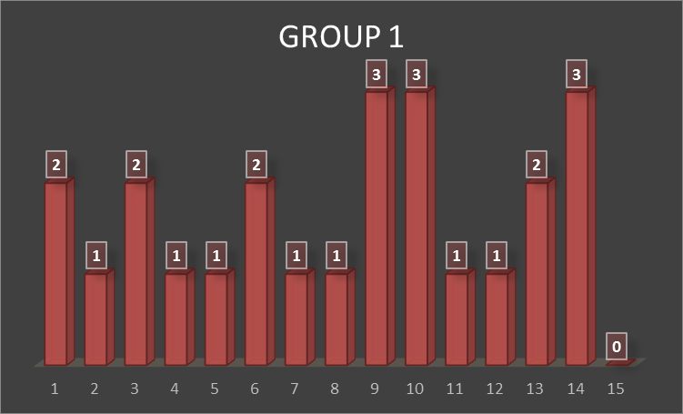
The values collected from the first group are normally distributed and the first assumption of the one-way ANOVA is satisfied. Similarly, data visualizations for the second group can be seen in the following visualization.
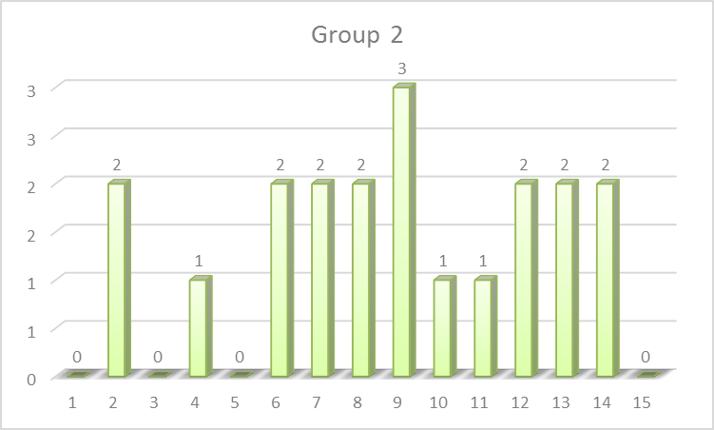
We can see from the graph that the data from group 2 is also normally distributed. Similarly, bar graph for group 3 can be seen as follows,
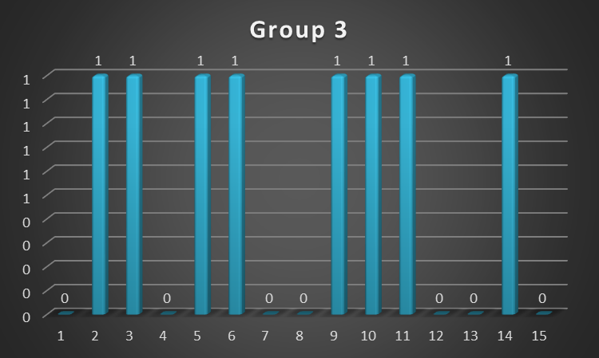
From this visualization, we can see that the data is in binary form. And that is si normally distributed. Thus the assumptions for ANOVA are met. For the fourth group, we have,
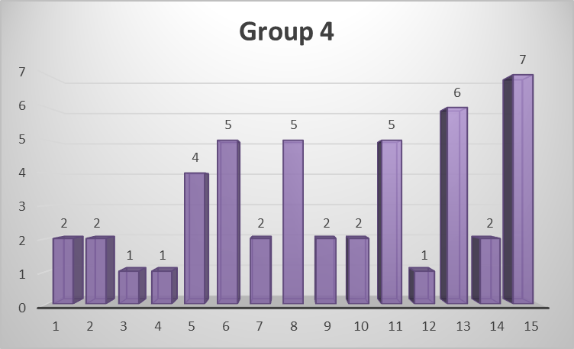
This group, as we can see from this visualization, is not normally distributed. With this, we can conclude that the ANOVA results for this group would not be trustworthy. For fifth group, the data can be visualized and tested for normalization using the following graph.
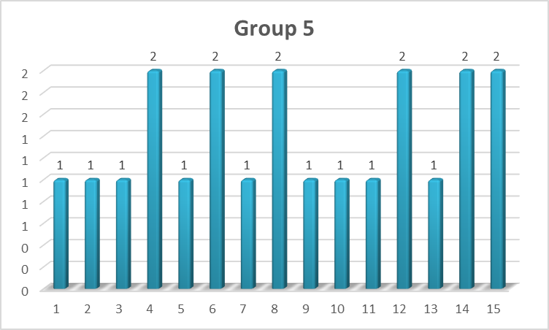
As inferred from the visualization, we can see that the data is normally distributed and that the assumptions for ANOVA are met in this graph. Data visualization for group 6 can be completed as follows,
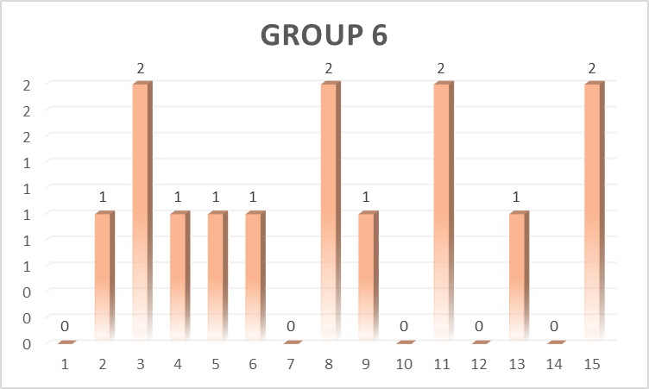
This data visualization shows that the data collected from group 6 is also normally distributed. Thus, the first assumption of ANOVA is met.
The result for one-way ANOVA, when implemented on the given data, gives us the following results.
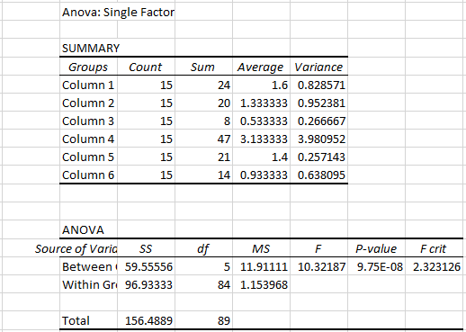

Results
The analysis of the results has shown that there is a significantly higher value of F indicated by the representation of graphs and figures. The higher F value has represented that the hypothesis projected has a stronger influence in the model. The hypothesis that working memory and short term memory are interrelated to each other is supported by the results as observed before. Therefore, the continued influence effect may arise because of the catastrophe of working memory. The misinformation and complete or incomplete evidence are reliant on the elimination of information from working memory (Garnefski & Kraaij, 2018). The values attained in each group has shown that continued influence effect has a strong relationship with the working memory.
Conclusion
After retracting and discrediting, inferences and judgments are often affected by misinformation (Baddeley & Hitch, 2017). This is termed as continued influence effect (Baddeley & Hitch, 2017). It has been studied in various studies that memory has been associated with continued influence effect and has a long-term role in processing memory (Baddeley & Hitch, 2017). Presently, the new researches have focused on association of working memory with continued influence effect (Baddeley & Hitch, 2017). It has been found that memory processing and integration of memory need to be updated to recall information from an event (Baddeley & Hitch, 2017). Misinformation removal is quite difficult in the processing of memory when it is encoded (Cho, 2016). Experimentally it has been evaluated that continued influence effect can be interpreted using abilities of one’s working memory (Baddeley & Hitch, 2017). As a result, the hypothesis of working memory that it can predict vulnerability of continued influence effect additionally and considerably as compared to short-term memory is correct (Buszard, Farrow, Zhu, & Masters, 2016). The hypothesis that working memory and short term memory are interrelated to each other is supported by the results as well as working memory is interrelated to continued influence effect is also supported by the results of the study (Buszard et al., 2016). Therefore, continued influence effect may arise because of the catastrophe of working memory (Baddeley & Hitch, 2017). The misinformation and complete or incomplete information are dependent on the removal of information from working memory (Wood & Rünger, 2016). The results are in alignment with the result of the study conducted by the Engle and the colleagues in 1999.

References
Baddeley, A. D., & Hitch, G. (2017). Working memory. In Exploring Working Memory (pp. 43–79). Routledge.
Buszard, T., Farrow, D., Zhu, F. F., & Masters, R. S. (2016). The relationship between working memory capacity and cortical activity during performance of a novel motor task. Psychology of Sport and Exercise, 22, 247–254.
Cho, J. (2016). The impact of post-adoption beliefs on the continued use of health apps. International Journal of Medical Informatics, 87, 75–83.
Garnefski, N., & Kraaij, V. (2018). Specificity of relations between adolescents’ cognitive emotion regulation strategies and symptoms of depression and anxiety. Cognition and Emotion, 32(7), 1401–1408.
Radvansky, G. A. (2017). Human memory. Routledge.
Sari, B. A., Koster, E. H., Pourtois, G., & Derakshan, N. (2016). Training working memory to improve attentional control in anxiety: A proof-of-principle study using behavioral and electrophysiological measures. Biological Psychology, 121, 203–212.
Wood, W., & Rünger, D. (2016). Psychology of habit. Annual Review of Psychology, 67, 289–314.

