Assignment 2: Analysis of data – Part 2
Name:
Student ID:
Swinburne Online

Assignment 2: Analysis of data – Part 2

Question 1 – Independent samples t-test

Hypothesis:
Researches hypothesise that Australian public service employees, who have less than five years tenure into heir job, are more engaged with their supervisor than Australian public service employees who have five years or more tenure.
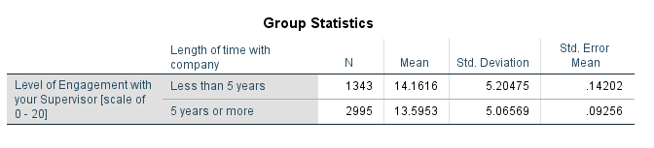

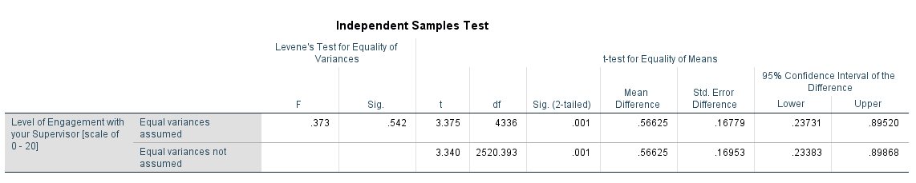

The SPSS output shows that the total sample of the study was 4338 employees, out of which 1343 employees had experience of fewer than 5 years, and 2995 employees had experience of 5 years and more. The statistics showed p=0.5, which means the hypothesis is significant to prove that Australian public service employees, who have less than five years tenure into their job, are more engaged with their supervisor than Australian public service employees who have five years or more tenure. This means the fresh employees need to learn more about their working and thus they remain in touch with their supervisors. On the contrary, experienced ones are confident about their working and thus do not find it necessary to remain in touch with their supervisors.

Question 2 – Independent samples t-test

Hypothesis: Researchers hypothesise that there is a difference in overage in the extent to which male and female public service sector employees are engaged with their job.
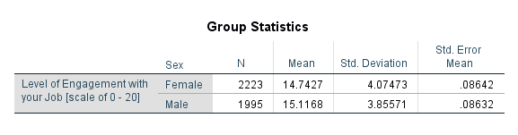
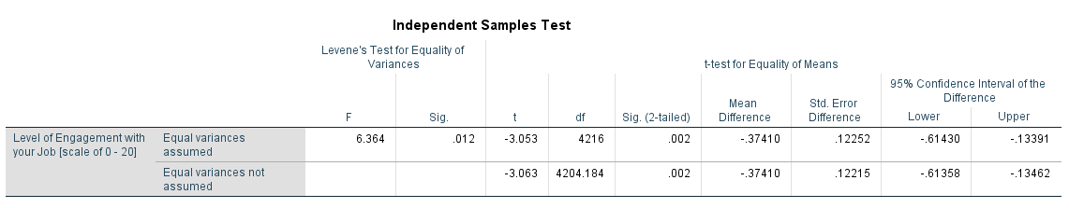

The SPSS output showed that total 2223 females and 1995 males are working at the company. However, the questionnaire response showed the significance of p=0.12, and significance (2-tailed) of 0.002, from which it can be revealed that there is no strong significance of the hypothesis. Thus, the findings proved that there is no difference in overage in the extent to which male and female public service sector employees are engaged with their job. This means the gender does not matter, instead it is the intention of the employee which influence the employee’s engagement with their job.

Question 3 – Paired samples t-test

Hypothesis: An employee relations counsellor hypothesis that Australian public service employees are more engaged with the team of colleagues that regularly work with than with their supervisor.

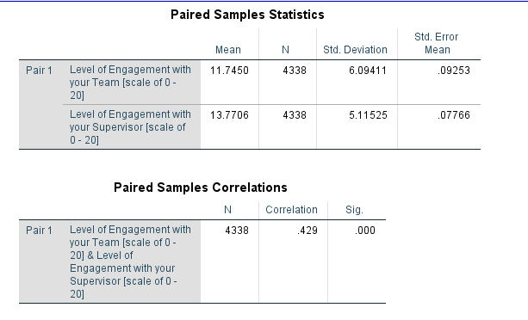
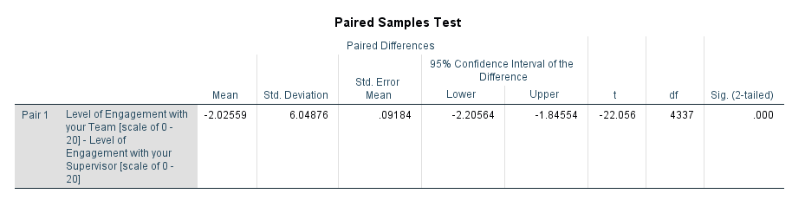

The SPSS output results showed the sample size of 4338 employees, which are either comfortable with their supervisors or with the team engagement to perform several professional tasks. However, the statistical findings showed no significance between the variables, which means that the hypothesis could not be proved as true. This simply means, that there is no significance in the hypothesis that Australian public service employees are more engaged with the team of colleagues that regularly work with than with their supervisor.
These findings help to conclude that overall it is the teamwork which matters, and for that both; the team engagement and supervisor's engagement, is essential. Only in this way, the employees will be able to perform their work with high efficiency.
Question 4 (a) – What is the population we can draw conclusions about in this study?

Data: The Indigo Insurance Company is a large company based in Melbourne. Several years ago, an email survey of all their employees found that employees were required to respond to an average of 50 work related emails per week with a standard deviation of 1.5 emails per week. However, an employee advocacy group believes the average number of work­related emails Indigo Insurance Company employees are now required to respond to is more than 50 emails per week. To investigate this further, the employee advocacy group took a random sample of 20 staff employed by Indigo Insurance Company during the second week of March 2018 and asked these employees to record the number of work­related emails to which they were required to respond.

The data shows that Indigo Insurance Company is a large company which needs to respond to an average of 50 work-related emails per week. However, when research was conducted to investigate either the Company employees are required to respond to more emails or not? For this purpose, the study selected 20 staff employees as a sample population.

Question 4 (b) – What does the highlighted section of the distribution in Figure 1 represent?

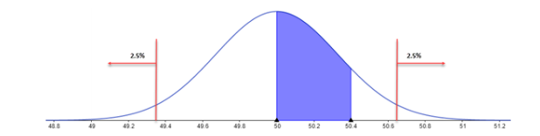
Figure 1 distribution of the sample mean number of emails answered per week for samples of size 20, taken from a population where the mean is 50 emails per week and the standard deviation is 1.5 emails per week (2018) courtesy of Swinburne University of Technology
The normal distribution figure shows the probability (50<=p<=50.4) which means that the company is required to respond to 50 or more emails per week. This means that the company must re-schedule the working of employees, where they need to work on more emails per week.

Question 4 (c) – The random sample of 20 employees of Indigo Insurance Company taken by the employee advocacy group turned out to have a mean of 50.8 work­related emails to respond to in that week. Does this sample look like it belongs to the sampling distribution displayed in Figure 1? Justify your answer.
Figure 1 shows the mean of 50 emails per week, where the probability was adjusted between 49 and 51. However, the employees responded to the survey, according to which the higher probability was found to be between 50 and 50.4. This means that company employees had to respond to 50 or more emails per week. As mentioned in the question that the random sample of 20 employees of Indigo Insurance Company taken by the employee advocacy group turned out to have a mean of 50.8 work­related emails to respond to in that week. Thus, this sampling distribution does not belong to the sampling distribution displayed in Figure 1.

Question 4 (d) – Given the sample was randomly selected and that the number of work­related emails each employee was required to respond to was recorded accurately, what conclusion can we reach from part (c)?

The figure clearly showed that most of the employees, out of selected 20 employees responded in the favour to increase the responding to more than 50 emails per week. When a random sample will be used in the survey, where the mean is 50.8 emails per week, the findings will be accurate and helpful inaccurate conclusion. From such selection of random sample size and mean, it can be easily concluded that company must re-schedule the working of employees, where they need to work on more emails per week.

