Finance
[Name of the Writer]
[Name of the Institution]

Finance
Introduction

Background of our company
Aus Financers Limited (AFL) is registered in 2012 as a financial advisory firm with the aim to provide versatile services to corporations, small businesses, and government organisations. AFL assist concerning investment advise, firm registrations, shares investments, Tax filing, audits, and business plan development. The company has a significant previous record with many large organizations and small businesses. Our comparative advantage over other financial firms is that we have highly professional and experienced advisors, we offer our services with the nominal fee, and develop long term relations with our clients.
In this report we will provide a detailed analysis and comparison of two major business organizations; the Boral Limited, and CSR Limited based in Australia. This report aims to guide one of our great client JV Group of Industries (JV-Group), one of the vast investors of the country owned and invested in more than 20 corporations.
This report will reveal and analyse the financial details of the two firms suggest to our client for future investments. We will review the financial information of these companies such as the ratio analysis, earning per share, capital structure of the firm, WACC, income statements, balance sheets, and cash flow statements. We will focus on the last three years data to provide a clear picture of these companies and their financial worth in current scenario. Here we will briefly introduce both firms, their history, business domains, and their comparative advantage over their competitors.

Boral Limited
Boral limited a multinational enterprise with headquarter in Sydney Australia, executing their operations in Australia, United States, and Asia. Its annual sales worth approximately A$ 4.39 billion, with above 16,000 employees across the world working in more than 700 different sites. The core business of the firm is the construction of buildings and infrastructure on an international level and deals in construction materials. In Australia they provide well-positioned construction materials business of Boral Australia, USG Boral operating in Asia have done joint ventures with their local companies and became a fast-growing plasterboard company. In the United States became a remarkable and renowned construction materials provider and construction services firm. The span of operations of Boral is 850 sites and distributes its construction materials to different places globally. In the fiscal year 2018 Boral marked a significant transformation, and successful integration with an American firm Headwater business in the United States, their joint venture achieved further profitability for Boral Australia.
Moreover, the company had consolidated in the same year that led a significant growth for its other subsidiary USG Boral. Meanwhile, the company increased its profit significantly after tax by 38 per cent in the year 2018. The strategy of the company is to deliver higher performance, and sustainable growth is seemed in progress, that yield the highest profit to its stakeholders. The highest profitability ratio, consistency in growth and successful expansion around the world, and a positive image in the market are the fundamental comparative advantages of the company. It pays high dividends with the growth rate for its stockholders attracts investors to buy its shares around the world. In the Australian stock exchange, its share price and demand are higher than other competitors.

CSR Limited
CSR is one of the major construction companies based in Australia producing building materials supplies to other construction companies. This company headquarter in Newcastle, New South Wales, operates and provided its products to Australia, Newzealand, and United States of America. Its major products are Glass plasterboards, bricks, Aluminium, and insulation. The company was founded in 1855 and has a successful track record and history in the manufacturing for the construction industry. It is a sustainable growth company with continuously growing profit, earning per share is recorded as 32.9c with 13 per cent growth, profit, after tax was A$ 142 million with a growth rate of 13 per cent and the full year dividend growth rate, is 18 per cent and its value for the year 2016 was 23.5c. CSR is a renowned brand in the construction industry earned high market trust and recognised as a top brand in providing construction materials for both residential and commercial constructions. The company's competitive edge is the provision of high-quality products with lower cost and has a strong distribution network to serve its customers across Australia and New Zealand. The company is continuously retaining it is earning to ensure its sustainable growth and expansion to provide high-quality products to its customers at their doorsteps. CSR is investing massive budget in the research and development to meet the changing customer's needs with the advancement of technology.
The company is highly concerned to meet the new challenges in the construction industry (CSR, 2019). CSR produces higher earning through its manufacturing and its property division with the aim to maximise its share price and deliver high returns on its shares to the stockholders. The property division is developing surplus earning by manufacturing sites for sale and deals in the industrial land in the industrial sites in Australia. The company is providing a vast range of products and systems which are sustainable in the sense of their energy efficient characteristics. The company is ready to cope with new challenges and avail new opportunities to meet the environmental concerns and produce eco-friendly products. Back from its origin in the 19th century the company is constantly growing through its primary objective to meet their customers' needs, through innovations.

Calculation and comparison of selected performance ratios

Boral Limited Ratio Analysis
Before going into the detailed financial analysis, I would like to present some facts and figures of Boral company for better understandings:

Fiscal Period June | 2016 | 2017 | 2018
Sales | 4 311 | 4 388 | 5 869
EBITDA | 645 | 715 | 1 056
Operating profit (EBIT) | 398 | 455 | 688
Pre-Tax Profit (EBT) | 284 | 301 | 483
Net income | 256 | 297 | 441
P/E ratio | 19,4 | 24,0 | 17,5
EPS (cts AUD ) | 31,5 | 29,0 | 37,4
Dividend per Share(cts AUD ) | 21,0 | 24,0 | 26,5

Liquidity Ratio analysis of Boral
Here we will analyse the liquidity and profitability ratios of the company. We have some statistics from the Annual reports of the company and the AUX website.
Liquidity Ratio Average from 2016 to 2018 three years data, according to BLD, (2019, n.p) the liquidity ratios average for three years, and its analysis are as under:
Current Ratio
(Values in a million) | 2016 | 2017 | 2018
Current Assets | 1684 | 1763 | 1738
Current Liabilities | 1181 | 1458 | 995

CR = Current Assets/ Current Liabilities
CR for the FY 2016 = 1684/1181 = 1.42
CR for the FY 2017 = 1763/1458 = 1.21
CR for the FY 2018 = 1738/995 = 1.7
Explanation
The current ratio gives us information about the efficiency of the company to finance its operating cycle, in other words, the ability of a company to convert its products into cash. The current ratio is calculated as the total current liabilities divided by total current assets. The current assets are the cash, account receivables and other current assets. Mostly the companies are found in trouble to get their payments from the market through their receivables due to bad debts, slow sales of the products, or having long inventory turnover (Makori and Jagongo, 2013, p.2). Which restrict a company to operate its daily activities, and alleviate its short-term obligations. The current ratio of Boral Limited is 1.7 for the year 2018. According to the financial experts, a company must possess a current ratio of more than 1, and if the current ratio is 1, it means that the company has an equal amount of cash to its obligations. If it is 2, it means the company has double amount of cash to its short term liabilities. The current ratio between 1 and 2 is the ideal value that Boral has maintained
Profitability Ratios of Boral
Profitability ratios reveal the detailed analysis of the company in different aspects.
 | 2016 | 2017 | 2018
Profit after tax | 256 m | 296 m | 473 m
Total Equity | 3506 m | 5440 m | 5730 m
Share price (in A$) | 5.76 | 6.64 | 6.62
EPS ( in Cent) | 33.3 C | 33.7 c | 40.4 c
Total Assets | 5800 m | 9313 m | 9510 m

Here we will calculate and analyse three types of profitability ratio, such as; Return on Equity, Price Earning Ratio, and Return On Assets Ratio.
For the year 2016, the Return on Equity is calculated as:
Return on Equity = Profit after tax/Net worth
= 256/ 3506
= 0.044 * 100
= 7.3 %
It shows that the net profit earned is 7.3% of the value of overall capital investment in the business. It is a positive and significant value, and it shows that business is earning enough amount that payback to the investors.
For the year 2017, the Return on Equity is calculated as:
Return on Equity = Profit after tax/Net worth
= 296/ 5440
= 0.054 * 100
= 5.4 %
As we discussed above the company's return is a positive value, the total current and non-current assets combined form the net worth of the business. Moreover, the cash we get is also counted in the current assets, so this value is significantly less.
For the year 2017, the Return on Equity is calculated as:
Return on Equity = Profit after tax/Net worth
= 473/ 5730
= 0.082
= 8.2 %
The ROE of the company shows that over time the company ROE is increasing. This shows the stability of the company with time.
Similarly, we will calculate and analyse the Price Earning Ratio briefly for three years varies from 2016 to 18.
Price Earning Ratio = Market price of Share / Earnings per share
Price Earning Ratio 2016 = 5.67/ 0.333 = 17.02
Price Earning Ratio 2017 = 6.64/ 0.337 = 19.7
Price Earning Ratio 2018 = 6.62/ 0.404 = 16.38
It shows that the company's share price is worthy in the market and people prefer to purchase it. In 2018 its value decreased but in fact, the devaluation occurred due to an increase in earnings per share and a slight decline in the share price of the company.
Return on Assets Ratio of Boral Limited
ROA = Net Profit / Total Assets
ROA for the year 2016 = 256 / 5800 = 0.044 = 4.4
ROA for the year 2017 = 296 / 9313 = 0.0317 = 3.17
ROA for the year 2018 = 473 / 9510 = 0.0497 = 4.97
The return of the company is compared with the total assets including the current assets. These values are significant, as the ROA varies firm to firm and industry to industry. It depends on the values of assets, the construction industry always having huge and expensive machinery. For this industry the ROA is reasonable.
Liquidity Ratio analysis of CSR Limited
Here we will analyse the liquidity ratios of the company. We have some statistics from the Annual reports of the company and the Annual reports of the company.
Current Ratio:
Table 1Ratio analysis
(Values in million) | 2016 | 2017 | 2018
Current Assets | 786 | 737 | 805
Current Liabilities | 489 | 514 | 506

CR = Current Assets/ Current Liabilities
CR for the FY 2016 = 786 / 489 = 1.6
CR for the FY 2017 = 737 / 514 = 1.4
CR for the FY 2018 = 805 / 506 = 1.59
The current ratio of CSR are also more than 1 in all these three years, which shows that company is getting its receivables on time and can manage its daily expenses with its sufficient working capital.
Profitability Ratios of CSR Limited
Profitability ratios reveal the detailed analysis of the company in different aspects.
Table 2 Profitability Ratios
 | 2016 | 2017 | 2018
Profit after tax | 166 m | 184 m | 213 m
Total Equity | 1317 m | 1206 m | 1274 m
Share price (in A$) | 3.31 | 4.51 | 5.18
EPS ( in Cent) | 32.9 C | 36.5 c | 42.3 c
Total Assets | 2216 m | 2097 m | 2138 m

Here we will calculate and analyse three types of profitability ratio, such as; Return on Equity, Price Earning Ratio, and Return On Assets Ratio.
Return on Equity = Profit after tax/ Total Equity
ROE for the year 2016 = 166 / 1317 = 0.075 = 12.6
ROE for the year 2017 = 184 / 1206 = 0.152 = 15.2
ROE for the year 2018 = 213 / 1274 = 0.167 = 16.7
Return on equity of the company soared afer the fiscal year 2015-16 where the value was 12.6, which increased in the next year to 15.2. Moreover, the in 2018 the rising trend continued, these values show the stability of the company, and significant profit of the company.

Here we will discuss the Price to earnings ratio of the CSR Limited.
Price Earning Ratio = Market price of Share / Earnings per share
Price Earning Ratio 2016 = 3.31 / 0.329 = 10.06
Price Earning Ratio 2017 = 4.51 / 0.365 = 12.35
Price Earning Ratio 2018 = 5.18 / .42.3 = 12.24
It shows that the company's share price is worthy in the market and people prefer to purchase it. In 2018 its value decreased slightly. However, the overall trend is significant, and it could attract more investors to purchase its share.

Return on Assets Ratio of CSR Limited
ROA = Net Profit / Total Assets
ROA for the year 2016 = 166 / 2216 = 0.075 = 7.5
ROA for the year 2017 = 184 / 2097 = 0.0877 = 8.77
ROA for the year 2018 = 213 / 2138 = 0.0996 = 9.96
The return of the company is compared with the total assests including the current and non current assets. The return on the assets is quite reasonable for this firm. As it holds huge machinery and expensive plants.

Share prices movements analysis
These graphs are taken from the website. According to Investing.com, (2019, n.p), the share price moves influenced by many factors.
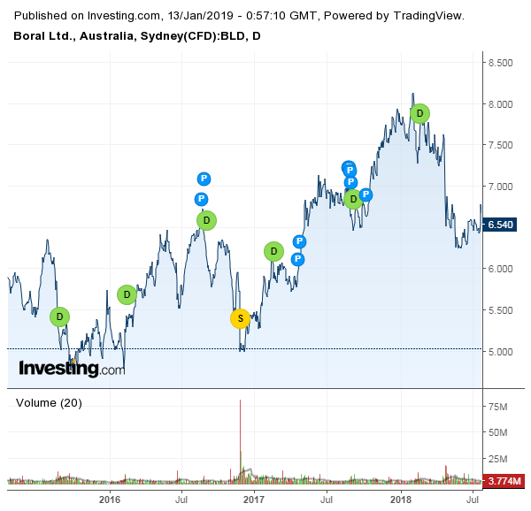
Figure 1 Stock price movement of Boral Ltd

N
News
E
Economic Calendar
D
Dividends
S
Stock Split
P
Candlestick Patterns

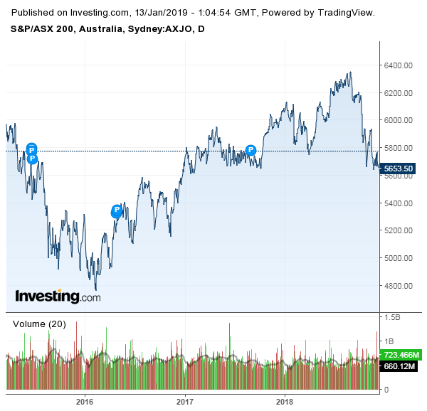
Figure 2Stock price movement of CSR LTD

Calculation and analysis of WACC
WACC of CSR Limited is calculated as under
WACC = (E / V * Ke) + (D / E * Kd) * ( 1 – Corporate Tax)
= (1274 / 2111 * 0.15) + (837/2111 * 0.07) * (1 – 0.3)
= 0.09 + 0.027 * (0.7)
= 0.817
WACC of Boral Limited is calculated as under
WACC = (E / V * Ke) + (D / E * Kd) * ( 1 – Corporate Tax)
= (5730 / 13290 * 0.15) + (2527 / 13290 *0.07) (1 – 0.19)
= 0.064 + 0.133 * 0.81
= 1.007

Capital structure policy
Debt Ratio of Boral Limited of the fiscal year 2018.
Debt Ratio = Total Liabilities / Total Assets
Debt Ratio = 1056 / 9510 = 0.111 = 11.1
It means the company has more about 9 times more assets to pay its liabilities. It shows that the company is safe from bankruptcy and solvency in crises.
Debt Ratio of CSR Limited of the fiscal year 2018.
Debt Ratio = Total Liabilities / Total Assets
= 837 / 2138
= 0.391 = 39.1
It means that the company has approximately three times more assets to pay its one liability. It is better to position, and a company can pay its debts.
Overall, the Debt ratio of Boral is more significant and safer as compared to the CSR.

Debt to Enterprise Ratio
Debt to Enterprise Ratio of Boral Limited for the year 2018:
Debt to Enterprise Ratio = Debt / Stockholder equity + Debt
= 2527 / 5730 + 2527
= 2527 / 8257 = 0.306 = 30.6
Debt to Enterprise Ratio of CSR Limited for the year 2018
Debt to Enterprise Ratio = Debt / Stockholder equity + Debt
= 357 / 1274 + 357
= 357 / 1631 = 0.218 = 21.8
The debt of the company is quite less, and the company is in a strong position to pay its liabilities by selling the 5th part of its total assets. If both of the company go for further financing and go for equity financing worth A$ 10 million It will increase the equity weighting of the working capital (Jiang et al., 2016, p.108). The firms will be in a good position to pay its debts. However there are certain shortcomings of huge equity financing, such as; higher taxation, the cost of equity is always greater than the cost of debt. Moreover, the earning per share will be decreased by adding more shares or shareholders. The total amount of dividend would be distributed among more number of shares (InvestSMART, 2019, n.p)

Letter Recommendation
Mr XYZ
C.E.O
JV-Group
Date
Dear CEO JV-Group
I want to put my recommendations being a consultant and professional investment advisor, based on our research and analysis of specific facts and figures. Our team worked on your task to properly analyse the market trend and financial position of different firms listed on the Australian Stock Exchange (AUX). We investigated several firms thoroughly and finalised two companies that are relatively strong and consistent in profitability and growth.
Boral Limited is a multinational brand in the construction industry executing its operations in three continents, Australia (Australia and New Zealand), America (USA), and Asia (Gulf countries). The company has better profitability and liquidity ratios, strong capital structure, and paying a consistent dividend. Furthermore, previous data reveals that the company share price is increasing continuously.
Next, I would recommend you CSR Limited, a manufacturer of the construction material. It is operating its business in Australia and Newzealand, having a strong distribution channel. The company was founded in 1855, having strong liquidity, profitability and capital structure ratios. The company is growing as per its previous record and providing a sufficient amount of dividends.
Therefore, being an advisor, I would like to recommend you these two firms for investment and become a part of the sustainable growth of these two companies.
Regards,
ABC,
Financial Advisor
Aus Financier Limited (AFL)
Sydney

References
CSR . (2019). Corporate. Retrieved 12 January 2019, from https://www.csr.com.au/about-us
(BLD), B. (2019). Boral Ltd. (BLD) Financial Ratios. Investing.com. Retrieved 12 January 2019, from https://www.investing.com/equities/boral-limited-ratios
InvestSMART. (2019). CSR Limited. [online] Available at: https://www.investsmart.com.au/shares/asx-csr/csr-limited/financials [Accessed 12 Jan. 2019].
Boral.com. (2019). [online] Available at: https://www.boral.com/sites/corporate/files/media/field_document/Boral-Annual-Report-2018.pdf [Accessed 12 Jan. 2019].
Investing.com Australia. (2019). S&P/ASX 200 Chart - Investing.com AU. [online] Available at: https://au.investing.com/indices/aus-200-chart [Accessed 13 Jan. 2019].
Makori, D.M. and Jagongo, A., 2013. Working capital management and firm profitability: Empirical evidence from manufacturing and construction firms listed on Nairobi securities exchange, Kenya. International Journal of Accounting and Taxation, 1(1), pp.1-14.
Alaka, H.A., Oyedele, L.O., Owolabi, H.A., Oyedele, A.A., Akinade, O.O., Bilal, M. and Ajayi, S.O., 2017. Critical factors for insolvency prediction: towards a theoretical model for the construction industry. International Journal of Construction Management, 17(1), pp.25-49.
Jiang, W., Lu, M., Shan, Y. and Zhu, T., 2016. Evidence of avoiding working capital deficits in Australia. Australian Accounting Review, 26(1), pp.107-118.

