Research Proposal
Your Name
Institution

Wi-Fi Network Proposal
This document is in response to the winning a bid for installing a new wireless network for AROD (not an actual company). In this project, we would like to provide an ideal solution for our new partner as per their requirements. Our main task is to install a wireless network throughout the town in the offices of AROD and also in the public areas. The company will sell the internet to its customers through a wireless network.
The wireless system would be installed through the small town of ABC and it will almost cover the residential and commercial area of the town. The Wi-Fi will provide a high-speed connection to the consumers at the cost suggested by the company. To make this project possible, Cisco Meraki hardware will be used. In addition, analytic wireless software will be used. Company is planning to get a good return on its investment in a period of two years.

Requirements
Requirements for the installing wireless network throughout the town are given below.

- The access points should comply with network security standards.
- Access points should be able to provide at least 100Mb/s speed.
- Client (AROD) should be able to manage bandwidth on each access point.
- Only authorized personnel should be able to configure access points.
- Diverse data routing shall be achieved by each access points
- The wireless network should be able to access within 500m meter at each access point without dropping signal.
- The network should have the ability to blacklist devices.
- Access points should be suitable for outdoor conditions
- Equipment should have the capability to operate 24/ 7
- The company should also provide after-sales services which include maintenance and fixing faults, within 24 hours prior to complain.

Secure Network
Secure Metropolitan Area Network (MAN) will be used for this project. MAN can interconnect many servers and network equipment. Different Local Area Networks (LANs) are interconnected to form a web of a network (RL Geiger, 2002). Various firewalls are also installed for securing the network from an external breach. Example of secure LAN, which will be a part of a bigger MAN is shown in the picture below (Smith, 2002).
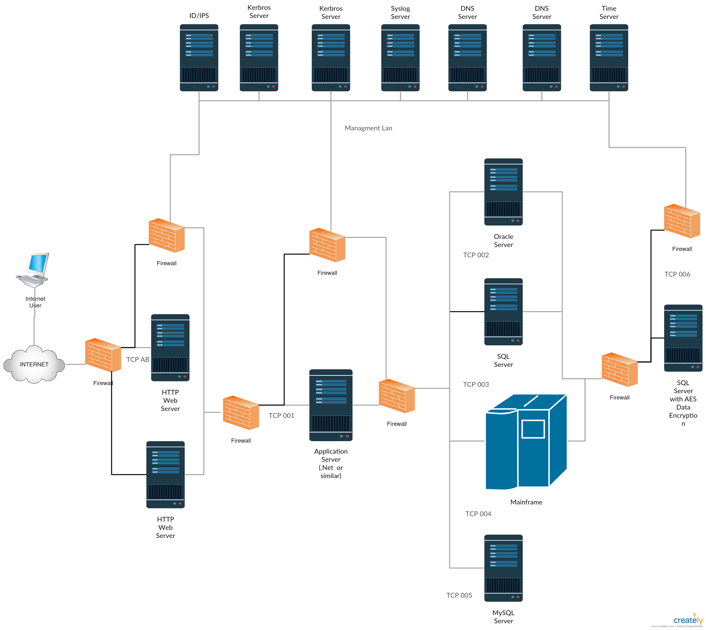

These requirements can help in understanding the size and scope of the project. Company has asked for 40 access points within the town, Access points are responsible for access between users. Secured high ranged LAN and WLAN routers will be used for this project. Company will decide their location, as they have to get the permit form the government

Additional security measures
Security risks associated with the network are shutting down of a system, and loss of sensitive data. These losses can be caused by computer viruses, rogue security software, Trojan horse, adware or spyware, network worm, DDoS attack, Rootkit, and SQL Injection attack (ASK Pathan, 2006).
To address all security threats and concerns, we have to search for weak spots within the network. Our skilled workforce has experience in searching the weak spots within the network, they also have technical skills and expertise over network security tools. We will take the following key actions to prevent any internal or external cyber-attacks.
- We understand common attacks. And we have good knowledge of cyber-attacks which targets weak network.
- We will establish a list of potential vulnerabilities, and look for anything suspicious or unknown to the network (after sales services)
- Use vulnerability and network scanning tool (after sales)
- In case of an attack, we have the ability to access the risk and we will be able to take reliable actions in such events.

Cost
The cost of the project, including network equipment and installation, is given in the below table. Servers are not included in the cost, the company already have old servers from its old cite. These old servers are moved to this town by the company, and they will be used in our project.
SR. No. | Product | Description | Qty | Unit Cost | Total Cost
1. | MR72-HW | Meraki MR72 Cloud Managed AP | 144 | $ 1,021.24 | $ 147,058.93
2. | MA-ANT-20 | Meraki Dual-band Omni Antennae | 288 | $ 127.10 | $ 36,603.71
3. | MS220-8P-HW | Meraki MS220-8P L2 Cloud Managed 8 Port GigE 124W PoE Switch | 40 | $ 801.36 | $ 32,054.40
4. | MA-PWR-CORD-USA | Meraki AC Power Cord for MX and | 40 | $ 17.64 | $ 705.60
5. | LIC-MS420-48-3YR | Meraki MS420-48 Enterprise License and Support, 3 Year | 1 | $ 1,697.22 | $ 1,697.22
6. | MS420-48-HW | Meraki MS420-48 L3 Cloud Managed 48 port SFP+ Aggregation Switch | 1 | $ 25,288.20 | $ 25,288.20
7. | LIC-MS220-8P-3YR | Meraki MS220-8P Enterprise License and Support, 3 Year | 1 | $ 52.92 | $ 52.92
8. | LIC-ENT-3YR | Meraki MR Enterprise License, 3 Years | 144 | $ 191.52 | $ 27,578.88
9. | M500XTM3 | WatchGuard Firewall M500 XTM 3 Year Bundle | 1 | $ 12,594.96 | $ 12,594.96
10. | PM | Project Management Services | 12 | $ 1,008.00 | $ 12,096.00
11. | PS | Professional Services - Configuration / Install | 16 | $ 945.00 | $ 15,120.00
12. | Miscellaneous |  |  |  | $ 39,149.18
13. | Total |  |  |  | $ 350,000.00

The total cost of the project will be 350,000 USD. Company will have to spend extra for the marketing of its internet services and establishing their offices within the town. Although marketing and construction of its offices is not our field, we have to provide the company with a secure Wi-Fi network which has the ability to support at least 5000 customers. If the company spend additional 100,000 dollars for its marketing and building offices, the total cost of the project would become 450,000 dollars. The payback period of this project will be 2.1 years if the company is able to get 700 customers after the completion of this project. We have done an economic and financial analysis of the project to get this result as a goodwill gesture.

References
ASK Pathan, H. L. (2006). Security in wireless sensor networks: issues and challenges. IEEE.
RL Geiger, J. L. (2002). Secure wireless electronic-commerce system with wireless network domain. Google Patents.
Smith, M. (2002). Multilevel secure network access system. Google Patents.

