Technical Description
[Name of the Writer]
[Name of the Institution]

Technical Description

Introduction
A computer is an electronic device assembled together through different components and chips in order to enable users to perform different tasks effectively and efficiently. A computer system is composed of several input and output devices which enable a user to interact with the computer system. Of all the input devices related to the computer, a computer mouse is one of particular importance. This technical description will include a brief introduction of the computer mouse, its specifications, description, and working. Lastly, in the conclusion of the computer mouse, the working will be explained for users that would enable them to use it with ease.
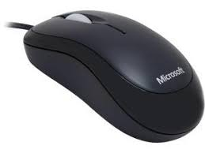
A computer mouse is an input pointing device attached to a computer used to control the cursor on the computer screen. Although relatively small in comparison to the overall computer system, the mouse is central to the working of the computer system. A computer mouse is a type of input device that can easily fit in the hand of the user making it easily usable. A computer mouse enables the user of the computer system to interact with the objects they see in the display screen. The mouse has a different part; the top part, bottom part, and inner circuitry. The top part has three components; the left click button, the right-click button, and the scroll wheel. The left and right-click buttons allow the user of the computer system to perform different tasks on the display screen of the computer. Furthermore, the scroll wheel enables the user to scroll u vertically or horizontally. The bottom part of the computer mouse contains a ball. The ball helps to smooth the motion of the computer mouse. Additionally, the motion of the ball is mirrored in the moving of the cursor on the computer screen. The cursor is the small arrow that the user can use to select any object on the screen along with multiple functions. Lastly, the internal circuitry of the computer mouse acts as a bridge between the user and the computer system. When the user of a computer system moves a mouse, the motion of the computer mouse is changed into an electronic signal that is mirrored on the computer display screen.
Specifications
There is no fixed size of the computer mouse. Numerous manufacturers make computer mouse of different sizes and shapes. Most of the time users buy that mouse which fits their hand perfectly. The size dimension of a typical computer mouse that comes standard with the computer system is following; the width of a standard computer mouse is almost 20 mm, the length of a standard computer mouse is almost 62 mm, and the height is about 8mm (Keyboard, Mouse & Display Specifications, 2019). These size specifications are for a typical mouse that comes standard in a computer system.
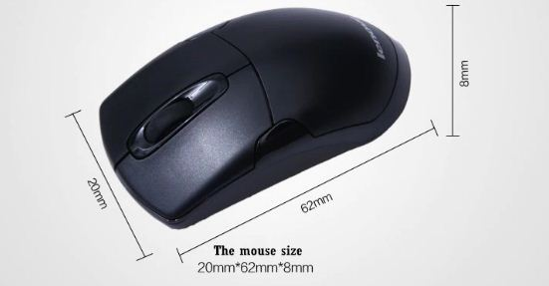
Next important factor that most buyers consider is the weight of the mouse. If a mouse is much heavier to use and does not move across the surface easily, most of the buyers will turn their attention elsewhere to exercise other options available. Therefore, mouse manufacturers have found the perfect solution as far as the weight of the mouse is concerned. The weight of the computer mouse is perfectly balanced for a computer user to use it easily. A typical computer mouse that comes along with a computer system normally weighs around 90 to 100 grams (Keyboard, Mouse & Display Specifications, 2019). Although it might be significant for some users, the computer mouse is designed in a way that it put minimum weight on the wrist of the users. Lastly, the composition of a computer mouse is essential to understand. The outer body of the computer mouse is made up of plastic. The outer body consists of the top part, the bottom part, and the internal circuitry. The ball inside the computer mouse is made of metal and upon which rubber has been coated. Additionally, the left click button, the right-click button, and the scroll wheel are also made up of plastic.

Description
The description of the technical description allows the targeted audience to fully understand the product under discussion (Tebeaux & Dragga, 2010). Below is the explanation of the features of the computer mouse.
The top part
The top part of the computer mouse that is made up of plastic has mainly three components on it. These three components are deemed essential for a computer mouse if the user wants to interact with the computer. The top part has the right-click button, the left click button, and the scroll wheel (Mouse and Pointers, 2018). All these components serve different functions. In order to understand the working of the left and the right-click button, it is imperative to understand an example. For instance, the icon of "My Computer" is being displayed on the screen. The user wants to open it. The user moves the mouse to the icon. Now the user has two choices. The first choice, using the right-click button, they can view various options such as properties. The second choice, the user can double click the left click button if they want to explore the "My Computer" icon further. This example gives an idea about the range of functions a user can perform using the left and right-click buttons. Additionally, there is a scroll wheel on the top part. The purpose of the scroll button allows the user to navigate vertically or horizontally on the display screen.
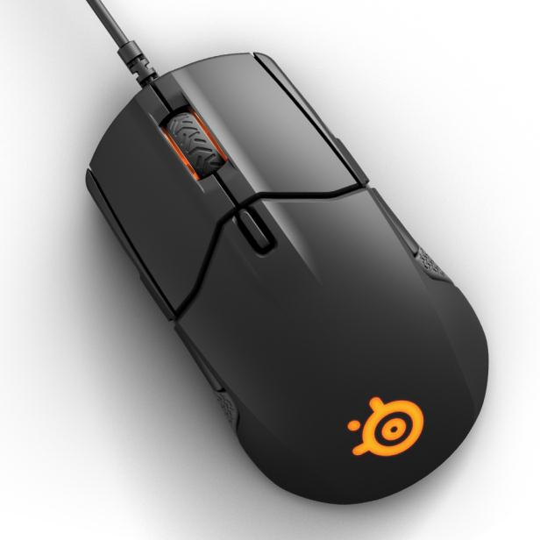
The bottom part
The bottom part of the computer mouse is a flat surface that enables it to move across the surface without any trouble. The bottom part is also made up of plastic just like the top part. Additionally, the bottom part of the mouse serves as a guardian of the inner circuitry. Moreover, the bottom part of the computer mouse has a small metal ball coated with rubber often called a tracking ball (Mouse and Pointers, 2018). The basic function of the tracking ball is to aid the mouse in moving flawlessly to give the user a perfect experience. Additionally, the motion of the tracking ball is captured and translated into an electronic signal. This electric signal is mirrored on the screen whenever a user moves the computer mouse.
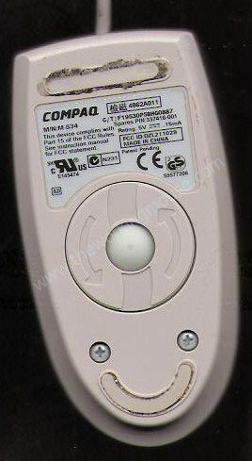
Internal Circuitry
The internal circuitry of the mouse is a combination of electronic components that are made out of copper (Mouse and Pointers, 2018). These electronic components are protected by both the top part and the bottom part. This internal circuitry tracks the motion of the mouse through the tracking ball. This motion is translated into the movement of the cursor on the screen whenever the user moves the computer mouse across the screen. Further ahead is a brief overview of the components that made up the internal circuitry. There is a switch in the internal circuitry that detects the clicks of the left and the right buttons of the top part. There is a socket which allows a user to connect the mouse with the computer. A chip that transfers data- clicks and scrolls- of the user to the computer which is reflected in the motion of the cursor. There are two small wheels that allow the tracking ball to move easily across the surface. A capacitor is an important part of the internal circuitry of the computer mouse that ensures the power supply to the mouse. Lastly, a resistor is placed in the internal circuitry that regulates the amount of power that is being supplied to the computer mouse.
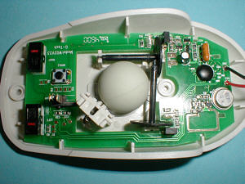
Few additional parts of the computer mouse enable it to connect it to the computer. First part is the cord. The cord is the wire that is wrapped inside a plastic sheet. The cord of a standard computer mouse is several inches long. The second part of the computer mouse is called the port. The port is always located at the end of the cord wire. The port is made out of plastic and metal. The purpose of the port is to allow connectivity between the computer and the mouse.
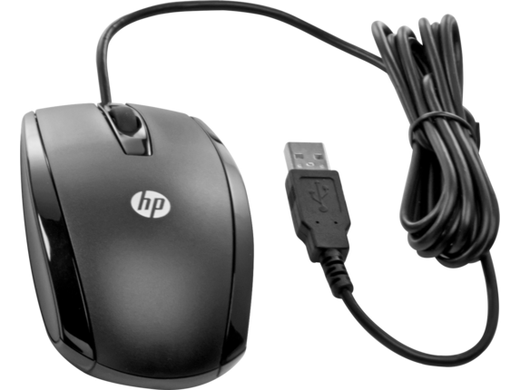

Conclusion
Taking into account the discussion above, it can be concluded that a computer mouse is an integral part of the computer system. The computer mouse allows the user to perform various tasks according to their needs. The working of a computer is easy for anybody to understand within no time. The computer mouse is a simple device that enables the user to interact with the computer. The working of the mouse can be easily understood without any prior knowledge and technical experience. In order to bring the mouse into use, the user has to connect it with the computer through the port. Once the mouse is connected to the computer, it will be ready to use within no time. A user after successfully connecting the mouse with the computer can perform a variety of tasks. For example, a user can open a number of icons using the left click buttons. Additionally, a user can explore various options by clicking the right button on an icon on the display screen of the computer. The controls and the working of the computer mouse are extremely easy for anyone to understand.
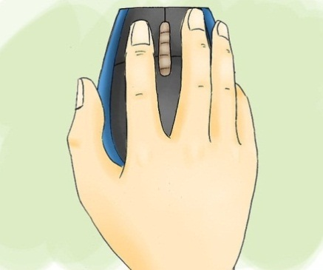

References

Keyboard, Mouse & Display Specifications. (2019). Support.xerox.com. Retrieved 7 August 2019, from http://www.support.xerox.com/docu/Xerox120_cd/Nuvera_6_0_ugta/english/spec_60.htm
Mouse and Pointers - Windows applications. (2018). Docs.microsoft.com. Retrieved 7 August 2019, from https://docs.microsoft.com/en-us/windows/win32/uxguide/inter-mouse
Tebeaux, E., & Dragga, S. (2010). The essentials of technical communication. Oxford, UK: Oxford University Press.

