Name of Student
Name of Professor
Name of Class)
Day Month Year
JAN TSCHICHOLD AND THE NEW TYPOGRAPHY: GRAPHIC DESIGN BETWEEN THE WORLD WARS
PREAMBLE
The following paper analyzes five significant typographical art pieces from an exhibition that is going on as a Bard Graduate Center Focus Project. The title of the exhibition is “Jan Tschichold and the New Typography: Graphic design Between the World Wars” that will be continued from February 14 to July 7, 2019. The overall event is curated by Paul Striton, an associate professor of Bard Graduate Center. The underlying pivot of the display is to portray the innovative and contemporary art and graphic design that specifically belong to the historical epoch of the 1920s to 1930s. Moreover, the exhibition also elaborates the influence of Jan Tschichold on the typography and graphic designing techniques of artists of that time. Jan Tschichold devised the rules and principles for the modern typography and graphic design and infused the vibrancy of innovative urbanism after the elongated period of war and its desolated effects. The exhibition is exhibiting more than one hundred and twenty instances of contemporary graphic designs, and the collection is comprised of different mediums and modes including magazines, books, business cards, posters, advertisements, catalogs, and brochures.

1. DIE SPORT AUSSTELLUNG (THE SPORT EXHBITION)
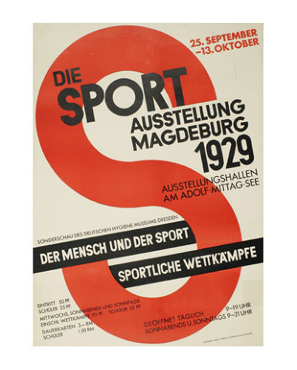
Walter Dexel made die Sport Ausstellung (the sports exhibition) in 1929, and the poster is a marvel of photolithography. Photolithography uses light to produce specific conductive paths of a printed circuit board layer. The depicted poster is based on a single alphabetical letter “S” but yet represents a great and tremendous textual logo design for the mentioned event of the sports exhibition. Throughout the creation of the poster, Dexel artistically implemented the principles of expressions, metaphor, and symbolism. The modern design of Dexel’s poster enhances the contour of a racetrack and stresses on the lithe and supple shape to highlight the athletic context of the occasion.

2. TANZFESTSPIELE (DANCE FESTIVAL) (POSTER FOR DANCE FESTIVAL AT THE SECOND GERMAN DANCE
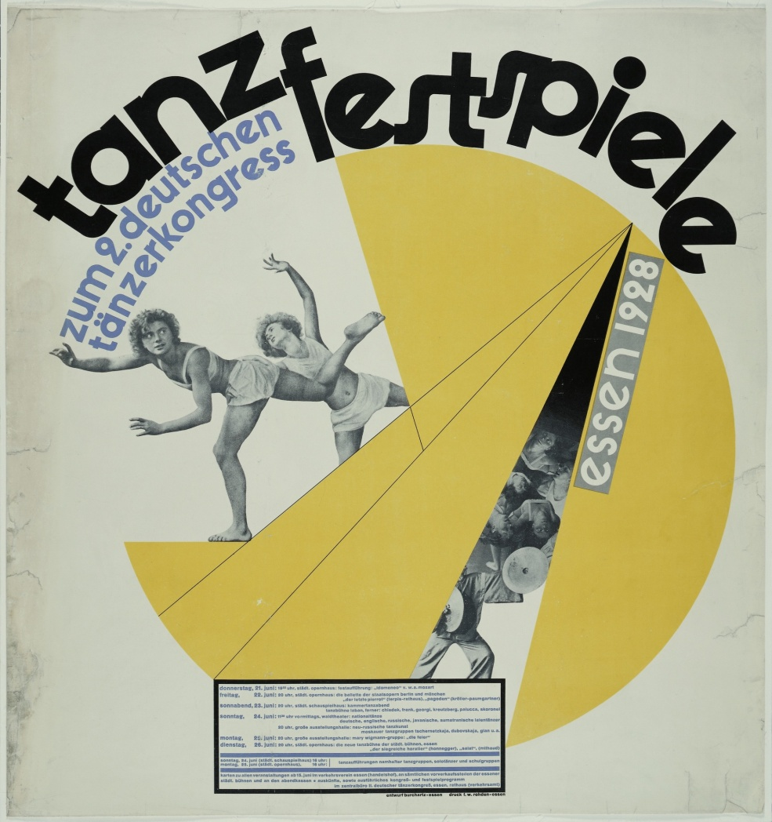

In 1928, Max Burchartz created the poster for the Second German Dance Congress, Essen, Dance festival that was titled “Tanzfestspiele (Dance Festival) The poster was printed by Graphische Anstalt F.W. Rohden and featured the medium of photolithography. The poster carries an evident style of new typographical approach that elaborates the imperativeness of orderly usage of dynamics and terminologies. The implications of modern typography became well adjusted with the prevailing culture of Weimer Germany, throughout that era which featured the aesthetics of physical fitness and athletic endeavors. According to László Moholy-Nagy, opticals should be hygiene-based for the visual captivity and health of the beholders. The poster graphics is an instance of typophoto that referred to as an excellent blend of photographic components and text. Typophoto is considered as an effective way of communication and proffers a clear and precise message. In the depicted poster, the women present a rhythmic posture that complies with the spherical shape and expressing the asymmetrical vigor that entirely belongs to modern life and modern art principles. Regarding this specific graphics piece, Tschichold affirmed that such graphics are the symbol of general life forms alteration.

3. THE DEVELOPMENT OF TRANSPORTATION, THE FIVE-YEAR PLAN
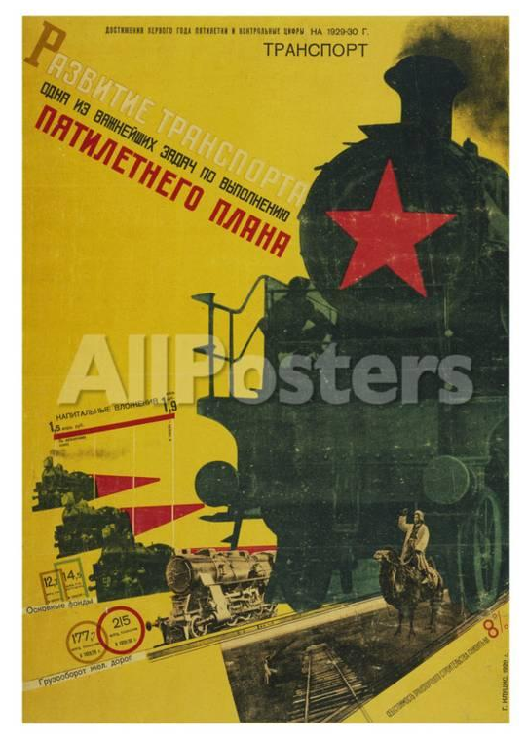
“The Development of Transportation, The Five-Year Plan” was made in 1929 by Gustav Klutsis and used Gravure as the medium. Gravure can be defined as a printing technique that involves intaglio through which the picture engraved on a copper rotating cylinder. Klutsis was a pioneer photographer and a constructivist, and his expertise enwraps the idea and approach of photomontage in an exacerbated manner. Photomontage was widely promoted throughout the Soviet Union in that period and was widely utilized for propaganda purposes. However, in that era, Stalin’s rule restricted several art techniques and modes but yet photomontage made its way through all the hurdles. The subject poster is a perfect instance of Klutsis photomontage skills through which he amalgamated different individual photographs and encapsulated them into a single subject. The poster demonstrates different individual pictures, based on the concept of transportation and in this order, Klutsis incorporates old and modern resources of transport altogether.

4.BUCHSTABEN UND SCHRIFTEN BAG A-Z
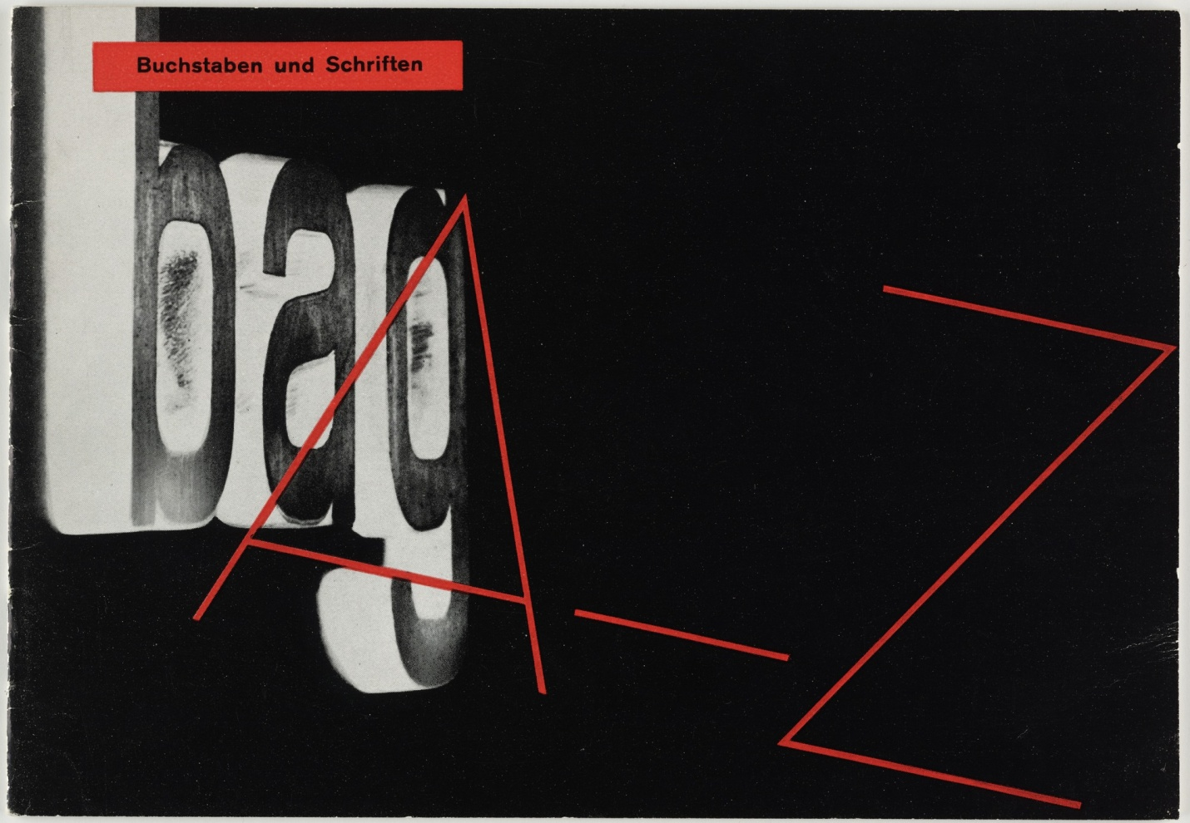
“Buchstaben Und Schriften Bag A-Z” that is translated as “Letters and Fronts Bag A-Z” is made by Anton Stankowski in the period from 1929 to 1934. The graphics piece used the medium of letterpress and was a present to Jan Tschichold collection by Philip Johnson. The graphic demonstrated above is the perfect instance of car radiators in the most modern and contemporary manner and possesses a significant counterpart of the innovative and newly devised typography altogether. The image belongs to the time when technology emerged and transformed the mechanism of cameras and their lenses. Through the usage of modern and improved cameras, it became convenient to capture the images of regular surfaces in the most extraordinary and eye-catching way. The poster fulfills the demands of aesthetics of modern typography and advertisement of the specific period.

5. YKO LABEL

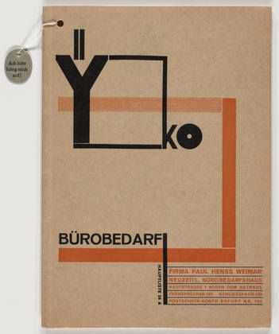

Made through letterpress, the “YKO Label” was created by Joost Schmidt. The label features a timeless quality and design and portrays captivating yet straightforward color scheme. Moreover, the incorporation of uncomplicated and straightforward geometrical graphics and shapes enhance the uniqueness of Schmidt work. Because of general and universal outlook and perspective, the poster still looks recent and contemporary even after all ninety years. Schmidt’s work carries a central position and significance in the movement of modern design and contemporary graphical structural implications.

CONCLUSION
The exhibition “Jan Tschichold and The New Typography: Graphic Design between the World Wars” displays the graphics and designing endeavors of artists and typographers who played an integral role in spreading the modern idea of constructivism and contemporary art. The origin of the constructive and modern art is associated with Russia, and the movement rejected the traditional art that previously catered the status and class-based communities. The modern art developed after the chaos of World War I and provoked people to reform the communities and society in an ideological way instead of one who evokes for warfare and conflicts. Kasmir Malevich was the pioneer who first-ever coined the term “constructivism” and defined it with the work and design principles of Aleksander Rodchenko. According to the subject movement, the graphic design enwrapped several métier of regular lives including the advertisements, book covers, logos of different products and posters. Jan Tschichold later inspired by the graphic designs of Rodchenko. The very same constructivism and design motifs are still widely utilized in graphic design in the technologically advanced time of today.

