1. Which planet has the highest density?
Which planet has the lowest density?
Which planet gets closest to Earth?
Which planet is furthest from Earth?
Which planet has the highest surface temperature?
Which planet (other than Earth) has had the most number of space-based missions visit it?
Which planet has the largest moon?
Which planet has the highest mass?
Which planet has the lowest mass?
Which planet has the largest radius?
Which planet has the smallest radius?
Which planet has the strongest magnetic field?
Which planet receives the least sunlight?
Which planet has a moon with the thickest atmosphere?
Which planet has a moon with the largest fraction of the planet's mass?
Which planet has a moon with liquid nitrogen geysers?
Which planet has an axial tilt closest to 90 degrees?
Which planet rotates in an orientation that is closest to the opposite direction that it revolves around the Sun?
2. Recall that speed is v=dtv=dt where dd is the distance traveled and tt is the time it took to make the journey.
The fastest space probe humans have made traveled at 6×1046×104 kilometers per hour.
On average it takes 200 days to reach Mars.
What is the distance in kilometers that such a spacecraft would travel?
×10×10 |  | km
What is this same distance in light-minutes?
light-minutes
Mars is, on average 20 light minutes away. Explain why this number is slightly larger than the number of light-minutes a spacecraft would travel to reach Mars.
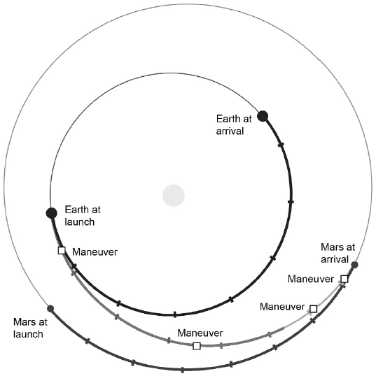
LicensePoints possible: 1
3. First erupting volcanoes to be discovered outside of Earth were discovered on this moon.
Largest subsurface ocean known containing more water than all the Earth's oceans.
Largest moon in the Solar System.
First moon in the Solar System discovered to have water geysers.
Moon with the thickest atmosphere.
Only moon in the Solar System less dense than water.
Moon with the greatest hemispheric contrast in albedo.
Furthest cryogeysers discovered from the Sun were found here.
Moon that is closest to the size of the main body it is orbiting.

