Darrel Lea
Student’s Name
Institution
Course Code
Date

- Introduction
  - Background
Darrel Lea is one of the renowned companies in Australia since it has existed for over fifty years. It manufactures and distributes liquorices, chocolate, and other confectioneries. It was founded Darrel Lea and operated for over 85 years as family business and over the years, it has grown to become the best liquorices and chocolate firm (Darrel Lea , 2018). Darrel Lea operated as a family business until 2012, when Queensland Owners of VIP Petfood acquired shares of the company due to losses it was facing. However, the Brand Darrel Lea is the name of the founder of the company, and over the years, it has been built to be a chocolate brand in the market. According to Darrel Lea (2018), the company is headed by the Chief Executive Officer (CEO) and it has several directors, which head various departments. The directors’ reports directly to the CEO while the CEO reports to the board of directors of the company. The board of directors is the final decision maker of the company and therefore, every major decision has to be made by the board of directors.
  - Brand Vision
Darrel Lea intends to build a unique name in the market, which customers can trust and enjoy for years to come. Therefore, the brand vision is to become a trusted name in the market, which every customer can relate to.
Brand Exploration
  - Brand Identity
Wilson (2014, p. 12) stated that brand identity is the way the clients look up at the brand and distinguish the brand from the other brand in the market. It is the most essential step in building brand in the market and therefore, Darrel Lea has applied several strategies to ensure that the its brand is identity in the market. Darrel Lea has various marketing strategies such as promotion, advertisement campaign and posters. However, over the years, the company has been missing from mass media and therefore, it is important reintroduce the company to the customers through mass media (Wilson, 2014, p. 22). Darrel Lea should invest in TV, radio and in door advertisement such as digital signage to reconnect with customers. Since advanced technology has changed the marketing environment, the use of social media network to market the chocolate and other products offered by the company would make it easy for the firm to build its brand identity in the competitive market. The use of facebook, twitter, Instagram and YouTube would be the best social media strategy, which would make the company to be known widely in the market and could edge out its competitors.
  - Brand Salience
Brand Salience is the quality noticeable in the market and therefore, Darrel Lea is identified by customers as a firm which provides fresh chocolate to customers. It is therefore, makes most customers to regard Darrel Lea in high standard in the market. Although the industrial competition is very stiff, Darrel Lea still remain most preferred chocolate firm and therefore, it means that most customers regard it in high standard as the quality provider of chocolate and liquorices.
  - Brand Meaning
2.31. Brand
Darrel Lea offers variety of product to its customers. According to Lannin (2015, p. 15), it offers about 800 products and therefore, customers can choose a product, which can satisfied his or her needs. Most of its products are fresh, and quality. The chocolates are made from fresh vegetables and in different flavor and therefore, all customers can get their favorite flavor. The products are also packed in nostagalia making Darrel Lea’s products to be uniquely identified in the market (Lannin, 2015, p. 21). The company is also known for its extra ordinary customer care support. This has helped in building its customers based in the market for century. Most products are priced fairly and therefore, affordable to most customers. Darrel Lea offer several products in different sizes and grams. Every client can get a product of his or her choice.
2.3.2. Brand Imagery
The brand imagery is the regarded as the way most clients perceive the brand in the market (Karmalkar, 2016, p. 5). Darrel Lea is known as a sexy and soft brand. It is lovely and most customers relate the brand with love and care and therefore, it is most preferred by couples, and teenagers. It is a symbol of love to many customers in the market. It is important for the company to improve the taste and also ensure that variety of flavor is available for customers.
  - Brand Reponses
    - Brand Judgments
Darrel Lea is a renowned brand and many customers regard it has a strong brand in the market. It is loved by many customers because of its quality and fresh chocolate product it has been producing for decades. Study has also indicated that client response to the brand is positive and strong. This is because of the company is still valued high in the market. It continues to expand to different location despite the management and financial challenges it has been facing. However, it would be important for the management to continue to build its product based on marketing and efficient service delivery to customers.
    - Brand feeling
According to Mabbott (2016, p. 12), many customers love chocolate and other products offered by the company and therefore, it customers have positive feelings towards the brand.
  - Brand Relationship
    - Brand Resonance
Research indicates that many customers have strong relationship with Darrel Lea products (Mabbott, 2016, p. 21). A study conducted by the company indicates that majority of its customers relate its products with love and therefore, this has helped the company to build a strong relationship with customers. This is the reason the company was acquired a $200 million despite experiencing a lot of loses and other market challenges in the past.

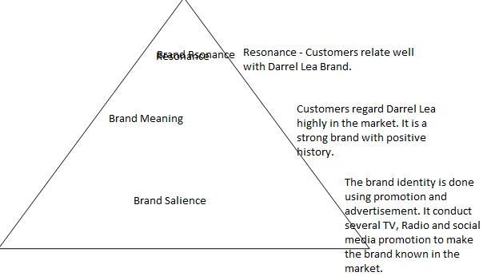
Figure 1: CBBE framework

Bibliography
Darrel Lea . 2018. Darrel Lea Management Structure . Darrell Lea expands products in turnaround triumph for once , 2-15.
KARMALKAR, H. 2016. Difference between brand awareness and brand salience. Brand Building , 2-18.
Lannin, S. 2015. Darrell Lea expands products in turnaround triumph for once-struggling company. International Journal of Business and Communication , 12 (3), 2-15.
Mabbott, G. 2016. The four Ps behind Darrell Lea's rocky road to a bitter end. Ad NEw International , 2-15.
WILSON, R. 2014. Darrell Lea: a take home message for marketers, CEOs and business owners. https://www.marketingmag.com.au/hubs-c/darrell-lea-a-take-home-message-for-marketers-ceos-and-business-owners/ , 2-35.

