Bronchoscopy
[Name of the Writer]
[Name of the Institution]

Bronchoscopy
Bronchoscopy is a procedure that allows the examination of the interior of the lungs and its pathways. It is notable to mention that bronchoscopy is used to detect certain lung problems that make it difficult for an individual to breath properly. It can also be used to detect and investigate infection, bleeding and tumors. For that particular purposes, doctors use an instrument called bronchoscope that is made up of fiber optic material. The bronchoscope has been inserted up to the lungs through the nose or mouth (Mahmoud & Kalanjeri, 2019). The device contains a light source and camera that helps healthcare practitioners to properly examine the entire lungs and its pathways.
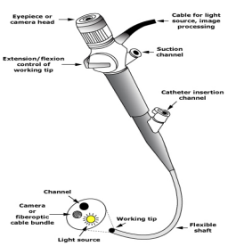
Source: https://www.heritagevalley.org/media/W1siZiIsIjIwMTgvMDEvMzEvM2l1dWs5MmNvYl9IVk1HX1B1bG1vbm9sb2d5YnJvbmNvc2NvcHkucGRmIl1d/HVMG_Pulmonologybroncoscopy.pdf
Before the process of bronchoscopy, a local anesthetic spray is used around the throat and nose of an individual. Healthcare practitioners provide with a sedative to help a patient to relax. It is notable to mention that general anesthesia is usually not required during bronchoscopy. After implementing anesthetic spray to nose and throat, the bronchoscope is inserted into the nose (Kabadayi & Bellamy, 2016). That instrument is inserted up to the airways (bronchi) of lungs. The instrument contains brushes in order to collect tissue samples from airways of the lungs. It is essential to take tissue samples from the lungs to identify the condition of the lungs. It is noteworthy to mention that samples from inside the air sacs are highly beneficial to effectively examine the condition of lungs. For this particular purpose, healthcare practitioners wash the lung with the help of saline during that procedure. The bronchial washing process is used to collect cells that are washed off from the airways' surface (Mahmoud & Kalanjeri, 2019). These cells are then examined under a microscope to investigate the lung. In order to avoid any complications during the procedure, the patient is connected to a heart monitor. Required time for the completion of bronchoscopy varies on the basis of health complication (Kabadayi & Bellamy, 2016). However, in general, half an hour is required to complete the entire procedure.
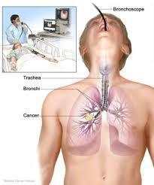
Source: https://www.indiamart.com/proddetail/flexible-fiber-optic-bronchoscopy-7112280648.html
Patients with acute hypoxemic respiratory require intubation post-procedure. Hence, it is required to operate these patients in secure settings to safely secure the airways. Patients on non-invasive ventilation (NIV) require special consideration during the procedure of bronchoscopy. In order to facilitate an effective bronchoscopy in patients on NIV, a nasal mask or high flow oxygen can be used to properly regulate the entire procedure without any complication (Kabadayi & Bellamy, 2016). T-adopter can also be attached to the facemask in order to insert the instrument for bronchoscopy for a patient on NIV.
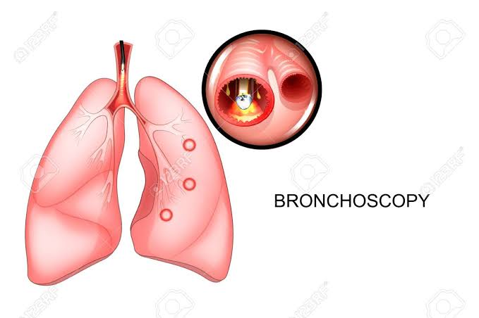
Image: Vector illustration of a bronchoscopy of lungs
It is necessary to adhere to some necessary practical techniques during the procedure of bronchoscopy. Healthcare practitioners should ensure that bronchoscope's light source, scope focus and white balance are properly adjusted before inserting the instrument through the nose (Kabadayi & Bellamy, 2016). Proper orientation of bronchoscope is highly necessary to conduct an adequate examination. Therefore, it is essential to keep the instrument in the center of the lumen to ensure the effectiveness of this procedure.
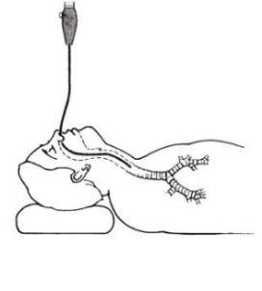
Source: https://stanfordhealthcare.org/medical-tests/b/bronchoscopy/procedures.html
Incidences of complications are low in bronchoscopy that indicates its effectiveness. Average mortality rate regarding the use of bronchoscopy is as low as 0.01 percent, however, in some cases, it shows 0.08-2 percent mortality rate. Common complications related to the use of bronchoscope include trouble breathing, infection, bleeding, lung damage, inflammation of lung tissue, narrowing of bronchi or trachea, and low blood oxygen level (Chen & Bai, 2019). During the procedure of bronchoscopy, there is a chance of lung collapse that is referred to as pneumothorax. Using a rigid bronchoscope rather than flexible bronchoscope can result in pneumothorax (Chen & Bai, 2019).

References
Chen, K., & Bai, C. (2019). Occupational adverse effects and protective factors in bronchoscopy. Journal of thoracic disease, 11(4), 1651.
Kabadayi, S., & Bellamy, M. C. (2016). Bronchoscopy in critical care. Bja Education, 17(2), 48-56.
Mahmoud, N., & Kalanjeri, S. (2019). Bronchoscopy. In StatPearls [Internet]. StatPearls Publishing.

