Lab Name

Date

Student Name

Instructor Name

Data Collected:

 |  |  | JULY 18,2019
Weather condition | CLEAR SKY | CLEAR SKY |  | CLEAR SKY | PARTIALLY CLOUDY
Time | 7:35 AM | 12:35 AM |  | 3:07 PM | 09:08PM
System Output | 2.20% | 2.10% |  | 2% | 2.40%
AC kW Output | 24.6 | 25.6 |  | 26.8 | 27.4
Total kWh reading | 26.4 | 28.4 |  | 30.6 | 32.8
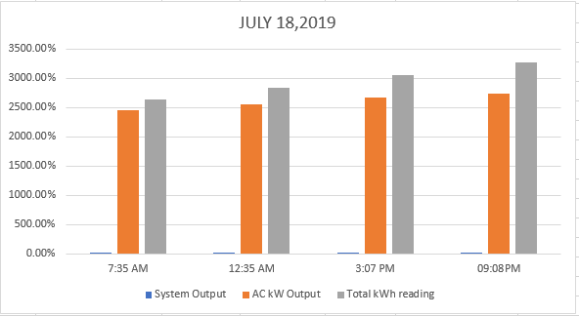

 |  |  | JULY 19,2019
Weather condition | Clear sky | clear sky |  | clear sky | cloudy
Time | 7:35 AM | 12:35 AM |  | 3:07 PM | 09:08PM
System Output | 2.00% | 2.10% |  | 2% | 2.80%
AC kW Output | 26.6 | 27.4 |  | 28 | 30
Total kWh reading | 28.8 | 30.4 |  | 32.6 | 34.8

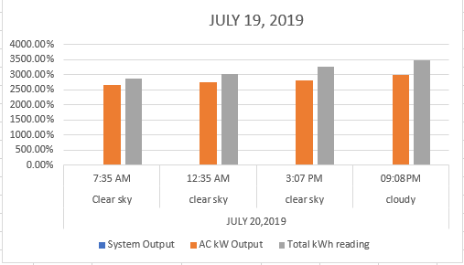

 |  |  | JULY 20,2019
Weather condition | clear sky | clear sky |  | cloudy | cloudy
Time | 7:35 AM | 12:35 AM |  | 3:07 PM | 09:08PM
System Output | 2.40% | 2.60% |  | 3% | 3.20%
AC kW Output | 24.6 | 26.4 |  | 30 | 34
Total kWh reading | 28.8 | 32.4 |  | 34.6 | 36.8

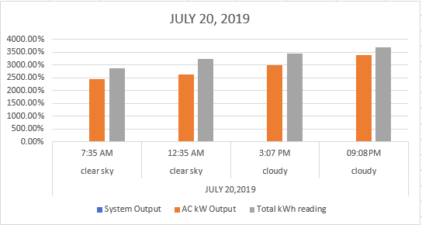

Observation
Following the analysis of the data collected from real time monitoring, it is observed that, if temperatures are high, it will give less energy to the panel. However, the solar panel works more efficiently and gives off higher outputs at low temperature.
  - The above claim can be proven by the fact that almost 1% of the solar radiations are converted into wind energy. This conversion is only due to the circulation of air from cold to warm areas. Besides, water energy sources are also considered an indirect form of solar energy owing to the fact that the stored water in dams or other natural reservoirs owes rainfall. Moreover, it is a very common phenomenon that rainfall occurs due to the evaporation of water because of the heat from the sun.
  - The main difference between active and passive solar system is that active solar system requires external devices such as pump or fans to pump the fluid. On the contrary, passive solar system does not require any pump or any other external device for the pumping of the fluid. Passive solar systems, unlike active systems, use liquid or air in solar collectors as a conductor.
  - Weather plays an important role in the production of energy by PV cell. Photon strikes the panel and get converted into direct current. After the production of DC (Direct Current) invertors convert this current into AC (Alternating Current). When the weather is cloudy but not windy, then amount of sunlight reaching the panel will be reduced, and thus, the production of DC will also be reduced.
  - The system that was observed for the three days of July can meet our energy requirements as our monthly requirement is 990kWh, and daily average production of this system is 34.8kWh. if this daily average is multiplied by number of days in a month, we get surplus energy i.e. 34.8 X 31 = 1078.8 kWh or 34.8 X 30 = 1044 kWh.
  - Conservation of energy plays a vital role to meet our energy requirements. If energy demand gets higher than the energy production, than energy sources would start draining, using renewable energy as an alternate would be beneficial to reduce our dependence on the non-renewable energy resources.
  - Batteries are the main source of energy storage. If our solar system is producing surplus energy, as in our case, then we can use a battery or a combination of batteries to store this surplus energy.
  - Experts are of the view that no renewable energy source would be able to dominate fossil fuels in the years to come. It is because fossil fuels are the primary source of energy for vehicles in America and will continue to have large share in energy production for America. Fossil fuels are cheaper than other renewable energy sources, and if fossil fuel is replaced with another energy source, it would simply increase the cost of the fuel. All renewable energy sources are costlier than fossil fuels.
  - The exercise we performed in the laboratory can be explained within the context of environmental science and sustainability course because all the living organism needs energy for their survival. The sources of energy such as sun, water, wood, coal, fossils surround us, and we need them in our lives. All the energy sources are environmental sources, and we constantly use them to meet our energy demands. So, that is why the lab experiments can be explained in the context of environmental and sustainability course. If environment is sustained, it means the energy sources are sustained

