Name of Student
Name of Professor
Name of Class
Day Month Year
Gallery Paper
This was for the first time since I am this much mesmerized while visiting Weatherspoon Art Museum. The place left me spellbound with the beauty and creativity of artistic features. The place is of ultimate beauty for the one’s who find calm in art. An actual representation of Art for Art’s sake. I have visited the art museum a couple of times before but this time when I came up with my mindset of finding a piece of art for my assignment, I was awestruck seeing the efforts and feels an artist puts in his work. It was not mere a single painting that grabbed my attention but every single piece that hit my sight was of ultimate beauty.
I personally liked this experience of visiting Art Museums as it is a refreshing activity for those who find art as a source of expression. You see paintings talking to you and narrating tales. Not mere paintings but the sculptures as well; they give you a stance of your own thought. You can dive in the ocean of your perceptions as deep as you desire. Same was my case when I visited Art Gallery.
Selected Painting
The painting that I have selected for this assignment is painted by Hung Liu. She was born in Changchun, China in 1948 and is a well-known Chinese Artist.
The name of the painting is Olympia triptych. It was painted in 2015. Its size is known to be 41 x 95 inches. It was originally made from oil paints on canvas, lacquered wood, resin, metal leaf, and hand painting with lithography link.

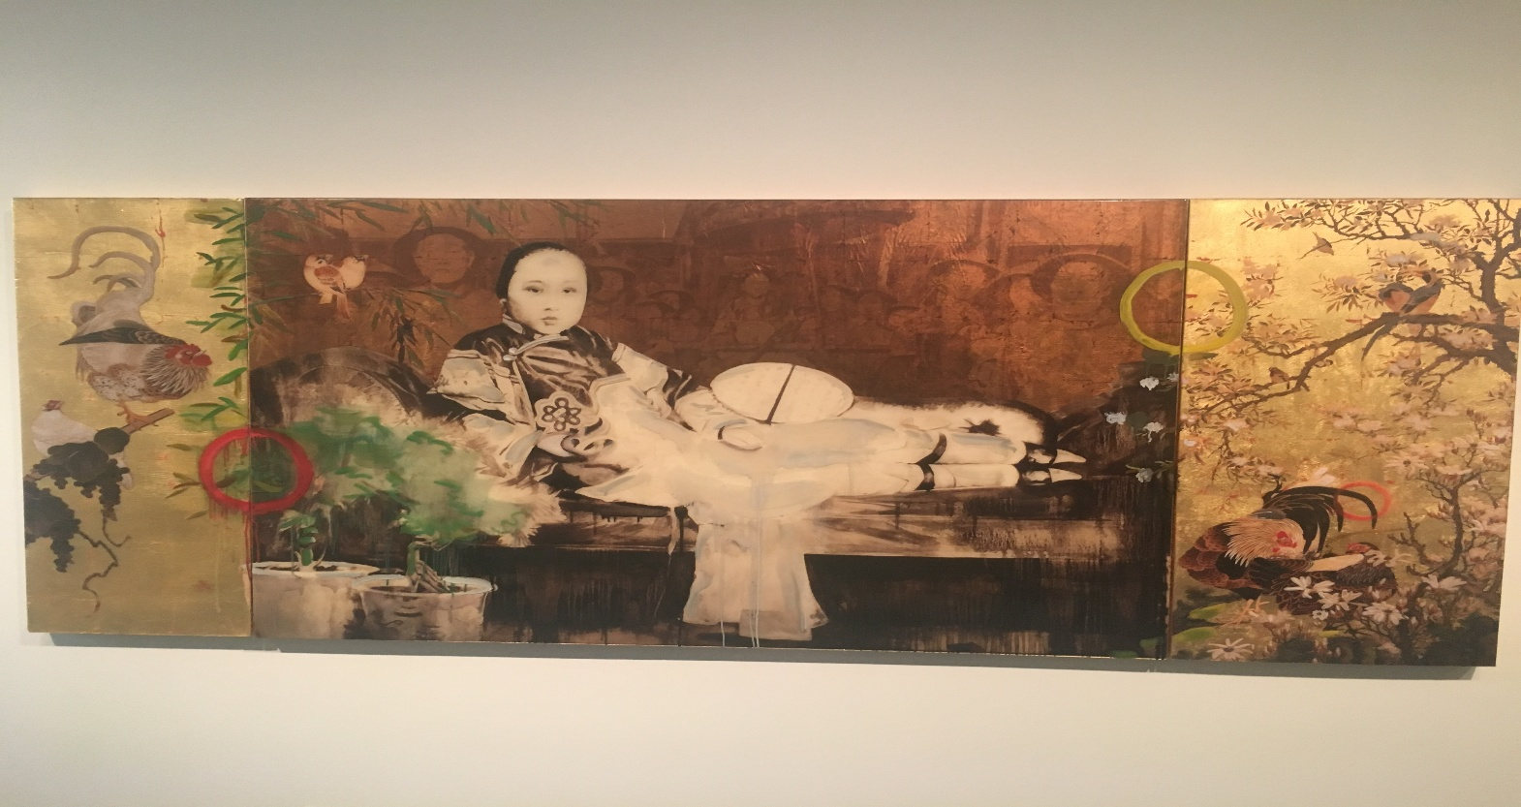

Analysis
The basic idea that generates in the head after having the first glance at the picture, is the portrayal of the Chinese heritage, embodied into beautiful psychedelic colors that give the essence of tranquility to the viewers mind, because colors are responsible for creating various personas in the minds of a viewer, the clothing reveals that the painter has crystal clear imagine of the Chinese feudal slave clothing during the reign of various Chinese dynasties. Since the painting is directly linked with the Chinese traditions, by observing they subjects face, it gives the notable expression of prosperity through the means of industrial revolution and supporting the ideas of communist legislatures, as China is already on its verge for being the dominating supreme power, the subject also indulges the essence of futuristic cyborg implants in the human race, that appears on the lower section of the human/subject, it has the source of having robotic characteristics, in the form of implants by replacing legs with robotic advancement, since China is also being prosper in terms of currency and technological advancement the painter also shows the signs of modernity originated for Chinese to be the first one to use cyborg implants. The painting can also be viewed as the modern expression of feminism, where the majestic subject is appeared as being calm and sound and the background appeared as being the men standing praising her for its elegance. One of the clear essence of the painting is related to the surreal element with in the picture that depicts the idea of beyond the perfection, because surreal art is the stage that is achieved after reaching perfection, second element in the back ground is the idea of adding red and a dark color , which makes the subject in front more appealing and noticeable by the viewer, Later it gives the idea of an army of soldiers in the background or the army of angels supporting the existence if a godly character, and they are all submissive to this entity that brightly looks into the eyes of viewers as it is demanding you to be submissive, secondly it is very unclear to this point to define the gender of the subject, which gives birth to this idea that the character is genderless, and show that according to the painter humanity is above all the social constructs, we label ourselves male or female, based on our appearance whereas gender based on how you feel and what you identify yourself to be at any point in life.
The idea that is generated in mind of a layman after seeing this picture is the objectification of women. Women have always been measured on the scale of their body. Let it be any era or any place in the world, women are always meat for the eye of man, not souls. This is the thought being portrayed in the painting.

Works Cited

Barnhart, Richard M., Yang Xin, and Nie Chongzheng. Three thousand years of Chinese painting. Yale University Press, 1997.

