Compensation Plan
Tracy (First M. Last)
School or Institution Name (University at Place or Town, State)

Total Rewards consists of monetary and non-monetary rewards provided by companies to attract, retain and motivate their staff (Mathis & Jackson, 2011). This program is aimed at aligning the business goals and objectives with employee’s rewards and recognition programs to achieve the business objectives effectively. This paper aims at designing a total compensation and reward program consisting of all the essential elements that an organization has to include in their reward program.
Total Reward and Compensation Program
The typical total compensation plan consists of compensation, benefits and performance and talent management programs.
Compensation
The first element of the program is compensation. The employees are entitled to receive fixed as well as variable compensation. Each employee is eligible for:
Base Pay: Fixed salary or basic compensation that an employee receives. Base pay must be decided on the basis of thorough analysis of an individual’s job responsibilities, job content, qualification and experience and salary range (“The Total Compensation Plan – Human Resources in the Food Service and Hospitality Industry,” n.d.).
Variable Pay: Bonus depending on employee performance. It would be in terms of cash.
Tenure Bonus: Eligible for employees who have completed a tenure of one year depending on the job description. This is a retention bonus.
Long-term Bonus: Employee who have completed more than a year in the organization. The options that can be offered are cash, performance shares or restricted shares.
Increase in Pay: realistic increase in pay if the employee has served the organization or more than one year.
Benefits
The second thing to be included in the plan is Benefits, an indirect way of giving rewards to employees which contributes to organizational commitment (Ju, Kong, Hussin, & Jusoff, 2009). Employees are eligible for these benefits regardless of their performance. As these benefits are expensive to offer, they must be evaluated before implementation and consulted with an external party.
Health care Benefits: Medical insurance including the dental insurance administered by a reputed health insurance company. Life and accidental insurance plans covered by the same insurance company.
Paid time off: Offering 3 paid leaves in a month and other leaves such as maternity leave considering the US employment and labor laws. The paid time off hours will be determined by the years of services.
Retirement Plan: offer a savings retirement plan for employees.
Facility to access gyms and other health care centers on discounts.
Workplace flexibility: Work from home benefits for experienced employees who have worked for more than 6 months
Performance-Based Awards
These rewards are based on the performance of employees and can be in the form of cash or non-cash benefits
Awards for an employee for the month / year
Appreciation Notes and Emails to the performing employees
Exceeding performance awards in the form of cash or pay raise
Career development and Talent Management
Internships: offering internships in international organizations according to the job description of employees
Training and Management Programs for employees depending on job needs and description
Seminars and Workshops for employees: workshops for skills development of employees such as soft skills and technical skills
Internal Promotions of employees based on their performance and job description of the new post.
Compensation Pie Chart
The compensation plan shows how the compensation is distributed among different elements of compensation plan.
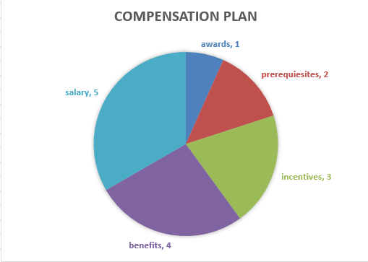

Implementation Plan

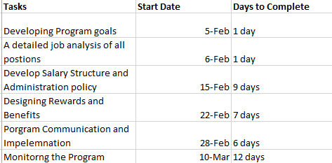
Compensation Benchmarking
Benchmarking is the process of identifying best practices and adapting them to improve your performance (Stapenhurst, 2009). Compensation Benchmarking is the process of using the internal job description to match to the established salary survey jobs with the aim to assess market rate for every benchmark position in the market. Compensation benchmarking helps an organization in identifying the market rate for the core positions. It is essential to guide the company in decision making regarding hiring, promotion and salary adjustments and budget planning for compensation and benefits. Labor cost is the highest for any organization and hence understanding the obvious value for each position helps an organization determine to develop a total reward policy for maximum benefit. It allows the leaders to identify the cost associated with compensation plans.
Without having a reasonable pay structure, organizations do the effort to retain talented employees. Making large financial investments each year is not suitable for an organization. Therefore, compensation benchmarking is important to maintain the competitive edge.
The success of the Compensation Plan
To measure the effectiveness of a compensation plan, first of all, it is important to obtain data from the participants of the plan. This will help evaluate the plan that if it has worked or not. The effective compensation plan must be linked with the organizational goals and objectives. If it is contributing towards the goals, the plan is effective. Obtain information regarding the results of the components of the plan that if the components of the plan are contributing towards the desired results or not. Monitoring the plan towards the desired objectives helps to measure the effectiveness of the plan. In addition, a cost-benefit analysis can be done with the Chief Financial Officer to measure the effectiveness of the plan.

References
Ju, S., Kong, L., Hussin, Z. H., & Jusoff, K. (2009). The influence of employee benefits towards organizational commitment. Asian Social Science, 4(8), 147.
Mathis, R. L., & Jackson, J. H. (2011). Human resource management: Essential perspectives. Cengage Learning.
Stapenhurst, T. (2009). The benchmarking book. Routledge.
The Total Compensation Plan – Human Resources in the Food Service and Hospitality Industry. (n.d.). Retrieved January 26, 2019, from https://opentextbc.ca/humanresourcesinfoodservices/chapter/the-total-compensation-plan/

