[Name of the Writer]
[Name of Instructor]
[Subject]
[Date]

Kidney Disease
Introduction
Kidneys are bean shaped organs of human body that are responsible for extracting wastes from blood and balances body fluids, they form urine and aid in maintaining metabolism of the body. Kidneys are in the upper abdominal cavity, where they are placed opposite to each other. The right kidney is located little bit lower than the left kidney. (Otero, et, al. 2019). A human body have two kidneys but there are people who born with a single kidney.
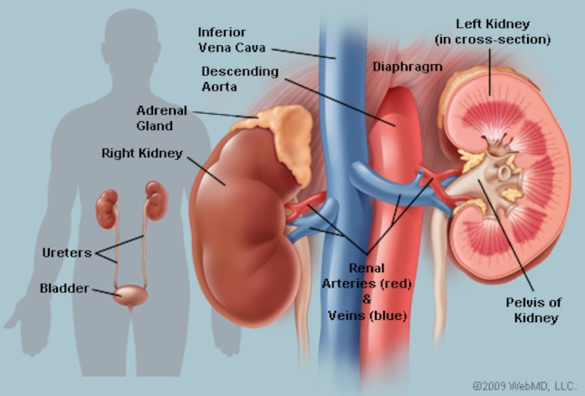
Discussion
In urinary system, kidneys are termed as multi-functional powerhouses of activity with major function, described as follows
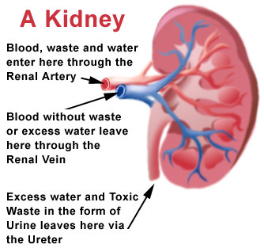
Waste Excretion
There are a number of materials that are not required by body but still found in body such as toxins, urea, nitrogen-based wastes and excess salts. Kidneys filter these waste materials in the form of urination. (Johnson, et, al. 2018, pp. 851-865).
Balancing of water level
Kidneys are made to ensure water balance in body by the chemical breakdown of urine. As there is reduced water intake, kidneys adjust by maintaining water level by lowering the process of extraction, the reverse happens in excess of water level in the body. (Otero, et, al. 2019).
Regulating blood pressure
Another major function of kidneys is to regulate blood pressure by adjusting pressure. Constant pressure is required to filter blood, taking into account that when it drops below normal, the kidney increase pressure. (Otero, et, al. 2019). Blood pressure is maintained by producing blood vessel constricting protein, also termed as "Angiotensin" that signals body to retain the level of sodium and water.

Regulation of Red Blood cells
It is another function of kidneys, taking into account that when kidney run lack of oxygen they send signals for a hormone “erythropoietin” that stimulates bone marrow to facilitate carrying of blood cells by more production of oxygen through bone marrow. (Otero, et, al. 2019).
Regulation of acids
Acids are produced by the human body as a result of cell metabolization. Consumption of food increase acid in our body that are neutralized by kidneys. (Otero, et, al. 2019).
Kidney Diseases
Any mismanagement or hindrance in the proper functioning of kidneys is called kidney disease. It is important to note that there are two categories associated with kidney disease, i.e. acute and chronic
Acute Kidney diseases
Acute kidney infection or kidney disease refers to any malfunction in kidneys such as blood loss as a result of injury, dehydration and excessive use of medicines. It also includes obstruction in urine leaving kidney, as a result of some cyst or stone formulation. (Johnson, et, al. 2018, pp. 851-865).
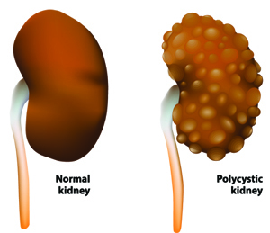

Chronic Kidney Diseases
When adequate functioning of kidney is disrupted over a course of time, i.e., many years, it is called chronic kidney disease. It is important to note that chronic kidney diseases also lead to kidney failure. Major chronic kidney disease are as follows
Diabetic Nephropathy
In this disease, there is damage to the capillaries of the kidney as a result of long term diabetes. Some symptoms of Diabetic Nephropathy are swollen legs, tiredness, nausea, headache, and itchy skin. (Johnson, et, al. 2018, pp. 851-865).
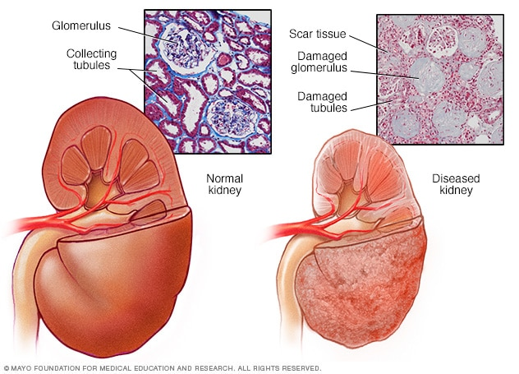
Kidney Stone
It refers to the formulation of a stone in the form of solid build-up of materials in the kidneys. Kidney stones can cause severe pain and they can block ureter.
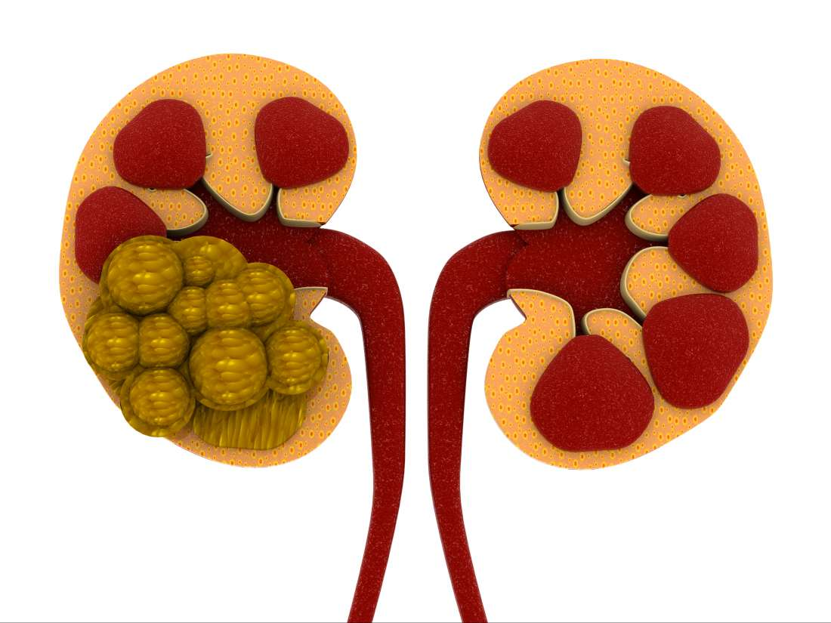
Renal Failure
In renal failure, a kidney is completely unable to filter and excrete out the waste products from the blood. (Katagiri, et, al. 2019, pp. 269-277). There are different causes of kidney failure, such as injury and over-consumption of medicine.
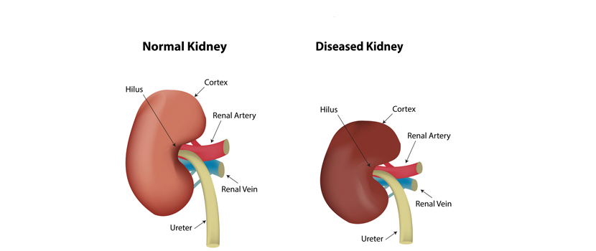
Kidney infections
Kidney infections are result of some bacterial or other infection in the bladder that is afterwards transferred to kidney. Some major symptoms of kidney infection are painful urination, lower back pain and sometimes fever. Kidney infection results in a change in urine such as, different odor, presence of blood and cloudiness. (Johnson, et, al. 2018, pp. 851-865). It is important to note, kidney infections are more common in women as compared to men.
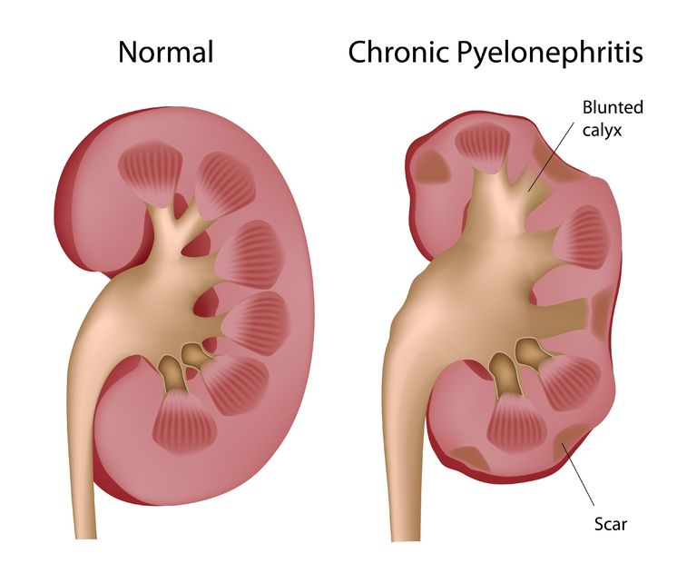

Kidney Hydronephrosis
This disease is also termed as, "water on the kidney" taking into account that it is the result of an obstruction that prevents adequate urination and intense pain. This situation may lead to the shrinking of kidney.
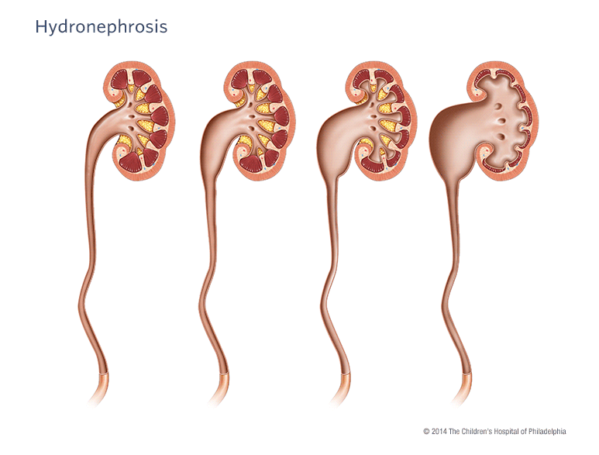
Nephrotic Syndrome
It is defined as damage to the kidney that may cause the protein level in urine to exceed than the normal range. It results in a shortage of protein throughout the human body that directs water into tissues. (Zarjou, Abolfazl, et al. 2019). Some symptoms of nephritic syndromes are increased level of cholesterol, anemia, puffy eyes, and fluid on the lungs.
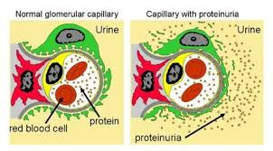

Duplicated Ureter
It refers to the formulation of two ureters between bladder and kidney, taking into account that it can increase the risk of urinary tract infection. About 1% of people in this world are affected by this disease. (Katagiri, et, al. 2019, pp. 269-277)
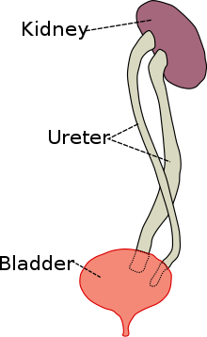
Kidney Tumor
It refers to the formulation of a tumor, either benign or malignant in the kidney. It is also called renal cell carcinoma or kidney cancer. (Johnson, et, al. 2018, pp. 851-865).
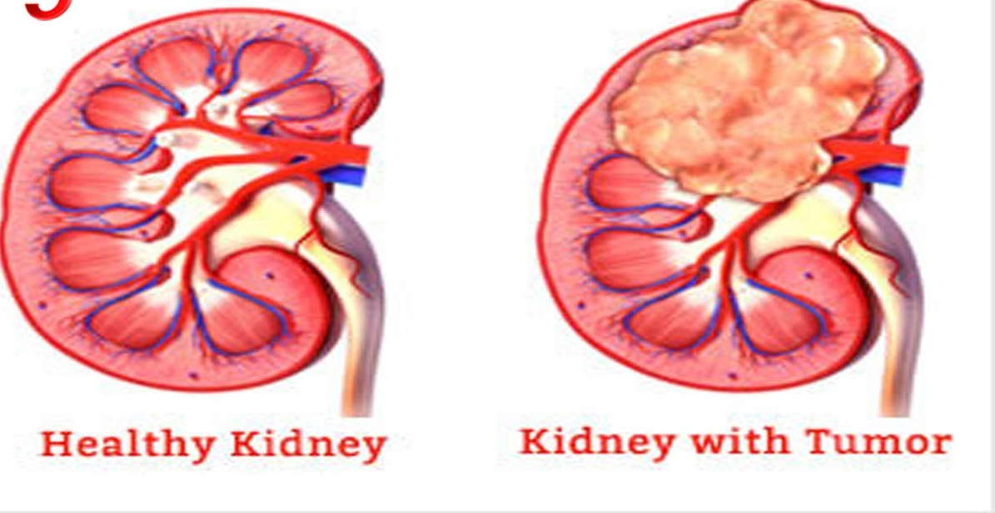

Interstitial Nephritis
Interstitial Nephritis is a kidney disease that is a reaction to bacteria or medication that can inflame spaces within kidney. (Johnson, et, al. 2018, pp. 851-865). The treatment of this disease involves changing the course of medication or removing the causes of inflammation.
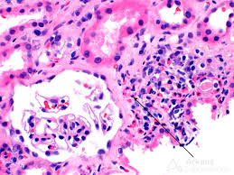
Glomerulonephritis
It is defined as a kidney disease that causes inflammation of kidneys' filtering units, also called glomeruli. It is important to note that glomerulonephritis may happen in both conditions, certainly as well as slowly over the course of years. The case of certain disease include strep throat and individual may recover soon. (Otero, et, al. 2019).However, in other cases, there could be a progressive loss of function of kidney.
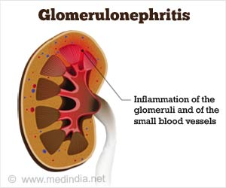

Conclusion
In a nutshell, it can be found that there are both, acute and chronic diseases associated with kidneys, having long term and short term effects. However, each disease can be treated with particular medication.

Work Cited
Johnson, Richard J., et al. "Hyperuricemia, acute and chronic kidney disease, hypertension, and cardiovascular disease: report of a scientific workshop organized by the National Kidney Foundation." American Journal of Kidney Diseases71.6 (2018): 851-865.
Katagiri, Daisuke, et al. "Acute Kidney Injury: Transition to Chronic Kidney Disease." Human Pathobiochemistry. Springer, Singapore, 2019. 269-277.
Otero, P. Alonso, et al. "High rates of protein intake are associated with an accelerated rate of decline of residual kidney function in incident peritoneal dialysis patients." Nephrology, dialysis, transplantation: official publication of the European Dialysis and Transplant Association-European Renal Association (2019).
Zarjou, Abolfazl, et al. "Dynamic signature of lymphangiogenesis during acute kidney injury and chronic kidney disease." Laboratory Investigation (2019): 1.

