Human Figures in Arts
Mark Wrublewski

HUM1002 History of Art from Middle Ages
30/10/2019

Early Renaissance (fourteenth century, 1300–1399
The artist: Giotto di Bondone
Title of the work of art: Lamentation of Christ
The date(s) it was created: 1306
The medium or materials used to create the work of art: oil paint in fresco technique
Where the work is located now. Church of St. Panteleimon (Gorno Nerezi)

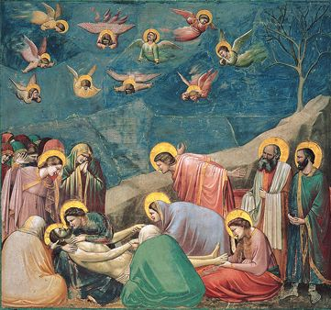

Historical importance
This fresco is included in the cycle of painting of the Skrovegni chapel, which has glorified and preserved the name of the artist for centuries. The master brought to his work something that was so lacking in the painting of previous eras - living emotions. It is enough to look at the fresco to immediately see its sharp difference from the works of church painting, made according to the Byzantine canons. There is no static and schematic in the image. Before us are living people, each of whom grieve differently. They are captured in different, but very natural and lively poses, and their clothes are folded with real bodies, and not illusory ethereal models. They have expressive and recognizable faces with individuality, and not differing in iconographic sketchiness.
The figure of Christ is striking this is really a dead body, not the dolls that were previously depicted. And the point is not in his mortal pallor, but in how the artist conveyed his lifelessness - relaxed, limp hands, thrown back head, outstretched legs, absent expression. And in contrast - the stormy emotions of the apostles surrounding him - the arms of the young apostle John, beloved disciple of Jesus, thrown back in despair, the restrained experiences of Joseph of Arimathea, who redeemed the body of Christ after the execution, and Nicodemus, who helped in his burial. Gathered around the still body of the myrrh-bearing wife, this is a real achievement in art.

Northern European Renaissance (fifteenth century, 1400–1499)
The artist: Rogier van der Weyden
Title of the work of art: Saint Luke Drawing the Virgin
The date(s) it was created: between 1435 and 1440.
The medium or materials used to create the work of art is oil paint.
The work is located now at: Museum of Fine Arts, Boston (Fred, 2017).

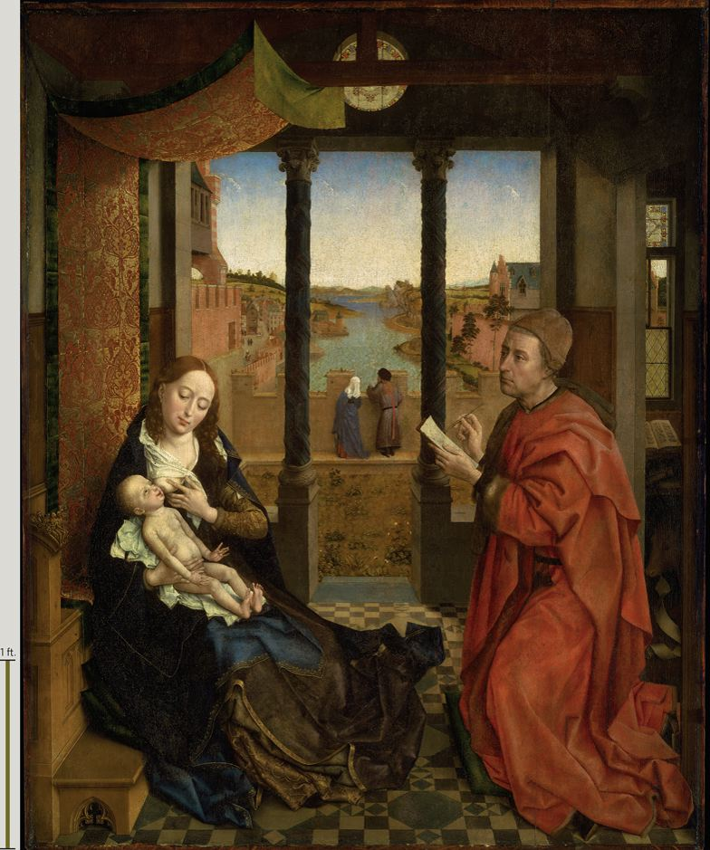
Historical importance
The image of the Madonna is one of the central images in all of Western European painting. And in the work of Rogier, he also occupies one of the main places. The piercing and reliable image of the Mother of God is created by the artist in the paintings of the "passionate" cycle. But no less expressive are his canvases, where the Virgin Mary is depicted with the Baby. Pay attention to the image of the "Madonna and Child" (after 1454), placed on the next page. The master does not resort to "additional" effects in order to emphasize the holiness of the Virgin. But Her very face emits an unearthly light. (Bartlett, 2014).
While the painting is realistic externally, there are no signs of holiness, it contains symbols such as, carved on the bench, naked Adam and Eve, symbolizing the Fall of man, who was born for his redemption. The balcony has a triple opening symbolizing the Holy Trinity and the circular window above it has three divisions. At the table below the window there is an open book, a symbol of Luke as an Evangelist. Underneath the table, in the deep shadow to prevent the illusion of reality from dissolving in his presence, is an ox, the symbol of St. Luke
Italian Renaissance (fifteenth century, 1400–1499)
The artist: Angelo Poliziano
Title of the work of art: Birth of Venus
The date(s) it was created: between 1484 and 1486
The medium or materials used to create the work of art : oil paint
Where the work is located now in Uffizi Gallery in Florence. (Cranston, 2017).
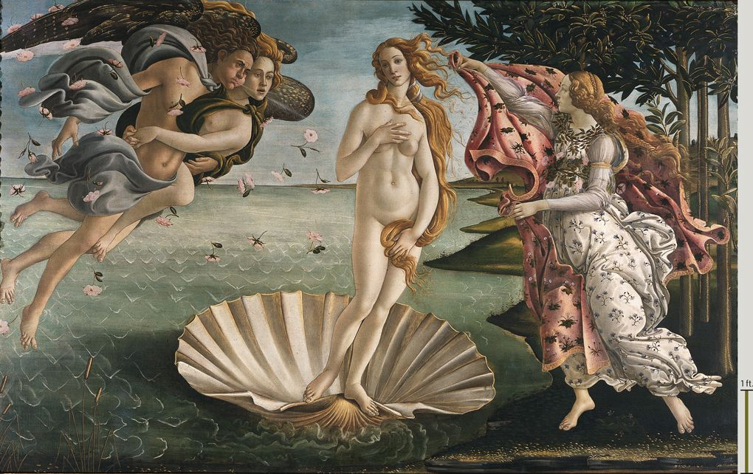
Historical importance
The topic is taken from ancient literature, more precisely, from Ovid's Metamorphoses. Naked Venus swims across the sea on a seashell, the god of the winds flies to her left, to the right, on the shore, Venus meets Ora with clothes in her hands in the nymph of the seasons. Violets bloom under her feet is a symbol of the renewal of nature. Among other literary landmarks is the poem "Stans" by Angelo Poliziano, a contemporary of Botticelli and the main Neoplatonist poet from the Medici circle. The philosophical interpretation of the work according to Neoplatonism is as follows: the birth of Venus is a symbol of the birth of love, the highest virtue and spiritual beauty, which is the driving force of life. (Malanima, 2018).
Among Renaissance artists, the naked Venus, in contrast to the dressed, symbolized heavenly love. Botticelli endowed his heroine with that chastity, which is revered as the highest virtue, hence the motive of worship present in the picture. The heroine’s beautiful face resembles the faces of Madonnas in Botticelli’s paintings, and therefore in this work the Christian theme sounds through the antique theme, and the combination of ancient humanism and Christianity gave the phenomenon of the Italian Renaissance.
Conclusion
In this fresco, Giotto was far ahead of his time, introducing emotions, movements, real human experiences into the monumental church painting. Pictures have ceased to be standard icons but have become a real reflection of reality - real or imagined. Botticelli has devoted a great deal of research to the "Birth of Venus." And in all, one way or another, poems by Angelo Poliziano are mentioned, which describe the same myth. There are different points of view, and among them there are two extremes, opposite: some researchers argue that Poliziano's poems were the main source of inspiration for the artist, that they were the basis of Botticelli's work; others argue that there is no connection between the picture and the poems. These are two extreme points of view, and there are many in between.

References
Bartlett, K. R. (2014). The Civilization of the Italian Renaissance : A Sourcebook (Vol. 2nd
edition). Toronto [Ontario]: University of Toronto Press, Higher Education Division. Retrieved from https://search-ebscohost-com.southuniversity.libproxy.edmc.edu/login.aspx?direct=true&db=nlebk&AN=1565411&site=eds-live
Cranston, J. (2017). Italian Paintings of the Thirteenth and Fourteenth Centuries. Art Bulletin,
99(2), 186–189. https://doi-org.southuniversity.libproxy.edmc.edu/10.1080/00043079.2017.13046
Fred P. Kleiner. (2017). Gardner’s Art Through the Ages: The Western Perspective, Volume II
(15th ed). Cengage. ISBN: 9781305645059
Malanima, P. (2018). Italy in the Renaissance: a leading economy in the European context,
1350–1550. Economic History Review, 71(1), 3–30. https://doi-org.southuniversity.libproxy.edmc.edu/10.1111/ehr.12650

