Religion in Sixteenth- and Seventeenth-Century European Art
Mark Wrublewski
BUS3001 Ethics in Organizations SU01
11/5/2019

Religion in Sixteenth- and Seventeenth-Century European Art
Michelangelo, Sistine Chapel Ceiling, 1508-12
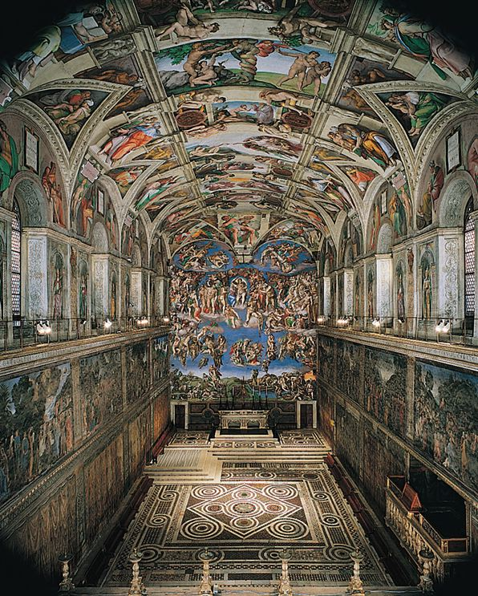
At the time of the beginning of the work of Michelangelo, 33 years old, he is already known and achieved success. Behind him is the creation of David and Pieta, all his time and skill is directed to work in sculpture, so the wish of Pope Julius II is like a bolt from the blue. “Michelangelo’s Sistine Chapel frescos are typical of the High Renaissance, and the artist’s own style, in their glorification of Christianity”(class notes: The High Resinance in Italy)
From Florence, Michelangelo goes to Rome at the invitation of the pontiff, Julius II wants the sculptor to execute for him a large-scale tombstone. Subsequently, Michelangelo will call this order his curse, the work will drag on for 40 years, and the vindictive Buonarotti will encrypt the image of this Pope in one of the unsightly figures in the scene of The Last Judgment.
May 1505. An understanding immediately arises between the pontiff and the sculptor, and it seems that the work is being argued. Michelangelo goes on a trip for valuable Carrara marble, and his pocket nicely burns a fee of 10,000 ducats, of which a thousand are for material. The initial design of the tombstone was huge and assumed 40 statues in human growth, so it only takes 8 months to choose the perfect material in quarries.
Everything is ready for work: marble is delivered to Rome along the Tiber, but by that time the mood and ideas of the Pope had already changed. Julius II aims to build the most grandiose Christian cathedral in the world, St. Peter's Basilica, and also wants to sing the greatness of the pontificate by renewing the frescoed venue of the meeting of the conclave, the Sistine Chapel. The work is expensive, and they need all the wealth available in the treasury, including the fee of our hero in ten thousand gold.
Grünewald, Isenheim Altarpiece, 1510-15
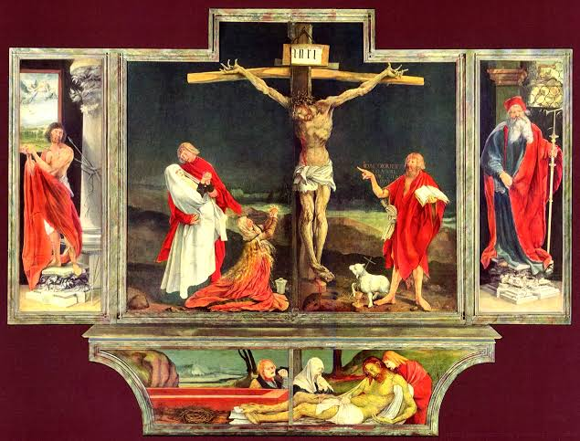
When the seriously ill came to the Isenheim Abbey, he was first taken to a church where he was silenced in front of an altar painting of Jesus' Passion painted by Mathis Grünewald . The idea of ​​healing was that pain can be overcome by experiencing Christ's suffering. The work was completed in 1515 as a result of four years of work. New ideas about the individual's relationship with God and society revolutionized the world at that time. The altar is now on view in the town of Colmar at the Unterlinden Museum, which was founded in 1853 in the church of the former Dominican Monastery to display and preserve Grünewald's work. (Isenheim)
At the same time as Michelangelo and Rafaello were commissioned by Pope Julius in Italy to strive for maximum harmony and balance, Grünewald did the opposite in Germany.Liisa Väisänen describes Grünewald as a reformer in both color and composition. People are like captured directly from the surrounding reality. John the Evangelist is reminiscent of a young German student, and John the Baptist has the characteristics of a rotten German country man.
Durer, Four Apostles, 1526
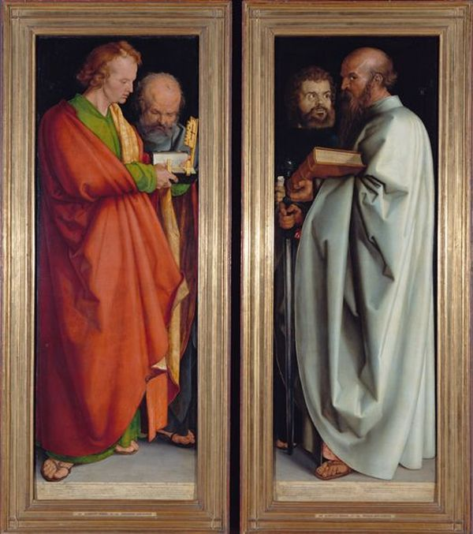
German painter, engraver, draftsman and art theorist. Born in 1471 in Nuremberg. First goldsmith's apprenticeship with his father, 1486/89 student of the painter Michael Wolgemut. Between 1490 and 1494, among others in Kolmar, Basel and Strasbourg. Two vertical boards fastened together with the image of the four apostles John, Peter, Paul, Mark (Dürer, 1996). Here, the viewer sees not only the significant innovations that characterize Dürer’s work as a whole - personalization of biblical heroes, dynamism of images, attention to detail, but also the philosophical ideas of the master, a peculiar illustration of his human ideal. The artist believed that a perfect person is one who is spiritually rich, has a will, is ready for action. He tried to portray all these high ethical standards in the apostles. Indeed, noble calm is read in their images, coupled with a lively character and a sharp mind. Divided into different wings, the work, meanwhile, seems indivisible in both compositional and spiritual terms. It is known that after the completion of the diptych, Dürer presented it as a gift to his hometown of Nuremberg, but appreciating the artist’s skill, the City Council decided to pay the author money for such a perfect gift.
Caravaggio, The Calling of St. Matthew, 1599-1600
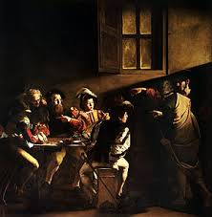

According to a long-established tradition, during the Christmas liturgy the Gospel of Matthew is read. On that festive evening, parishioners who filled the church — and among them were two Matthew brothers with wives and children, as well as some friends — were imbued with special reverence, listening to the words of the reading deacon, and before their eyes was a picture illuminated by many burning candles, telling about an important episode from the life of the first evangelist. It is known that at the gates of Capernaum Christ met the publican Levi and called him to become an apostle. But Caravaggio in his own way decides this scene from the Holy Scriptures (Olson, 2002). At first glance, the picture is difficult to determine where the action takes place. Only the window shutter on the wall - in Italian houses, as in Russian huts, it is always outside - indicates that the people depicted in the picture sitting at the table after the works of the righteous. Caravaggio is true to himself. Having violated the established traditions in the interpretation of the gospel plot, he creates a typical genre scene for the life of a Roman street, devoid of any hint of holiness. Everything in the picture is extremely clear, reliable and vital. The red-bearded tax collector or tax collector Levi calculates the collected daily revenue with the help of an old man with glasses.
Rubens, Elevation of the Cross, 1610

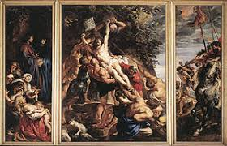
Peter Paul Rubens was a Flemish Baroque artist, best known for his extravagant “European” painting style. He was knighted, felt rich, incredibly rich from commissions, and died before he survived his talent. The theme of the Erection of the Cross does not appear until the end of the XVI century (around 1590) and it owes its existence to the counter reform. It is necessary to make the scene feel as if the spectator was present. The table is worth sermon, failing to understand it, the faithful is touched. His spirit was to rise from the terrestrial sphere to the celestial sphere, between art and religion, it is mass communication. The particularly spectacular presentation device can be brought closer to theatrical devices. It is intended to obtain the support of the crowds by artifices giving to the cosmetic effects the depth of a truth. (McCarthy, 2008). There are two approaches, one for the crowd and the other for the individual. The triptych is a pictorial composition with multiple panels that are fixed or mobile. Sundays during Mass, or during certain religious holidays, the shutters are open revealing the message delivered to the faithful. The outer faces are often reserved for Saints revered by the church. As a result, the sculptural appearance of saints (grisaille imitating stone) belongs to a tradition peculiar to the southern Netherlands.

References
Dürer, A. (1996). Four apostles, 1526. University of Manitoba.
Fred P. Kleiner. (2017). Gardner’s Art Through the Ages: The Western Perspective, Volume II
(15th ed). Cengage. ISBN: 9781305645059
Isenheim Altarpiece (exterior). Retrieve from :
http://www.learner.org/courses/globalart/work/234/
McCarthy, D. (2008). ART 232-01, History of Western Art II, Spring 2006.
Olson, T. P. (2002). Pitiful Relics: Caravaggio's Martyrdom of St. Matthew. Representations,
77(1), 107-142.
The high Renaissance of Italy.Retrieve from :
https://myclasses.southuniversity.edu/d2l/le/content/54185/viewContent/2179898/View
The Sixteenth Century in Northern Europe. Retrieve from
https://myclasses.southuniversity.edu/d2l/le/content/54185/viewContent/2179899/View

