[Jessica Malou Koenig]
[Name of Instructor]
[English]
[Date]

The Roles Photography played During the Crimean and American Civil War
A certain substance when illuminated undergoes several permanent changes. In the early nineteen century, these substances were utilized in the making of drawings known as photographs. When daguerreotypes were introduced in the US the people were highly fascinated by the possibility of capturing living beings, surroundings and several other objects on silver plates. In the context of the American civil war, photographs played a very important role. The war attracted people who were eager to show their photographic skills in the highly unsafe battlefields. Most of the photographers were lured by the possibility of profit yet some went on to the battlefield for the sake of adventure. It is estimated that there were roughly three thousand photographers who were involved directly or indirectly in taking pictures from the battlefield. This essay will discuss the role and aim of being the photographs that were taken during the war. Also, the contribution of pictures in the American civil war.
The American civil war is one of the most studied and written parts of US history. This war was fought between the North also known as the union and the south known as the confederacy in the US from 1861 to 1865. The major of the war was the enslavement of the black people. However, territorial and sectional political control was also the major reason for the conflict. When Abraham Lincoln was elected as the president of the United States the secessionists' forces attacked Fort Sumter causing the initiation of the war (Bestor). The ensuing outbreak of several armed hostilities was due to the growing sectional friction over slavery. Most of the southern states' economy was based on agriculture specifically, farms that produce commercial crops such as cotton. All these farms relied solely on free labor force who were slaves. They invested most of their money on slaves. In contrast, the Northerners invested more in transportation systems consisting of long roads, canals and other communication networks such as books, magazines, and newspapers. They were mostly in favor of protecting free labor and prohibiting slavery. Abraham Lincoln was also among the people who were against slavery so as soon as he became president of the United States the war started (Fernée). On the other hand, stemming from Russia, was the result of Russia pressurizing turkey. The Crimean war was the war that threatens multiple European commercial strategic interests in both the middle east and India. Religious differences also played as a catalyst in the Crimean war. It was during this time a photographer known as Roger Fenton became the first person to document war with the help of photographs.
Moving on towards the American civil war, it was the first armed conflict that was widely recorded and documented by using photographs that depict wartime. This fact alone suffices to arouse the curiosity and interest of people in getting to know more about the conflict (Gunderson). The images of unburied or wounded soldiers, wrecked landscapes were widely published and photography became the privileged means of depicting the conflict. The photographic records of civil war are divided into two categories. The first is photographs taken in the studios that are improvised as battlefields while the second photographs were actual images taken on the battlefield. The first category contains portraits of the soldiers who before going to the battlefield wanted to eternalize their pictures as a souvenir for their family and friends. Some of the pictures taken of the soldiers as shown below in figure 1.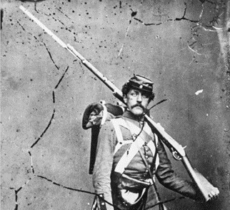
Fig.1: A portrait of a soldier before leaving for war (Gardner, Alexander, and Everett F.
Bleiler. Gardner's Photographic Sketch Book of the Civil War. Vol. 1. Courier Corporation,
1959.)
However, some adventurous photographers capture the images of the battlefield and the soldiers fighting in real life. This provides the opportunity for the soldiers to immortalize themselves as they will always be remembered for their bravery. Most of the photographers were from the North yet some of them were from the South. Mostly the Southern photographers were working under the worse condition as compared to their Northern fellow photographers because of lack of supplies and photo galleries. The second category contains the outdoors photographs that depict road construction, weapons, and bridges, etc (Sontag). A smaller portion of these photographs includes military actions, soldiers with amputated limbs and several African American people. The picture below shows dead soldiers on the battlefield.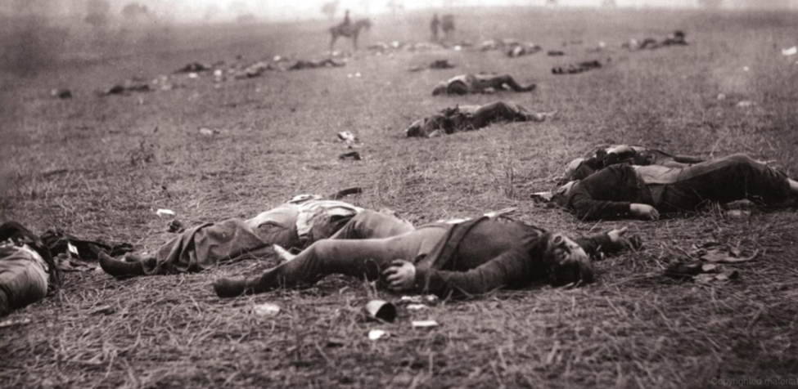
Fig.2: Dead soldiers on the battlefield (Gardner, Alexander, and Everett F. Bleiler. Gardner's
Photographic Sketch Book of the Civil War. Vol. 1. Courier Corporation, 1959.)
The above picture shows dead soldiers whose bodies are tormented while some of them have amputated limbs. This depicts how war can have severe consequences.
Mathew Brady was the first-ever photographer who aimed to capture the images of the battlefield yet was not encouraged by the American Photographical society. He then formed a corps of photographers who work on a field and capture several images of various locations and construction sites. Later another photographer Andrew Russell took pictures of construction sites from different angles that were very helpful for the war department. These images were used by the soldiers so that they could familiarize themselves with the terrain (Sontag). This led to the use of photography as an effective tool to trace spies among troops. Many military leaders hired several photographers so that they can gain intelligence regarding the emplacements of their enemy and road or hidden bridges and tunnels, etc. Some pictures of the battlefield and other sites are as follows: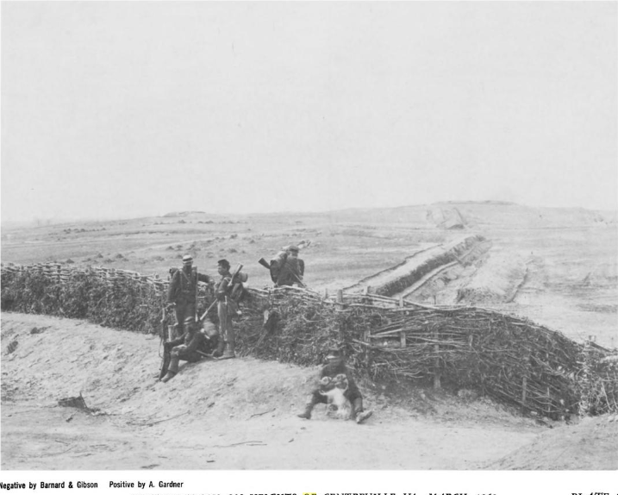
Fig.3: soldiers on the battlefield (Gardner, Alexander, and Everett F. Bleiler. Gardner's
Photographic Sketch Book of the Civil War. Vol. 1. Courier Corporation, 1959.)
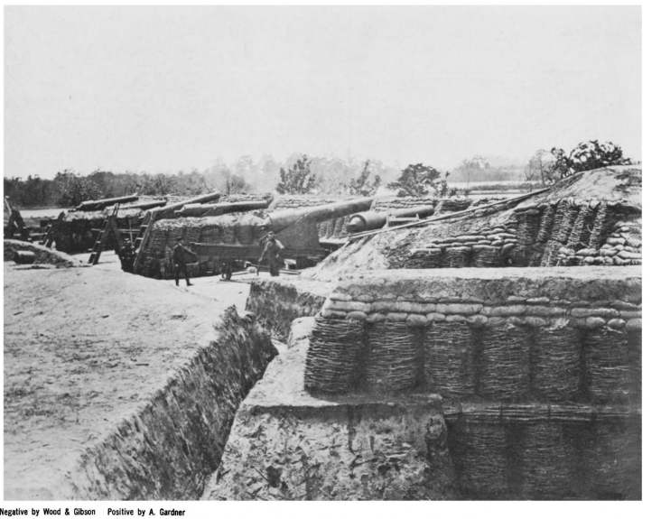
Fig.4: soldiers on the battlefield (Gardner, Alexander, and Everett F. Bleiler. Gardner's Photographic Sketch Book of the Civil War. Vol. 1. Courier Corporation, 1959.)
Both the pictures above show the battlefields and soldiers planning to fight while it also shows the weapons that a group of people has. This image could be very beneficial for the enemy as they can get an idea of the surroundings and the weapons that their opponents have.
The photography during the American civil war also helped in highlighting the minorities' participation in the war. Most of the Black males were conscious that their participation in the war could eventually lead to their recognition and help them in living a slavery-free life. Although African Americans faced several difficulties as according to the Federal Law 1792 they were not allowed to be recruited in the army. Additionally, in the North, racism was at its peak. Due to which searching for the pictures of black people from the civil war is like searching for a needle in the haystack. Most of the pictures depict black people in the war as contrabands while many were just studio portraits. Specifically, discussing field photography, the photographers usually capture encampments and regiments. However, in these pictures as well most of the black people were seen in the background only and due to low picture quality, their pictures were unrecognizable. Thus the photographs play a key role in depicting the racism against black in the American civil war. Although black males were accepted in the army yet they were still considered lower than the white soldiers and often used to serve the white officials (Frazier).
During the war, many of the soldiers died yet some of them were severely injured. Despite severe injuries, many soldiers were still alive. The photographers objectified the bodies of the dead soldiers to gain appreciation and attention. Many dead bodies were laid in between the rows of glass cases while several were placed in a different position so that their pictures could be taken and placed in the museum. Dead bodies were perceived as specimens for the photographers. Not only dead bodies the soldiers whose limbs were amputated or were paralyzed were also subjected to objectification and abstraction. The creation of the Army Medical Museum founded by William Alexander was aimed to collect the war souvenirs and exemplars of the battlefield but all these objectified images of soldiers’ dead body and tormented body parts were displayed for the exhibition. Even when the corps of the soldiers were not found they were snatched from the graves showing the darker side of the profession of photography.
The American civil war not only causes several casualties but also cause destruction of many cities. The photographs also played a key role in depicting the destructive power of the war. Although the main purpose of the photographers was to document war yet they also show the images of the wreckage. The main focus of the photographers was to capture images that show army life, destroyed buildings, and institutions. Moreover, images of intact valleys and forests were also captured. These pictures helped a lot in understanding how war can destroy not only the people but the environment as well. It also changes the way we perceive the battlefield (Trachtenberg). Although, dying on the battlefield is considered honor yet the images showed the struggles that soldiers faced during the war.
Photographs serve as a medium to tell us how people, objects and places appeared at a given time. They represent an impression and interpretation of things rather than the things themselves. Photographs played a key role in both the American civil war (Foner) and the Crimean war. The images taken during the wartime depict the ugliness due to an armed conflict. Although due to lack of technologies the action of the battle was not recorded yet still the pictures provided enough evidence of the destruction and issues during wartime. The pictures highlighted racism as well as the objectification of human dead bodies. However, they also show the post-war destruction as well that help people in understanding how conflict can cause severe consequence.

Work Cited
Bestor, Arthur. "The American Civil War as a Constitutional Crisis." The American Historical Review 69.2 (1964): 327-352.
Fernée, Tadd. "The American Civil War as a social revolution: the Enlightenment, providential consciousness and changes in moral perception." English Studies at NBU 1.1 (2015): 80-96.
Foner, Eric. "The causes of the American civil war: recent interpretations and new directions." Civil War History 20.3 (1974): 197-214.
Frazier, E. Franklin. "The Negro in the United States." (1949).
Gunderson, Gerald. "The origin of the American civil war." The Journal of Economic History 34.4 (1974): 915-950.
Sontag, Susan. "Looking at war." The New Yorker 9 (2002): 82-98.
Trachtenberg, Alan. "Albums of war: on reading Civil War photographs." Representations 9 (1985): 1-32.

