Finding the EMF and Internal Resistance of a Cell
Name
[Name of the Institution]

Abstract

This report aims at describing the experiment conducted to find and calculate the EMF and internal resistance of a battery or a cell. Initially, the important concepts related to this topic are discussed. A general overview of current, voltage, internal resistance and EMF is provided. Then the details of the experiment are discussed. The equipment used to conduct the experiment is also listed. The whole procedure of finding the EMF and the internal resistance of a battery or a cell has been explained in a detailed manner. Finally, a graph is also plotted from the experimental data.

Aim

The aim of the experiment and this report is to determine the EMF (electromotive force) of a cell or a battery and calculate its internal resistance.

Introduction

Every cell and every battery consists of some medium through which current flows. This medium offers some resistance to the current flowing through it. This resistance inside the cell or the battery is known as internal resistance. When current flows through the battery, as a result of this resistance, some heat is lost within the cell. It warms up the cell. Moreover, all the voltage provided by the cell does not reach the load. Some of it is dropped across the internal resistance as well. This report explains the difference between terminal voltage and EMF and provides the whole procedure for finding the internal resistance in a cell through an experiment in the laboratory.

Finding the EMF and Internal Resistance in a Cell

Before explaining the details of the experiment, some of the fundamentals associated with the experiment will be discussed below.
Voltage (V)
Voltage is the potential difference across a conductor. It is the potential difference between two points (All About Circuits, 2018). The unit of voltage is volt (V).
Electric Current (I)
Electric current can be defined as the rate of flow of charged particles (or electricity) through a medium (All About Circuits, 2018). The medium is called a conductor. It can be a copper or a silver wire.
The unit of current is ampere (A).
1 ampere = 1 coulomb per second
Resistor (R)
A resistor can be defined as an electrical component that limits the flow of current that flows across its terminals (All About Circuits, 2018). All the conducting mediums offer resistance to the current flowing through them. The measure of hindrance offered by the resistor is called resistance.
The unit of resistance is ohm (Ω)
Cell
A cell is a device that stores and converts chemical energy into electrical energy (Nustem, 2018). It is also known as an electrochemical cell. A cell is used to provide power to electric appliances.
Battery
A battery is a group of cells. A cell is a single unit and battery is a grouping of a number of cells.
Figure 1 represents a cell and a battery symbolically.
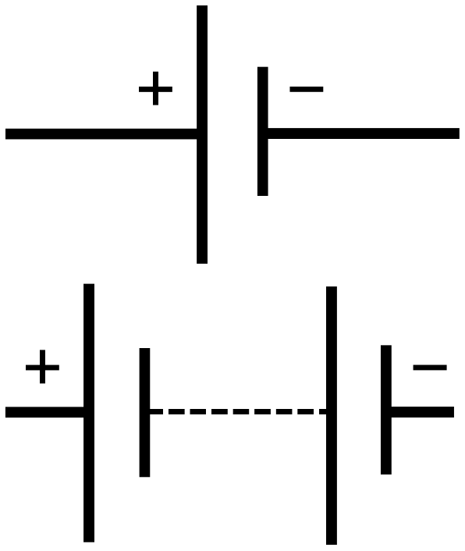
Figure 1: Battery and Cell
Ohm’s Law
Ohm’s law relates current with voltage is a circuit. It can be defined as a law according to which the voltage across the two ends of a conductor is always proportional to the current that flows through it. Mathematically, it can be expressed as follows.
V=IR
Where V denotes voltage across the conductor, I represents current and R represents the resistance offered by the conductor to the flowing current. Resistance (R) is the constant of proportionality in the above equation.

The EMF (Electromotive Force)
EMF or electromotive force is the quantity of chemical energy that is converted into electrical energy by the source such as a cell or a battery when a unit charge flows through it. The unit of EMF is volt.
EMF = energy / charge
EMF gives us a measure of the energy within a battery that forces the current to flow in the circuit. Since the current always flow as a result of potential difference, EMF itself is a potential difference. The units of potential difference and EMF are the same.
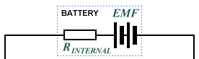
Figure 2: EMF
In Figure 3, the voltage across the terminal will be the EMF because no current is flowing through the circuit.
Internal Resistance
It has been explained earlier that each cell in a battery has an internal resistance (r). The unit of internal resistance is ohm (Ω).
When an external load is added to the terminals of a battery, some voltage is dropped across the internal resistance of the cell or battery. This results in the dissipation of energy in the form of heat within the cell. That is the reason why a cell or a battery warms up when it is supplying current.
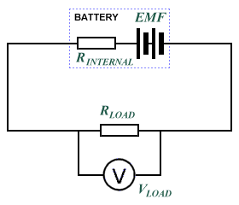
Figure 3: EMF
Therefore
E = voltage across R + lost volts
In order to also measure the current as well, we need to add an ammeter in series with the battery.
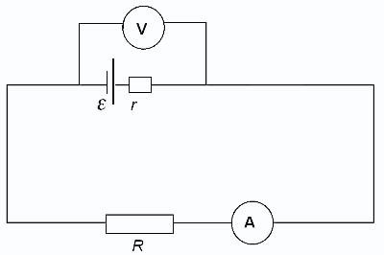
Figure 4: EMF and Internal Resistance

When current flows through a circuit, it is resisted by the internal resistor of the cell. As a result, some thermal or heat energy is dissipated in the cell. It causes warming up of the cell. Figure 4 shows that the cell is in series with its own internal resistance and also with the resistor (R) which has been connected externally. The same current flows throughout the circuit i.e. across the load, the internal resistance and the cell.
As per the Ohm’s law:
V = IR
Hence from Figure 4:
E = I (R+r)
Or E = IR + Ir
As IR=V
So E = V + Ir
We can see from the above equation that EMF (E) is the sum of terminal voltage and voltage dropped across the internal resistance. It clearly shows that the EMF is greater than the terminal voltage. When I=0, then E=V.

Equipment Used (Apparatus)
The following equipment and electronics tools are required in the experiment to find the internal resistance.
- Battery or Cell
- Resistors box including 2k, 4k, 6k, 8k, 10k resistor
- Voltmeter
- Ammeter
- Connecting wires
- A push button will be required to reduce risks. It allows connecting circuit only momentarily.

The procedure of Finding Internal Resistance and EMF (Electromotive Force)
In order to find the Electromotive force of the battery, the voltmeter should be connected across the terminals of the battery. When no current flows through the circuit, the voltage at the terminal is equal to the EMF of the battery or the cell.
Then the circuit should be set up as shown in Figure 4. The battery should be connected in series with the resistor and an ammeter. A voltmeter should be connected across the resistor or the terminals of the battery.
First, the values of the current (I) and terminal voltage (V) should be measured using a 1K resistor. The values are recorded in tables. Then the same procedure is repeated for resistance 2K and then 4 and so on. The experiment is repeated for accuracy.

Tabulated Results
We already know that E = I(R+r)
The value of internal resistance of r can be found by rearranging this equation.
r = (E –IR)/I
For R=1K => r=41.67 Ω

Resistance / Ω | Terminal P.D. / V | Current / A | Internal res / r
1 K Ω | 4.8 V | 0.0048 A | 41.67 Ω
2 k Ω | 4.898 V | 2.449x10⁻³ A | 41.65 Ω
4 k Ω | 4.948 V | 1.23x10⁻³ A | 42.27 Ω
6 k Ω | 4.965 V | 8.274 x10⁻⁴ A | 42.3 Ω
8 k Ω | 4.9736 V | 6.217 x10⁻⁴ A | 42.46 Ω
10 k Ω | 4.979 V | 4.979x 10⁻⁴ A | 42.17 Ω

Plotting the Graph
The graph can be plotted by plotting the current (I) along the x-axis and the terminal voltage (V) across the y-axis.

Calculating the value of r from the graph
The graph shows a straight line. If we take two points on the graph and find the slope, we will have the value of the internal resistance. The following points on the graph have been chosen at random
Y1 = 4.965
Y2= 4.898
X1= 0.0008275
X2= 0.002449
R = slope = [y2 – y1] / [x2 –x1]
= 41.31 Ω

Discussion
By connecting a resistance (R) of low value to a cell, very little resistance is offered and hence, the current (I) flowing through the circuit has a higher value. By increasing the resistance, the current flowing through the circuit is decreased. On the other hand, by increasing the resistance, the terminal voltage (V) is increased.
We also observed that when the external resistance (R) was not connected yet, the terminal voltage was the highest. This is the EMF of the battery. The Y-intercept of the Voltage-Current Graph should give the value of EMF, because Y-Intercept, the current value is zero. Moreover, the internal resistance can be found by finding the slope of the Voltage-Current graph.

Risk Assessment
It is important to connect the resistors with the battery with due care. If a very low-value resistance is used, a very high current will flow through the circuit. It will damage the circuit. Therefore only high-value resistance should be connected. In addition to this, another precautionary measure is to use a push button in the circuit. It allows connecting the battery with the rest of the circuit only momentarily.

Conclusion

Our experiment shows that every battery or cell consists of an internal resistance which hinders the flow of current through the battery. As current flows through it, the battery warms up and some energy is dissipated in the form of heat. Consequently, the voltage that the battery supplies to the external load are less than the EMF of the battery. The value of internal resistance is as low as 40-50 ohms. By plotting the current-voltage graph, the value of this internal resistance can be found from calculating the slope of the graph.

References
All About Circuits, 2018. Ohm’s Law - How Voltage, Current, and Resistance. [Online]
Available at: https://www.allaboutcircuits.com/textbook/direct-current/chpt-2/voltage-current-resistance-relate/
Circuit Globe, 2018. Cell and Battery. [Online]
Available at: https://circuitglobe.com/difference-between-cell-and-battery.html
Nustem, 2018. MEASURING THE EMF AND INTERNAL RESISTANCE OF A CELL. [Online]
Available at: https://nustem.uk/activity/emf-and-internal-resistance/
[Accessed 2019].

