Concept map

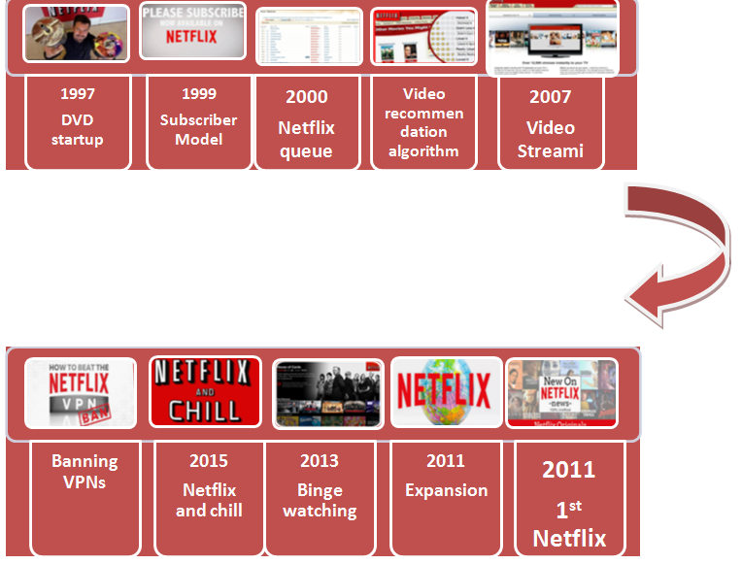

References
Burroughs, B. (2019). House of Netflix: Streaming media and digital lore. Popular Communication, 17(1), 1-17.
Gomez-Uribe, C. A., & Hunt, N. (2016). The netflix recommender system: Algorithms, business value, and innovation. ACM Transactions on Management Information Systems (TMIS), 6(4), 13.
Jenner, M. (2016). Is this TVIV? On Netflix, TVIII and binge-watching. New media & society, 18(2), 257-273.
Ranjan, A. A., Rai, A., Haque, S., Lohani, B. P., & Kushwaha, P. K. (2019). An Approach for Netflix Recommendation System using Singular Value Decomposition. Journal of Computer and Mathematical Sciences, 10(4), 774-779.

