[ Nia Matthews]
[Name of Instructor]
[ Art Appreciation]
[24 June, 2019]

Museum Paper

Art is the expression of beauty. It is the description of aesthetics and the innate abilities. Throughout the annals of history, art has been used to promote multifaced ideas. Traditionally, people reflected their ideas and cultural patterns with the help of art and literature. At present, artwork has many dimensions in its list of purposes. Artwork is used to propagate the major normative patterns, values and beliefs which are mostly important for the elite section in the society. Similarly, it is associated with the sense of aesthetics as it is the represents the ideals of beauty and high morality. In this modern twenty-first century world, some people have also started artwork for advertisement motives. Undoubtedly, now art is mostly practiced by those who are more into business and profits.
- The image is from the ancient French history which was all about aristocracy and the power in essence. It is depicted in the artwork that French people were ruled by nobility and the monarchy at that time. The French society had a very conservative and ignorant way of life. If one carefully observes the archaic world, he observes that it was all prevalent in that time period where only a few persons controlled the lives of people and their activities. However, this thing changed after the advent of the period of enlightenment and French revolution. Nevertheless, this image shows the period of French history which was totally backward in human ideals and the mode of governance because a man single-handedly ruled the world of its citizenry with his iron-hand.
- The image below shows the famous French ruler and the monarch Louis XIV. He remained the ruler of France and the French people for a very long period of time. He is utterly famous in the world history due to his ulterior expansionist designs. Louis XIV was immensely powerful and ruthless in dealing with the world and the people in general. The same set of things are depicted in this image. He is sitting comfortably in the position of dominance such as atop an eagle. He is holding a thunderbolt which is signifying that he had the legitimate control of power in that society. Moreover, all the beautiful things and joys are encircling him as if he were the centre of the universe. Several symbols are used in this artwork to actually portray that ancient time in the history.
- The composition of the image often proves instrumental in telling the background thoughts of the artist. Size really matters in the creation of masterpieces and the size of this artwork is huge. The size was chosen adequately to reflect the magnificence of the then situation. In addition, different colors in this artwork reflected radiance, comfort, ease and joy if that time, but it was restricted to only a small number of people. Various colours are used in the painting to highlight the importance of vibrancy and liveliness in the artwork. The colors and the materials matter because paintings or the artwork is all about taking into consideration all such things. It is about the creation of masterpiece and such details do matter in the process.
- The image show the values, beliefs of that ancient society in France. However, as it is said that all history is contemporaneous so one can find the relevance of those archaic values and issues even today. Such issue of power and privileges re still found in various societies today. Still, there are a number of people that are caught in the bad governance models and under the authoritarian leaders. Even today, the power and prestige of a selected few is common and prevalent around the globe. Thus, in some ways, it is different but mostly the ideas and approach are still relevant today.
- The thing I would change in this artwork is probably the size of the central image of Louis XIV. He is represented like a nucleus or the sun but the size of the centre should be enhanced more to better project the idea of superiority. Overall, the colour scheme in this image is nice. However, the focus is more on other things rather the central piece of the art. Hence, some issues of proportionality lie in this artwork where the artist has focused much on other details.
- The composition is done on a canvass of silk and wool. This is the beautiful representation of French society and the city of Paris in the old era and history. The choice of colours is really admiring where a perfect balance has been chosen between the bright and subtle colours. Red, silver, and gold have been used abundantly for portraying the right context in the French throne.
- I like all the works in the exhibition. Several artists and their creations were displayed in the gallery. All those paintings had their own substance and theme which they reflected impeccably and beautifully. I think art is beautiful as it displays the practical ideas of the time in a very subtle manner. However, not all art works are amazing as some artist include their own personal biases in their creations. Though, total objectivity is utopian in the world, nevertheless, the space for subjectivity must be limited. Only the real and practical artwork stirs emotions, not the unauthentic works of artists.

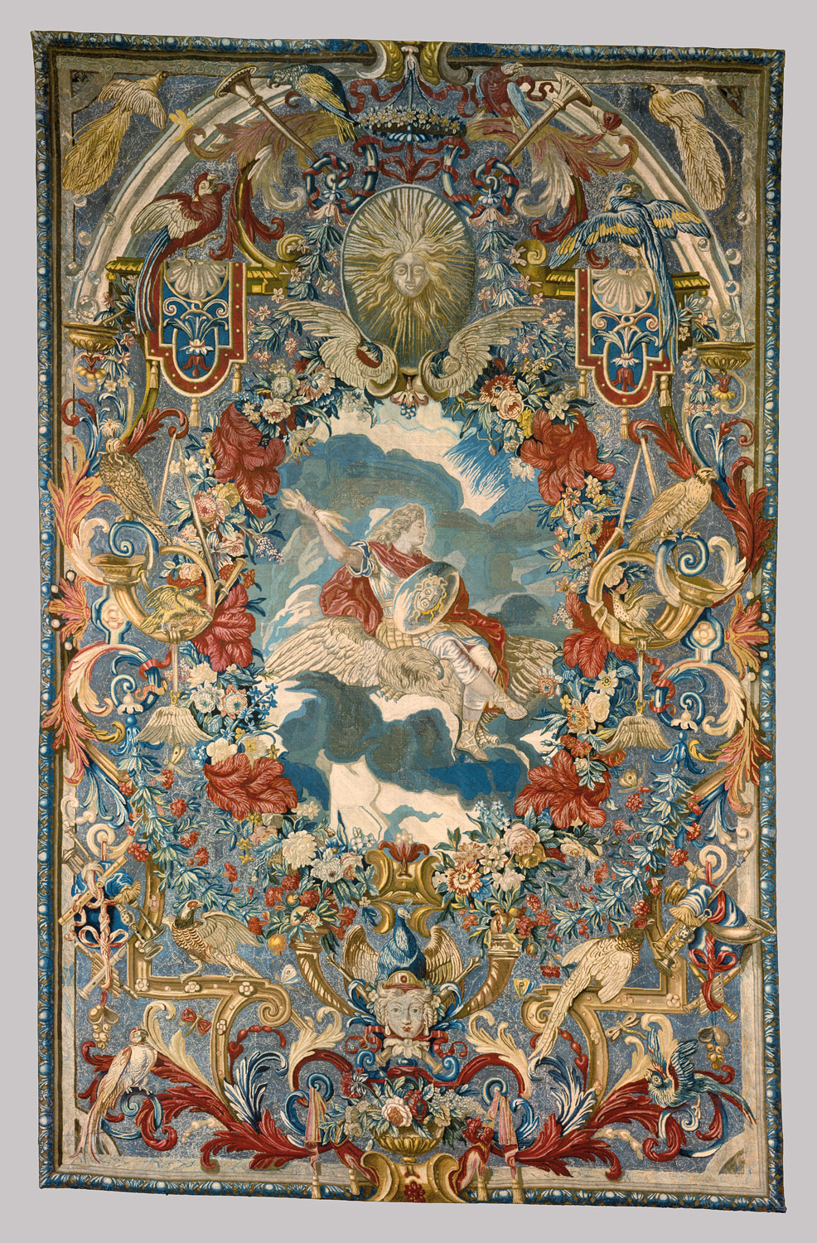Figure 1. The artwork

